Granbury Volunteer Fire Department

Standard Operating Guidelines

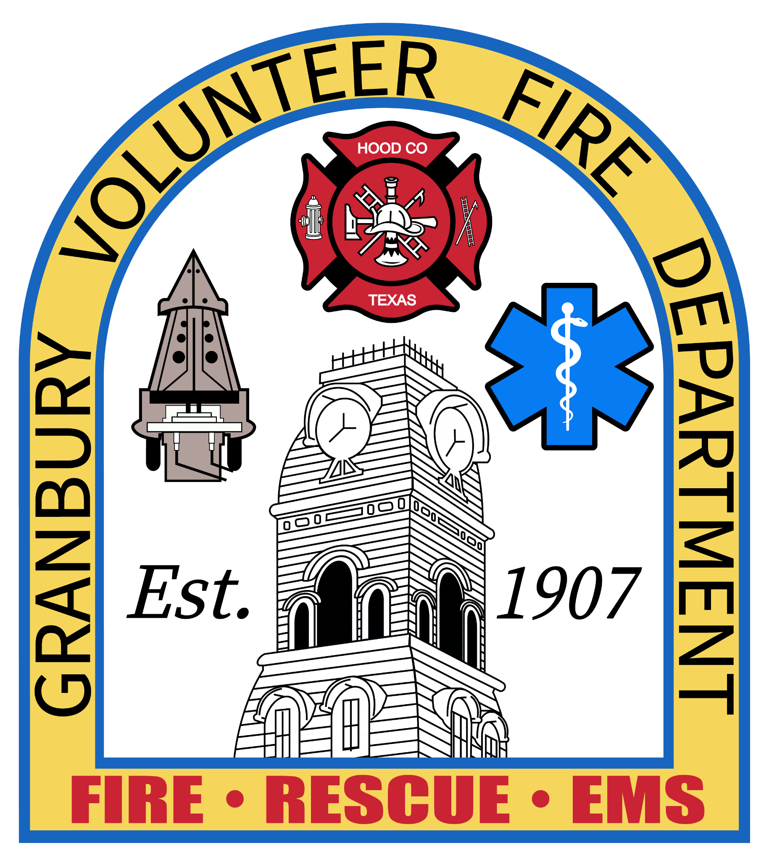

Chief: Matt Hohon

Assistant Chief: Tim Hallman

Captains: Kevin Jones, Mack Bennett, Brad Snyder, Bob Haggard, Steve Wiley, Jesse Slaughter

Implemented – July 02, 2020

Revised - Nov 17, 2023

What Are Standard Operating Procedures and Guidelines or SOP / SOGs?

Standard Operating Procedures (SOPs) or Standard Operating Guidelines (SOGs) are written policies that define what is expected from fire service personnel while performing their job duties. According to the National Fire Protection Association (NFPA), these procedures are considered organizational directives that establish a standard course of action. SOP/SOGs are designed to provide comprehensive guidelines on how a fire department should operate.

SOP/SOGs can be created for all fire service functions, including administration and emergency response operations. The presentation and organization of procedures may differ depending on the department's needs and preferences.

It is important to note that SOP/SOGs are different from pre-incident plans or pre-plans, which describe emergency response strategies for a specific facility. Pre-plans allow the department to gather information on designated locations, identify potential hazards, and assess site-specific factors. Meanwhile, SOP/SOGs are more generic in nature and are applicable to all emergency incidents or to a specific category or type of emergency.

SOP/SOGs do not provide technical information or step-by-step instructions for performing a job. Instead, they describe the department's rules for doing the job. Personnel are trained separately on the knowledge and skills needed to perform specific job tasks, such as managing programs, fighting fires, providing medical care, and more. SOP/SOGs describe related considerations such as safety, equipment maintenance, personnel duties and rights, command structures, coordination with other organizations, reporting requirements, and more.

In summary, SOP/SOGs do not explain the technical skills required for a job but rather provide procedural guidance on how to perform the job according to a department's rules.

Why are SOPs/SOGs important?

In modern society, fire service organizations face a multitude of challenges. With limited resources and increasing legal and regulatory requirements, departments are required to continuously expand their missions, including emergency medical care, hazardous materials response, technical rescue, fire prevention/public education, and terrorism incidents. They must also contend with increasingly complex emergency response techniques and equipment, such as personal protective measures, chemical safety, infection control, building and industrial codes, information management, and training systems. What's more, they have to coordinate and report their actions with other groups, such as emergency response agencies, community managers and planners, mutual aid organizations, federal and state governments, and member associations.

To meet these growing demands, fire service organizations need help navigating the maze of regulatory and administrative requirements. That's where SOPs/SOGs come in. SOP/SOGs provide a mechanism for identifying needed changes, articulating strategies, documenting intentions, implementing regulatory requirements, enhancing training, and evaluating operational performance. For members, SOP/SOGs clarify job requirements and expectations, providing a format that can be readily applied on the job. They explain in detail what the department wants them to do in the situations they are most likely to encounter, improving safety, performance, and morale. For department Chiefs and Officers, the advantages of SOP/SOGs are equally great. SOP/SOGs provide tools to direct and control the rapid pace of change, thereby improving operational efficiency, greater accountability, and reduced liability.

It is important to note that SOPs and SOGs are different. SOPs are rules that outline job requirements and expectations in a format that can be readily applied on the job. They explain in detail what the department wants personnel to do in the situations they are most likely to encounter. On the other hand, SOGs are recommendations for actions to be taken or performed, but allow personnel to work with flexibility. For instance, SOPs might include rules on sexual harassment, while SOGs might pertain to actions taken by a firefighter on an emergency scene.

In short, SOPs/SOGs are a vital component of fire service administrative and emergency response operations. Fire service organizations that choose to ignore this fact are increasingly vulnerable to accidents, lawsuits, unnecessary costs, personnel problems, and damage to their professional image.

**Table of Contents (This is out of order at this time)**

Guidelines – Will Have a “G” in the top left of the page

* Aerial Device and Maintenance & Inspection Page 08
* Post Incident Analysis Page 11
* Staging Apparatus Page 12
* Atmosphere Monitoring Systems Page 14
* Department Issued Badge and Shield Numbers Page 20
* Carbon Monoxide Alarms Page 21
* Code of Ethics Page 25
* Critical Incident Stress Debriefing Page 27
* Deal with the Media Page 31
* Non-Emergent Apparatus Use Page 34
* Elevator Entrapment Page 35
* Emergency Vehicle Driver & Officer Responsibilities Page 37
* Emergency Vehicle Maintenance Records Page 40
* EMS Response as First Responder Page 43
* Facility Security and readiness Page 45
* Fire Prevention Activity Report Page 47
* Forced Entry Page 49
* Fuel Tank Storage Page 51
* Fundraising and Solicitation of Funds Page 52
* Funeral Service Page 54
* Ground Ladder Testing Page 56
* Health and Safety Page 59
* Helicopter Response Page 62
* Hose Loading Page 65
* Incident Management on HazMat Scene Page 66
* Initial Arrival Guideline Page 68
* Cadet Member Program (Cadets/Probationary) Page 69
* LODD Notification Page 74
* Maneuvering at an Incident Page 76
* May-Day Page 77
* Mission Statement Page 82
* Mutual Aid Page 84
* Non-Mask Members on Apparatus Page 85
* Non Members Riding Apparatus Page 86
* Grooming and Personal Appearance Page 88
* Personal Accountability Procedure Page 90
* Personal Vehicle Safety Checklist Page 92
* Job Descriptions Page 95
* Probationary Firefighter Training Requirements Page 97
* Non-Emergent Response Page 98
* Communications Page 99
* Recommended Practice for RIT Deployment Page 102
* Records Retention Page 107
* Recruiting Citizen Help on Scene Page 108
* SCBA Page 109
* Respiratory Protection Program Page 111
* Safety Vests Page 114
* SCBA Inspection Page 115
* Scene Preservation Page 118
* Seat Belt Use Page 122
* Non-Smoking and Tobacco Free Areas Page 123
* Social Media Page 124
* Sprinklered Building operations Page 128
* Response Time Standard Page 130
* Fire Standby Agreement Page 156
* Testing and Inspections Page 132
* Uniforms, Badges and Issued Equipment Page 134
* Use of Department Owned Property Page 138
* Vehicle Safe Operations Page 139
* Probationary Members Riding Apparatus Page 143
* Organization Structure Page 144
* Unlocking Vehicles with and Without Life Safety Concerns Page 145

SOGs added after 03/08/2020 will be listed below

* Response Schedule Page 146
* Water Rescue________________________________________ Page 148
* Driver Qualifications Page 159
* Vehicle Extrication Page 162
* Awards and Nominations Page 165

**Intentionally Left Blank**

| See the source image | | |
| --- | --- | --- |
| **G** | **SOG Title: Aerial Testing** | |
| **SOG Number:** | |
| **Original Date: 1/27/20** | **Revision Date:** |
| **Granbury Volunteer Fire Department Standard Operating Guidelines** | | |

**Aerial Device Maintenance & Inspection**

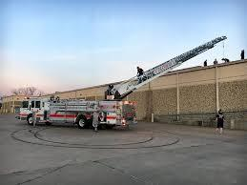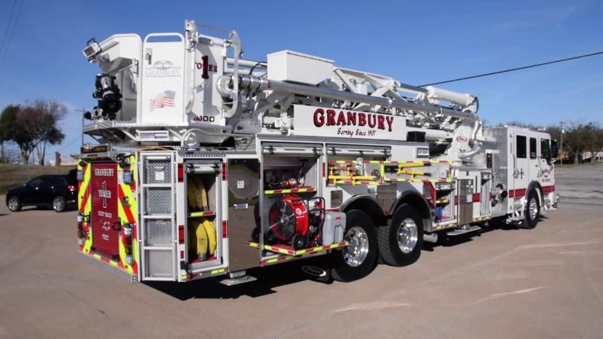

**Purpose:**

Aerial devices are critically important pieces of apparatus to fire departments. Aside from the obvious size difference when compared to other types of apparatus, aerial apparatus are different because of the mechanical function of the aerial device itself. The purpose of this guideline is for the Granbury Volunteer Fire Department to take steps to make certain that these devices stay in safe working order to safeguard personnel and to help prevent mechanical damage and/or structural failure of the aerial device itself.

**Procedure:**

While there are many potential causes of loss to aerial devices, two are identifiable with preventable results. First, is metal fatigue; second is improper and/or lack of proper maintenance. Some definitive steps that may be taken to help reduce wear and tear and the potential of structural failure.

**Budget and Maintenance:**

* It is recommended that Granbury Volunteer Fire Departments set aside enough money in its budget to conduct the annual testing and maintenance as well as being prepared long-term to deal with parts and components that may need to be repaired or replaced.
* Perform routine maintenance & inspection on every aerial device and within the range indicated by the manufacturer’s instructions. Items such as cables, rail guides and pulleys should be free of debris and be properly lubricated. Look for any obvious signs of neglect or damage to the aerial device during a documented visual inspection.

**Testing:**

There are very specific testing requirements for all types of aerial devices. These are spelled out in the NFPA Standard 1911 the Standard for the Inspection, Maintenance, Testing and Retirement of In-Service Automotive Fire Apparatus. There are two levels of testing:

* **Annual Testing** may be conducted by a qualified individual (as defined in NFPA 1911 Chapter 19) once a year. As defined in NFPA 1911-19.8, this is essentially a visual inspection and a documented operational test. However, there are a number of related tests in NFPA 1911 that are required in conjunction with the actual aerial tests, including but not limited to: pumps & waterways; electrical systems; breathing air systems; cab & chassis; and road testing.
* **A highly qualified and certified NDT Level II Technician as defined by the American Society of Nondestructive Testing must conduct Nondestructive Testing (NDT). Sometimes referred to as a five-year Nondestructive Test**. NDT is a general term for one of a number of different methods that can be used to inspect the aerial device’s structural components without physically altering or damaging the materials. These could include, but are not limited to, liquid penetrant inspection; magnetic particle inspection, radiography, metal hardness and ultrasonic testing. When properly conducted, the tests are designed to detect any metal fatigue, cracks or deformities in the frame, ladder, ladder rails, turntable, out rigger, bolts and any other critical metal structural component. These tests must be conducted at least every five years AND whenever the aerial device has been damaged or stressed beyond normal limits.

**Selecting the Proper Test Agency:**

Fire departments are responsible to know what test is required, when it is required and for making certain, the testing service provider conducts it. There are a number of testing agencies through-out the United States, both regionally and nationally, that can provide NFPA 1911 testing. However, the number able to provide non- destructive testing is smaller. Be specific by asking for either the Annual Test or the Nondestructive Test. Many fire departments have thought they were getting the NFPA required testing completed by a private company only to find out later the agency they chose was not performing, nor certified to perform, the NDT.

When selecting a private service company, verify that the third party meets certification and testing standards and has the proper insurance prior to signing an agreement. If the company cannot provide documentation that, the personnel and the test they will perform will meet the testing standard or if they cannot provide the appropriate certificate of insurance, look for another test agency to perform the work.

**Test Results:**

A written report from the testing agency will be provided with an explanation of the findings. This report should detail all of the tests that were conducted, but also the results of each of the specific inspection and test items and any required repairs.

Occasionally, there will be critical items identified which will require the aerial device to be placed out-of-service until repairs are made. It is strongly recommended that a qualified mechanic or technician make these repairs.

More often non-critical issues may be discovered that suggest maintenance or repair. While these items may not require the aerial device to be taken out of service, do not ignore them. Small problems left unattended can lead to larger problems. An example of this would be a small oil leak. Not enough to fail the test, but large enough to leave residue on metal surfaces; the oil residue will allow dirt to accumulate on these surfaces; the dirt particles will cause abrasion as metal to metal contact occurs and eventually cause uneven and/or premature wear.

**Summary:**

Follow these best practice recommendations:

* Plan a budget for aerial maintenance, testing and repairs.
* Refer often to the manufacturer’s recommendations for use, service and maintenance.
* Follow the NFPA 1911 Standard for testing frequency and content. Know the difference between Annual and Nondestructive testing.
* Research testing agencies before hiring one to conduct the testing.

| See the source image | | |
| --- | --- | --- |
| **G** | **SOG Title: Post Incident Analysis** | |
| **SOG Number:** | |
| **Original Date:1/25/20** | **Revision Date:** |
| **Granbury Volunteer Fire Department Standard Operating Guidelines** | | |

**Post Incident Analysis**

**Purpose:** Post-incident critiques of major and significant incidents provides an opportunity to review the effectiveness of actions and procedures in their application during actual incidents. It is also an opportunity to review the overall quality of the services provided to the customers at the incident. This review is extremely valuable in improving procedures and incident operations. Formal departmental critiques will be conducted at the discretion of the any member, officer or Chief.

Firefighter stress/ptsd help hotline: 866.676.7500 or 888-731-3473

| See the source image | | |
| --- | --- | --- |
| **G** | **SOG Title: Staging Apparatus** | |
| **SOG Number:** | |
| **Original Date: 02/1/20** | **Revision Date:** |
| **Granbury Volunteer Fire Department Standard Operating Guidelines** | | |

**Practice for Apparatus Staging**

**Purpose:**

In order to enhance accountability and effectiveness, it is recommended that fire crews utilize a standard system of initial placement for responding equipment and personnel prior to assignment at emergency incidents.

**Procedure:**

Level I Staging

* Automatically applies to all multiple unit response.
* First engine and truck will respond directly to the scene, give a brief initial report and advise actions to be taken.
* When the first arriving units report on the scene and announce a "Nothing Showing or Investigating", all subsequent responding units will report to Level 1 staging.
* When the first arriving units report on the scene and provide an initial radio report, the first engine and ladder will report to the scene and all subsequent responding units will report to Level I staging.
* All other responding units will stage in direction of travel, uncommitted, approximately one block from the scene until assigned a task.
* Staged units will, report their arrival on location at staging area to communications. It may be necessary at times to be specific when announcing staging area in extraordinary response situations.
* Staged units should stay off the radio until orders are received from the first arriving unit or the incident commander.

Level II Staging

* This procedure will relate to large, complex type situations requiring an on-scene reserve of units and will involve formal staging in an area designated by the incident commander.
* The incident commander will formally announce Level II staging and give the approximate location of the designated staging area. The staging area should be away from the incident command post and incident scene in order to provide adequate space for assembly and for safe and effective apparatus movement.
* All responding units will report to and remain in the staging area until assigned a task.
* In the absence of a designated staging officer by the incident commander, the first arriving officer to the staging area will automatically become the staging officer and should notify command.
* The radio designation for the staging officer will be "Staging".

Responsibility of the staging officer:

* + Report directly to the incident commander or the operations section chief.
  + Ensure that all equipment is parked in an appropriate location.
  + Maintain a log of units available in the staging area and inventory any specialized equipment that might be required on the scene.
  + Assume a position that is visible and accessible to all incoming units.
  + Communicate directly with communications to request additional units in order to maintain a base level of resources set by the incident commander.
  + When requested by the incident commander/operations officer, the staging officer will verbally assign units to report to specific sectors.

| See the source image | | |
| --- | --- | --- |
| **G** | **SOG Title: Atmosphere Monitoring** | |
| **SOG Number:** | |
| **Original Date: 2/1/20** | **Revision Date:** |
| **Granbury Volunteer Fire Department Standard Operating Guidelines** | | |

**Atmosphere Monitoring Systems**

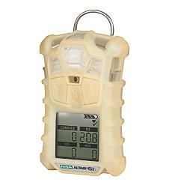

**Purpose:**

This standard operating procedure/guideline addresses monitoring carbon monoxide (CO) levels during overhaul, equipment and uses, removal of SCBA. The purpose of the air management policy is to improve firefighter safety by describing how we will manage the air in our SCBA cylinders while operating in the hazard zone at an incident.

**Procedure:** It is the responsibility of all members using, or supervising the use of, atmospheric monitoring instruments to span and/or calibrate these devices in the following manner.

**Calibration:** Calibration will be done on each instrument (except RMD* instruments) prior to making entry into the following atmospheres:

* Contaminated atmospheres
* Atmospheres which may suddenly become contaminated
* Atmospheres where there is suspected oxygen deficiency
* Atmospheres that are suspected of being contaminated or oxygen deficient or at any other time it may be necessary to render an instrument in a ready state of condition.

This instrument will be spanned on the proper calibration gas, hose and regulator to ensure the instrument of choice is in proper operating condition. At any time, the instrument does not span or calibrate correctly, and you cannot resolve the problem, you will not use the instrument. You will then bring the instrument to the senior crewmember or officer and change out for another instrument.

**Tracking:** To keep track of all calibration being performed on all atmospheric monitoring instruments, a Control Log has been developed. It is called the "Meter Calibration and Span Control Log." This Control Log will be used to document weekly calibration and being done prior to the use of the instruments. The form will be completed on a monthly basis and forwarded to an officer. Calibration of instruments will be on a weekly basis to ensure proper maintenance is being performed on all instruments, according to manufacturer's recommendations. Calibration of all instruments (except RMD* instruments) will be performed at each station on a monthly basis and logged into master control file for each instrument. This master control file will act as a legal history of that instrument's performance.

**Carbon Monoxide Monitoring**: When on scene it is recommended to take these actions for the various range of readings taken:

* 0ppm to 5ppm – Residents inside the property can stay inside the building. Advise individuals to contact property owner and or have a technician make appropriate repairs within the 24 hour day.
* 5ppm – 25ppm – Residents inside the property can stay inside the building. Open the house up, turn on fans and secure/turn off the suspected gas appliance. Advise individuals to contact property owner and or have a technician make appropriate repairs immediately.
* 25 ppm or greater – Carbon monoxide levels are toxic and the residence must be evacuated, EMS notified for evaluation of all individuals.

All Carbon Monoxide calls are serious, even low amounts of CO with a long exposure time can cause serious health effects. Any CO dispatched call the fire crews must check the entire house. It is recommended and a goal to allow the individuals into their home or business. Fire crews can monitor an atmosphere with high readings, secure/turn off the gas appliances and vent he structure. After 15 minutes of using positive pressure fans, fire crews will take another reading to verify the structure is safe for entry. If the readings are now 0ppm, the individuals can be let back into their property, with the advisement of having repairs made to whatever device caused the Carbon Monoxide hazard.

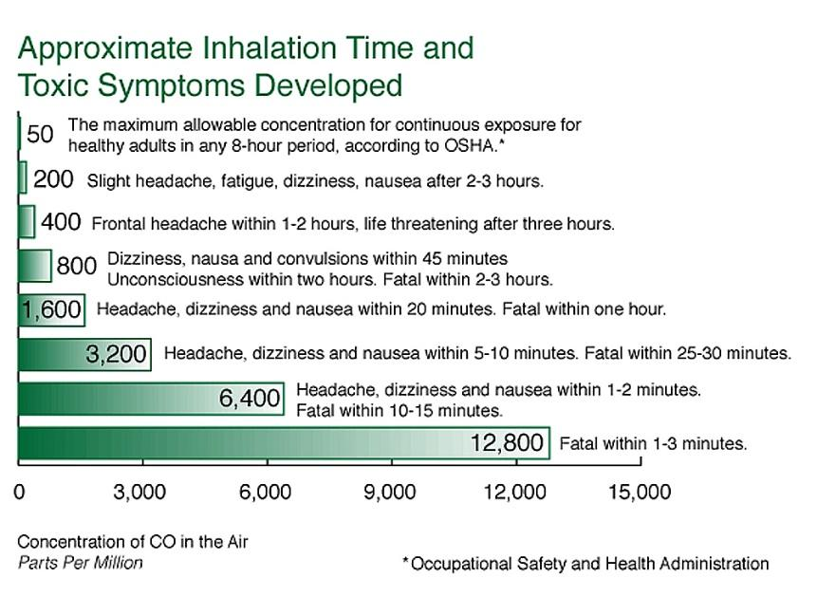 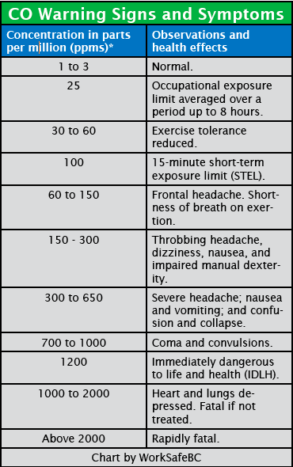

**Hydrogen Sulfide (H2S):** Hydrogen sulfide is a colorless, flammable, extremely hazardous gas with a “rotten egg” smell. Some common names for the gas include sewer gas, stink damp, swamp gas and manure gas. It occurs naturally in crude petroleum, natural gas, and hot springs

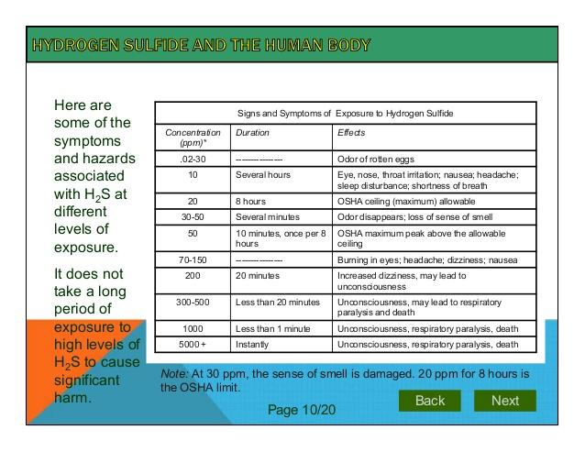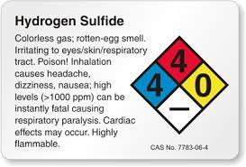

**Oxygen Levels:** Because there are no warning signs of reduced oxygen concentrations, these environments are extremely dangerous. Effects of exposure to low oxygen concentrations can include giddiness, mental confusion, loss of judgment, loss of coordination, weakness, **nausea**, **fainting**, **loss of consciousness** and death.

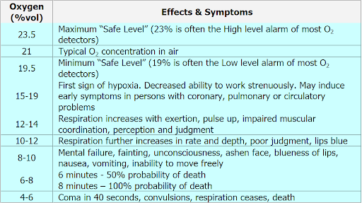

**LEL/UEL:** The lower explosive **limit** (**LEL**) or lower Flammable **limit** (LFL) is the minimum concentration of gas or vapor in air below which the substance will not burn. The upper explosive **limit** (**UEL**) or Upper Flammable **limit** (UFL) is the maximum concentration of gas or vapor above which the substance will not burn

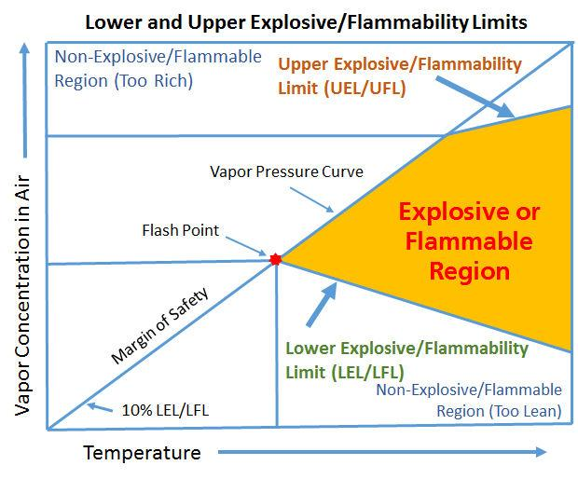

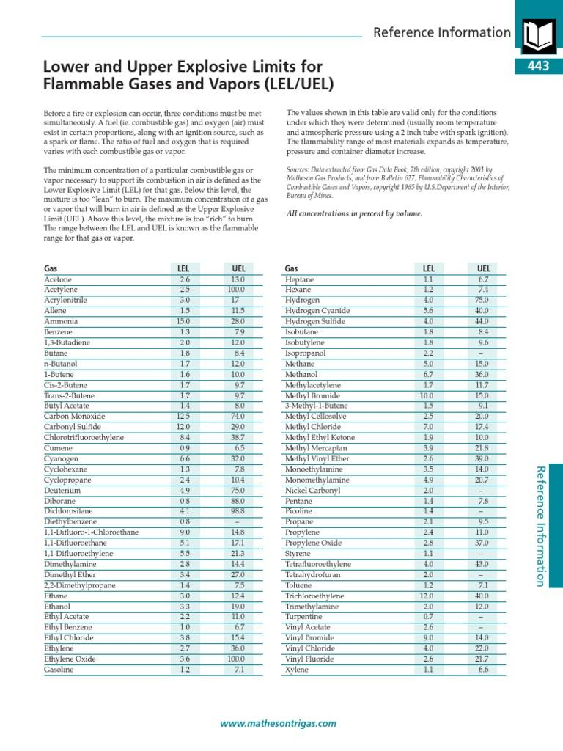

| See the source image | | |
| --- | --- | --- |
| **G** | **SOG Title: Department Issued Badge and Shield Numbers/Equipment Number** | |
| **SOG Number:** | |
| **Original Date: 2/8/20** | **Revision Date:** |
| **Granbury Volunteer Fire Department Standard Operating Guidelines** | | |

**Department Issued Badge and Shield Numbers / Equipment Number**

**Purpose:**

The Granbury Volunteer Fire Department will issue a specific badge and shield number. This number is for administration purposes. The Equipment Number is based in sequential order of their application processed and completed.

In the event a new probationary member requesting a previous members badge number, a son requesting his father’s badge number, that number can be passed to the new probationary member upon request to the Chief.

The number that you are issued with be given upon availability of the range of badge numbers. Your seniority is based from the date you were voted on probation. If multiple potential members are joining on the same date, the seniority will be based off age and the oldest will get the first available number.

| See the source image | | |
| --- | --- | --- |
| **G** | **SOG Title: CO Alarms** | |
| **SOG Number:** | |
| **Original Date: 1/30/20** | **Revision Date:** |
| **Granbury Volunteer Fire Department Standard Operating Guidelines** | | |

**Carbon Monoxide Alarms**

**Purpose:**

The purpose of this standard is to ensure consistency in response, investigation, action and reporting of carbon monoxide alarms. As in all standards, it is the intent to provide sufficient guidelines. However, caution must be exercised to assure proper and effective investigation of all potential sources of carbon monoxide.

**Definitions:**

Carbon Monoxide (CO) is an odorless and colorless gas. CO is a common by product of incomplete combustion of any organic material. CO is a major toxic component in cases of smoke inhalation, CO causes poisoning by interfering with the binding of oxygen with the hemoglobin in the bloodstream, myoglobin in the heart and muscle tissue throughout the body. CO is a toxic substance and is highly combustible gas that burns rapidly.

**Procedure:**

Upon arrival, the first officer/unit will attempt to determine if the alarm activation is valid through the following methods:

* Get the occupants out into fresh air immediately
* Discussion with occupants to determine how long they have been inside the structure
* Entry into the structure only after donning full protective clothing including SCBA and monitoring interior atmosphere with appropriate atmosphere monitoring devices (CO Detector)

EMS should be notified and dispatched immediately if occupants show any signs/symptoms of Carbon Monoxide exposure:

* Disorientation
* Dizziness
* Nausea
* Vomiting
* Facial discoloration (redness)
* Difficulty breathing
* Any exposure to carbon monoxide

If it suspected that the activation is valid, the following sources of Carbon Monoxide should be investigated:

* Furnace and chimney flue
* Stoves
* Appliances that use flammable fossil fuels
  + Natural gas
  + Propane
  + Oil
  + Kerosene
* Faulty space heaters
* Fireplaces
* Indoor operation of grills/cooking appliances
* Seepage from other sources
  + Garage
  + Storage closets/sheds
  + Adjacent structures
* Reverse drafting due to changes in air temperature or pressure

If the problem involves a utility, the proper agency should be contacted and requested to respond immediately.

The fire department will not attempt any repairs or alterations to any appliance or other device. The fire department will advise the occupant only.

Fire Department actions will be limited to:

* Evacuation and securing the structure involved
* Ventilation of structure
* Monitoring conditions within structure and the environment
* Assisting public utilities where requested
* CO checklist will accompany all investigations

Using the CO Detector:

* After activating the detector, zero the device in fresh air (reading between 0 ppm and 1 ppm) follow the manufacturers’ recommendations.
* Beginning at the lowest level, preferably near the heating system to begin a survey of the structure, moving from the lowest floor to the highest. Concentrate on air ducts and returns.
* IF ANY READING OF 35 PPM OR GREATER IS RECORDED, DON AIR MASKS IMMEDIATELY BEFORE CONTINUING THE SURVEY.

FOR READINGS OF 5 PPM OR LESS:

* Inform occupants that our detection equipment did not detect an elevated level of CO at this time (do not indicate that there is or was not elevated levels of CO).
* Recommend occupants check their CO detector per manufacturer and reset detector (under no circumstances will we reset a household detector)
* Inform occupants that once detector is reset to call the fire department again if it reactivates

FOR READINGS BETWEEN 5 PPM AND 25 PPM:

* ANY READING ABOVE 5 PPM WILL BE CONSIDERED ABOVE NORMAL (refer to SCBA protocol above)
* Inform occupants that our detection equipment has registered a dangerous level of CO
* Recommend that all occupants leave the premises and begin to ventilate the structure
* If an appliance is determined to be malfunctioning, turn it off if this can be done in a safe manner and advise the homeowner to contact the appropriate utility company
* If the CO readings can be stabilized below 5 ppm, then the structure can be reoccupied AT THE DISCRECTION OF THE OWNER
* (Stabilized is defined as readings below 5 ppm in an enclosed structure for a minimum of 20 minutes after ventilation is completed)

FOR READINGS ABOVE 25 PPM:

* ANY READING ABOVE 25 PPM WILL BE CONSIDERED POTENTIALLY LETHAL (refer to SCBA protocol)
* ORDER THE OCCUPANTS TO EVACUATE IMMEDIATELY
* contact the utility company and inform them of the air monitoring findings
* begin ventilation
* If utility company does not respond and the CO levels can be stabilized below ppm limit, then the structure can be reoccupied AT THE DISCRETION OF THE OWNER
* If the utility company responds, then upon arrival inform them of our findings and tum the incident over to the utility company representative
* Make preparations for a potential flash fire of the CO gas.

TERMINATION

* Prior to termination, the following should be performed:
  + Review actions taken with the occupant
  + Inform occupant of monitoring levels at arrival and during and after operations
  + Inform of possible likely source(s)
  + Inform of actions taken to return premise to acceptable conditions
  + Advise the occupant to have all appliances services as a precaution if not completed recently

**CHECKLIST FOR CARBON MONOXIDE**

Location of Incident __________________________________________ Date

Headache ☐ Yes ☐ No

Fatigue ☐ Yes ☐ No

Nausea ☐ Yes ☐ No

Dizziness ☐ Yes ☐ No

Confusion ☐ Yes ☐ No

Are any of the members of the household feeling ill? ☐ Yes ☐ No

Do you feel better when away from the house? ☐ Yes ☐ No

Since the detectors when off, have you?

Can you shut off carbon monoxide sources? ☐ Yes ☐ No

Which ones?

Can you let in fresh air? ☐ Yes ☐ No

If yes, how and for how long?

PPM acceptable ☐ Yes ☐ No Reading ___________ ppm

| **Checklist** |  | **ppm** |
| --- | --- | --- |
| Chimney | Clogged flue/blocked opening | ____________ |
| Fireplace | Gas/wood | ____________ |
| Portable Heater | Emissions | ____________ |
| Gas Refrigerator |  | ____________ |
| Kitchen Stove |  | ____________ |
| Cook Top Vent |  | ____________ |
| Gas Dryer |  | ____________ |
| Water Heater | Chimney pipe | ____________ |
| Furnace | Gas/oil: flue/chimney | ____________ |
| Barbecue Grill | In enclosed area | ____________ |
| Car Garage | Car started or running recently | ____________ |
| Operating Fireplace | Possible downdraft | ____________ |

CARBON MONOXIDE DETECTOR:

Make______________________ Model________________________ Serial #

Officer/Senior Member Completing Checklist

| **See the source image** | | |
| --- | --- | --- |
| **G** | **SOG Title: Ethics** | |
| **SOG Number:** | |
| **Original Date:** | **Revision Date: 1/25/20** |
| **Granbury Volunteer Fire Department Standard Operating Guidelines** | | |

**Code of Ethics**

**Purpose:** To preserve the public trust, a National Firefighter Code of Ethics was developed by a group of fire service leaders that calls on individual firefighters to pledge their support for maintaining the highest level of professionalism and behavior. Signing this symbolizes your personnel commitment.

Fire Fighter Code of Ethics

I understand that I have the responsibility to conduct myself in a manner that reflects proper ethical behavior and integrity. In so doing, I will help foster a continuing positive public perception of the fire service. Therefore, I pledge the following...

* Always conduct myself, on and off duty, in a manner that reflects positively on my department, the fire service and myself in general.
* Accept responsibility for my actions and for the consequences of my actions.
* Support the concept of fairness and the value of diverse thoughts and opinions.
* Avoid situations that would adversely affect the credibility or public perception of the fire service profession.
* Be truthful and honest at all times and report instances of cheating or other dishonest acts that compromise the integrity of the fire service.
* Conduct my personal affairs in a manner that does not improperly influence the performance of my duties, or bring discredit to Granbury Volunteer Fire Department.
* Be respectful and conscious of each member's safety and welfare.
* Recognize that I serve in a position of public: trust that requires stewardship in the honest and efficient use of publicly owned resources, including uniforms, facilities, vehicles and equipment and that these arc protected from misuse and theft.
* Exercise professionalism, competence, respect and loyalty in the performance of my duties and use information, confidential or otherwise, gained oy virtue of my position, only to benefit those that I entrusted to serve.
* Avoid financial investments, outside employment, outside business interests or activities that conflict with or arc enhanced by my official position or have the potential to create the perception of impropriety
* Never propose or accept personal rewards, social privileges, benefits, advancement, honors or gifts tht1t may create a conflict of interest, or the appearance thereof.
* Never engage in activities involving alcohol or other substance use or abuse that can impair my mental state or the performance of my duties and compromise safety.
* Never discriminate based on race, religion, color, creed, age, marital status, national origin, ancestry, gender, sexual preference, medical condition or handicap.
* Never harass, intimidate or threaten follow members of the service or the public and stop or report the actions of other firefighters who engage in such behaviors.
* Responsibly use social networking, electronic communications, or other media technology opportunities in a manner that does not discredit, dishonor or embarrass Granbury Volunteer Fire Department, the fire service and the public. I also understand that failure to resolve or report inappropriate use of this media equates to condoning this behavior.

______________________________________ Signature ______________________Date

| See the source image | | |
| --- | --- | --- |
| **G** | **SOG Title: Critical Incident Stress Debriefing** | |
| **SOG Number:** | |
| **Original Date: 2/8/20** | **Revision Date:** |
| **Granbury Volunteer Fire Department Standard Operating Guidelines** | | |

**Critical Incident Stress Debriefing**



Firefighter stress/PTSD help hotline: 866.676.7500 or 888-731-3473

**Purpose:** Addresses situations that indicate a need for CISM, identifying individuals needing CISM, procedures for notifying a qualified debriefing team, conducting a defusing, post-incident follow up.

**Introduction:**Case studies by medical groups of major incidents where numerous injuries or fatalities occurred have revealed that significant numbers of rescue personnel experienced some form of stress-related symptoms following the incident. Many of these symptoms were brief, and most personnel had no long-term detrimental effects. These studies, however, have also revealed that a small percentage of personnel do experience continuing, long-term detrimental effects resulting from exposure to such incidents. Some of these effects have been delayed, surfacing later after a period of no apparent symptoms. Without professional intervention, these personnel have experienced declining work performance and deterioration of family relationships as well as increased health problems. Personnel that have been repeatedly exposed to serious incidents or personally significant incidents multiple times may also exhibit stress-related problems, called cumulative stress. The objective of this procedure is to provide professional intervention to minimize stress-related injury to Fire Department personnel.

**The Critical Incident:** Fire department response to incidents that cause personnel unusually strong emotional involvement will qualify for some form of critical incident stress intervention (i.e., defusing, debriefing, or one-on-one contact). The following are examples of incidents that require intervention:

* Any incident that effects any one-crew member profoundly, where he/she may need confidential support.
* Serious injury or death of a fire department member or other emergency personnel (including suicide).
* Mass casualty incidents.
* Death of a child, or violence to a child.
* Serious injury or death of a civilian resulting from fire department operations (i.e., auto accident, etc.).
* Loss of life of a patient following extraordinary and prolonged expenditure of physical and emotional energy during rescue efforts by fire department personnel.
* Hindered, failed, or complicated situations that affected goals (possibly cause of death, or injury).
* Drownings or near-drownings involving a child.
* Incidents that attract extremely unusual or critical news media coverage.
* Any incident that is charged with profound emotion. • Any incident in which the circumstances were so unusual or the sights and sounds so distressing as to produce a high level of immediate or delayed emotional reaction.

**ON-SITE MANAGEMENT:**  Minimizing exposure to these stressful incidents result in fewer stress-related problems. Command should reduce this exposure by rotating personnel and by removing initial personnel from the scene as soon as possible.

Any personnel directly involved in high-stress incidents (particularly previously listed examples) should be considered as high priority for immediate removal from the scene. Relief from duty for these personnel may also be a consideration.

On-site evaluation and contact by a critical incident stress team (CIST) member should also be considered for some critical incidents when time and circumstances permit. In such situations, a Critical Incident Stress Team Member can observe, watch for acute reactions, provide support, encouragement, consultation, and be available to help resting personnel deal with stress reactions. Team members should be considered a resource available to Command for assignment to Rehab, or other sectors as needed.

**ACTIVATION OF THE CRITICAL INCIDENT STRESS PROCESS:** Company officers, the incident commander bear the responsibilities for recognizing significant incidents that require intervention. When an incident is identified as a "critical incident," a request for a defusing or debriefing should be made to your senior member, Officer or Chief.

Any incident commander, officer, or crewmember who may have experienced a traumatic event may initiate the CIS process by contacting Chief or Assistant Chief. The Chief will work in conjunction with the scene officer, evaluate the incident, and determine what level of intervention is necessary (i.e., defusing or debriefing). The form of intervention utilized will depend greatly upon how early the team is activated and the nature of the incident, strict confidentiality is to be maintained during the entire process.

Any member who feels the need for a personal, confidential one-on-one or defusing may initiate the process by contacting the Chief or Assistant Chief and they will start the CISM process.

**AFTER ACTIVATION OF THE CIS TEAM:** Any member who feels the need for a personal, confidential one-on-one or defusing may initiate the process by contacting the Chief or Assistant Chief and they will determine the situations where the critical incident warrants, make contact in person to determine what form of intervention is necessary.

**TYPES OF INTERVENTION:** The type of intervention by the CIS team will be determined by confidential discussion of the critical incident with the company officer, crewmembers, and/or deputy chief. The types of intervention are as follows:

* One-On-One - Done by either a Fire Department member or professional counselor. One-on ones may be done anytime.
* Defusing - Conducted normally by two Fire Department members, no professional counselor involved, within close proximity, preferably 30-45 minutes after arriving at the station, being informal and confidential.
* Debriefing - Critical incident debriefing is not a critique of fire department operations at the incident. Performance issues will not be discussed during the debriefing. The debriefing process provides formats in which personnel can discuss their thoughts and reactions and thus, reduce the stress resulting from exposure to critical incidents. All debriefings will be strictly confidential. Debriefings can be conducted by professional counselors and fire department members and should be done within 72 hours of the incident but after 24 hours if possible. Debriefings are formal lasting one-to-two hours and may be preceded by a defusing a short time after the incident.
* Follow-up Debriefings - Are rare and are usually conducted weeks or months after the incident where there is concern of delayed or prolonged stress symptoms. This type of debriefing may be done informally.

**ATTENDANCE:** Attendance of defusing’s or debriefings are not mandatory but are highly suggested of all personnel who were directly exposed to the traumatic aspects of an incident selected for intervention. The officer involved may grant exceptions following assessment.

**LOCATION:** Defusing’s and debriefings may be conducted anywhere that provides ample space, privacy, and freedom from distractions. Any meeting facilities, centrally located to the involved crews, are worthy of consideration.

**STATUS OF CREWS DURING INTERVENTION:** During one-on-one, defusing’s, and debriefings all crews involved will be out of service (unavailable) and all radios, pagers or other distractions will be secured. Confidentiality will be strictly maintained.

**THE CRITICAL INCIDENT STRESS TEAM:** The CIS team will consist of professionals in stress-related counseling as well as Fire Department personnel. The Fire Department members' role in the CIS process will be to assist and support the professional counselors as necessary during a debriefing process. During a defusing, the Fire Department members will conduct the defusing without a professional counselor present. One-on-one meetings may be conducted by a professional either counselor or Fire Department member, depending on what the incident calls for and/or what the involved personnel request.

**RELIEVING PERSONNEL FROM DUTY:** Circumstances of a critical incident may result in a recommendation by the CIS team that individuals or crews be taken out of service. Such decisions may include returning personnel to their stations in an out-of-service status and allowing crews to determine for themselves when they are mentally and physically prepared to return to service. In other circumstances, the crew member(s) may decide that they cannot return to duty, or the professional counselor may recommend relief from duty. If this is the case, the Assistant Chief or Chief will be responsible for making appropriate arrangements. Under no circumstances is a recommendation for relief from duty to be construed as critical or negative.

| **See the source image** | | |
| --- | --- | --- |
| **G** | **SOG Title: Dealing with the Media** | |
| **SOG Number:** | |
| **Original Date:** | **Revision Date: 1/25/20** |
| **Granbury Volunteer Fire Department Standard Operating Guidelines** | | |

**Dealing with the Media**

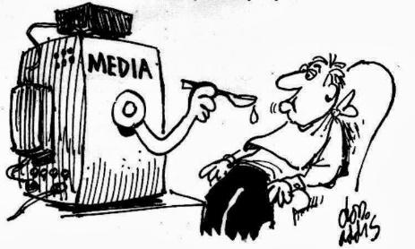

**Purpose:**

The media performs many functions that may have an impact on Granbury Volunteer Fire Department. It can educate the public and surrounding community about Granbury Volunteer Fire Department and its mission. It might publicize successes and provide positive press. Unfortunately, however, the media is quick to broadcast when things do not go quite right.

Taking a proactive approach to risk management within Granbury Volunteer Fire Department is important in helping avoid unwanted situations.

**Procedure:**

Laying that foundation may help prepare for future interactions. The following are suggestions on how to work with the media and what to do should a crisis occur within Granbury Volunteer Fire Department.

**Tips for Working with the Media**

* **Media policy for the Granbury Volunteer Fire Department** – Various forms of communication:
  + Phone Call – The Media can and will call the Fire Station asking for information about a recent dispatched call. The individual is to take a message of the contact and forward the message to the Chief of Assistant Chief. Granbury Volunteer Fire Department does not give out any information about our members, calls or patients unless the request was processed through the proper channels. The departments Chiefs or Public Information Officer, which is an employee of the City of Granbury, will release any information about the department. Do not release any information over the phone to the media.
  + Email – If you are contacted by email by a member of the media requesting information, forward the email to the Chief or Assistant Chief and they will process the request for information. Do not release any information via email to the media.
  + A knock on the front door – If a member of the media arrives at our station, invite them inside, take their request, and forward it to either the Chiefs or Office Manager. Do not release any information verbally to the media.
* When the media is making a request for information please note the following to be forwarded to the Chiefs, Office Manager or City PIO:
  + Name
  + Number
  + Organization Represented
  + Questions
  + Time and date of when the request was made
  + Who took the message
* The City of Granbury’s Public Information Officer is Bethany Kyle, [bkyle@granbury.org](mailto:bkyle@granbury.org)
* It is important to have a positive relationship with the local media. They are essential to being able to connect with a large population quickly. We want to be open and honest with the media, they have a job to do as well. Have a good working relationship with the local community can often begin with positive press.
* Any call received from the media, the message must be passed in a timely manner. It is true that you can't be sure the media will get the facts right, but not returning phone calls or a consistent "no comment" is not recommended. Journalists may want instant answers, but it is more important to provide accurate answers. Efforts to get accurate information and then providing it on a deadline will help build respect and trust with media contacts.
* Some misinformation is unintentional. Perhaps a media representative misunderstood information that was provided. It is advisable to correct this as soon as possible. If additional information comes along after an interview or there was a misinterpretation of information, call in or email the correct information immediately.

**What to do When a Crisis Occurs**

* **Act quickly to alert fire department and city management** - The media can broadcast a story across the state or country within seconds. It is important that executive members, including board members, are made aware of a situation that might attract press attention so they can respond appropriately to questions from outside the Granbury Volunteer Fire Department.
* **Contact the insurance company and/or attorney** -The situation may not end up as a claim but often the insurance company and attorney may offer advice on an approach with media representatives. They may be able to offer loss control approaches to help mitigate damage or bad will that can often result in litigation.
* **Get the facts** - Interview involved members to clarify exactly what occurred. Find out as many details as possible. In most cases, the media spokesperson provides general statements to the press, but the details may be helpful in constructing those general statements.
* **Communicate with families** -Before talking to the media, or as soon as possible afterwards, set up a system to communicate with members or those associated with the Granbury Volunteer Fire Department. It is important these individuals learn about potential problems that might bring negative press from the Granbury Volunteer Fire Department, as these stakeholders may sometimes be the biggest allies and supporters.
* **Council members regarding confidentiality** - Do not forget HIPAA and the need to protect private health information! Remind members about client confidentiality, privacy rules and release of information. Advise members of the Granbury Volunteer Fire Department's media policy, the steps to take when contacted by the press and to refer calls from media or others outside the Granbury Volunteer Fire Department to the designated spokesperson.
* **Implement damage control** - If members are informed, they may feed misinformation to the media. To help minimize gossip and speculation, schedule a member meeting for the involved location or department to review what happened and emphasize the facts that have been discovered up to that point. Supervisors may also need to evaluate whether counseling services are advisable for members, based on the circumstances of the crisis.

**Summary:**

Proper preparation and planning can go a long way toward improving a Granbury Volunteer Fire Department's image in the media.

Developing sound media relationships up front may help in crises that attract public scrutiny. Being the primary source of information may also help guide what information is written. When it comes to managing the media, having a formal policy in place that outlines the Granbury Volunteer Fire Department's response plans is crucial.

| See the source image | | |
| --- | --- | --- |
| **G** | **SOG Title: Non-Emergent Apparatus Use** | |
| **SOG Number:** | |
| **Original Date:2011** | **Revision Date:1/25/20** |
| **Granbury Volunteer Fire Department Standard Operating Guidelines** | | |

**Non-Emergent Apparatus Use**

**Purpose:** Part of meeting our goals as members of Granbury Volunteer Fire Department is to be available for service whenever possible. When the appropriate number of members, a minimum of three (3), are at the Fire Station and would like to get lunch. The Granbury Volunteer Fire Department does allow that crew of three (3) or more, to take an apparatus and drive non-emergent to a local business in the City of Granbury, sit down and eat inside the business considering these factors:

1. A minimum of three (3) crew members on the apparatus are active members
2. All crew members have all of their provided PPE on the apparatus
3. The engineer is qualified to drive and operate the apparatus
4. Any non-member for Granbury Volunteer Fire Department has filled out the appropriate paper work and has permission to be on the apparatus
5. Understand if an emergency call is paged, toned or received in any manner they immediately, pay the owner of the business and leave for the call.

Having volunteer crews available for service and having volunteer crews in service in public spaces are a major benefit for the image of the department and add to the quality of service we provide by aiding in faster response times.

*If confronted by a member of the public with a concern for the use of taxpayer money misused, the senior member of the crew will politely explain the service they are currently providing by having Granbury Volunteer Fire Department members immediately available for calls. Lastly, either the senior member will take down contact information so the Chief or Assistant Chief can follow up with the concerned citizen.*

| See the source image | | |
| --- | --- | --- |
| **G** | **SOG Title: Elevator Entrapment** | |
| **SOG Number:** | |
| **Original Date:** | **Revision Date:** |
| **Granbury Volunteer Fire Department Standard Operating Guidelines** | | |

**Elevator Entrapment**



**Purpose:** The purpose of this Standard Operating Guideline is to provide guidelines for the necessary methods needed too safely rescue of persons who have become trapped inside an elevator for any reason.

**Response:**

1. Unless information is received from Dispatch indicating a medical emergency or a person trapped in the mechanism of the elevator, responses to elevator emergencies will be non-emergency. Any officer may upgrade the response to an urgent response.
2. Upon confirmation that a person is trapped in the mechanism of the elevator, the alarm should be upgraded to multiple crews and apparatus assignments.

**Procedure:**

1. The Incident Commander will meet with the complainant, and to determine if there is a person trapped in the elevator and how many people are affected.
2. Upon the determination that a rescue is necessary, the Incident Commander will request the property owner to contact an elevator repair service to respond. If the property owner/manager is not available then secure the elevator.
3. If the elevator service is equipped with Phase I recall service, attempt to recall the elevator. If this does not free the elevator, continue as below.
4. In an immediate emergency, a member will be sent to the elevator mechanical room and shut down the power to the effected elevators. The member will turn power off to the elevator and use a padlock provided under the officer’s seat of apparatus to “Lock out and Tag out”. The power source will be locked and tagged out, placing the elevator out of service. Once the power has been shut down to the elevator, a designated crewmember will remain in the mechanical room until released by command.
5. The position of the car in the hoist way will be determined. It may be necessary to open the hoist way door to determine the cars position.
6. The company officer will establish contact with the car’s occupants, and attempt to determine if any medical conditions are present, and then advise them to do the following:
   1. Sit on the floor, with your back against the wall of the elevator.
   2. Do not smoke.
   3. Stay away from the elevator doors
   4. With the rescue is in progress, talk to the occupants and explain what the crews are doing to ensure the safety of the occupants. With power turned off to the elevator the lights could be off in the elevator car.
7. Once the above has been performed, the hoist way doors closest to the car will be opened using a hoist key.
8. All doors opened should be blocked open using a wooden door wedge.
9. Request the occupants of the elevator car activate the car’s STOP switch.
10. Only in the event of an ongoing medical emergency within the car will the door to an elevator be forced open.

**Occupant Removal:**

1. All occupants who cannot walk without assistance will be removed with the aid of a stair chair, backboard, or stokes basket.
2. Any occupant who can walk out will be assisted to do so if the car floor is even with the floor.
3. If the car floor is not even with the floor, a member will board the car and the car occupants will be assisted from the car using an attic ladder with a member in the car and at the floor level assisting the occupants. Any time an occupant must climb more than 4 feet from the car floor, a safety line will be secured to the car occupant as fall protection with harness.
4. If the cars doors cannot be opened normally, a roof hatch may be used to affect the rescue. When a roof hatch is used to evacuate the car’s occupants, safety lines will be attached to the occupants as fall protection.

**Termination:**

1. Once a rescue has been completed, the hoistway doors will be closed and kept closed.
2. Any disconnected power supplies will be left off and lock out / tag out devices may be removed at the direction of the Incident Commander.
3. The building’s representative should be advised to leave the elevator out of service until it can be repaired by an authorized service company.

| See the source image | | |
| --- | --- | --- |
| **G** | **SOG Title: Driver and Officer Responsibilities** | |
| **SOG Number:** | |
| **Original Date:1/25/20** | **Revision Date:** |
| **Granbury Volunteer Fire Department Standard Operating Guidelines** | | |

**Emergency Vehicle Driver and Officer-in-Charge Responsibilities for Safe Arrival**

**Purpose:**

This is to provide guidance for the safe operation of an emergency vehicle, which depends heavily on the thoughts and actions of the driver and the added resources and direction of the front seat officer. The primary task of any emergency vehicle driver should be to operate the vehicle in such a manner as to provide an optimum level of safety for both passengers and the public.

**Procedure:**

Another concern for emergency vehicle drivers is to be aware that civilian vehicle operators may not react in the manner in which you expect or feel to be appropriate. In light of this, you should attempt to leave yourself alternative options when passing or overtaking civilian vehicles. Keep in mind that, when you are driving an emergency vehicle to an emergency, if another driver fails to yield the right of way, as an emergency vehicle driver you should not:

* Assume the right of way
* Force the right of way

For optimum safety, the officer or person riding in the front seat officer’s location should be in a position to assist the driver with certain functions that can improve his or her ability to concentrate on driving and traffic awareness. Your emergency services provide by Granbury Volunteer Fire Department should review the following best practices and compare them to your Granbury Volunteer Fire Department’s SOGs, state statutes and applicable standards. Prior to implementation, the SOGs should be reviewed by legal counsel.

**An emergency vehicle driver should:**

* Complete a “Circle of Safety” inspection around the vehicle to be driven prior to starting the vehicle—to see that all equipment is secured, that all compartment doors are securely closed, and that any physical obstructions are moved out of the way
* Drive defensively
* Will not move emergency vehicles until all personnel in or on the vehicle are seated and secured with seat belts and in approved riding positions
* Operate the emergency vehicle in as safe and prudent a manner as possible
* Drive with the safe arrival of the emergency vehicle and crew to the emergency scene as a primary responsibility
* Be aware of his or her rate of closure (speed relative to the rate of time and space reduction) on other vehicles and pedestrians
* Maintain a safe following distance, allowing 1 second of following distance for every 10 feet of vehicle length for speeds under 40 mph (adding 1 additional second for every 10 mph for speeds over 40 mph)
* Be prepared, during an emergency response, to bring the vehicle to a complete stop for the following:
  + When directed by a law enforcement officer
  + For red traffic lights
  + For stop signs
  + At negative right-of-way intersections
  + When the driver cannot account for visible traffic in the lanes of traffic in an intersection
  + When other intersection hazards are present
  + When encountering a stopped school bus with flashing warning lights
* Obey, during non-emergency travel, all traffic control signals and signs and laws and rules set forth by state or local jurisdiction
* Come to a complete stop, during emergency response or non-emergency travel, at all railroad grade crossings and:
  + Turn off all sirens and air horns
  + Operate the motor at idle speed
  + Turn off any other sound-producing equipment or accessories
  + Open the windows and listen for a train horn

**Officer or Senior Member in Seat Position**

Whether an elected or appointed officer or not, the individual riding in the front passenger seat of an emergency vehicle is generally taking on the role of officer in charge of that vehicle. While not in physical control of the operation of the vehicle, the officer in charge provides an additional set of eyes and ears for the driver and should take responsibility for certain tasks (see below) that allow the driver to concentrate on operating the vehicle in a safe manner.

**The Officer should:**

* Confirm for the driver that all personnel on the vehicle are seated and secured with seat belts and in approved riding positions prior to movement of the emergency vehicle
* Issue verbal warnings about observed road and physical hazards to the driver
* Direct the driver to cease any unsafe driving, such as excessive speed or unsafe intersection practices
* Operate the radio and communications equipment during response and relay any relevant information to the driver for confirmation
* Operate the sirens and audible warning devices
* Check the map book, run cards or computer-aided response monitor to assist the driver in determining the safest and most direct route to the emergency scene
* Observe the driver to help ensure that the vehicle is being operated in a safe and prudent manner during the response in accordance with departmental policy and state statutes
* Assist the driver in crossing intersections and backing up according to the specific responsibilities outlined in Granbury Volunteer Fire Department SOGs

| See the source image | | |
| --- | --- | --- |
| **G** | **SOG Title: Emergency Vehicle Maintenance Record** | |
| **SOG Number:** | |
| **Original Date: 1/27/20** | **Revision Date:** |
| **Granbury Volunteer Fire Department Standard Operating Guidelines** | | |

**Emergency Vehicle Maintenance Record**

**Purpose:**

To provide documentation of maintenance performed on Granbury Volunteer Fire Departments vehicles.

**Procedure:**

A maintenance record for each Granbury Volunteer Fire Department vehicle will be maintained by _____________.

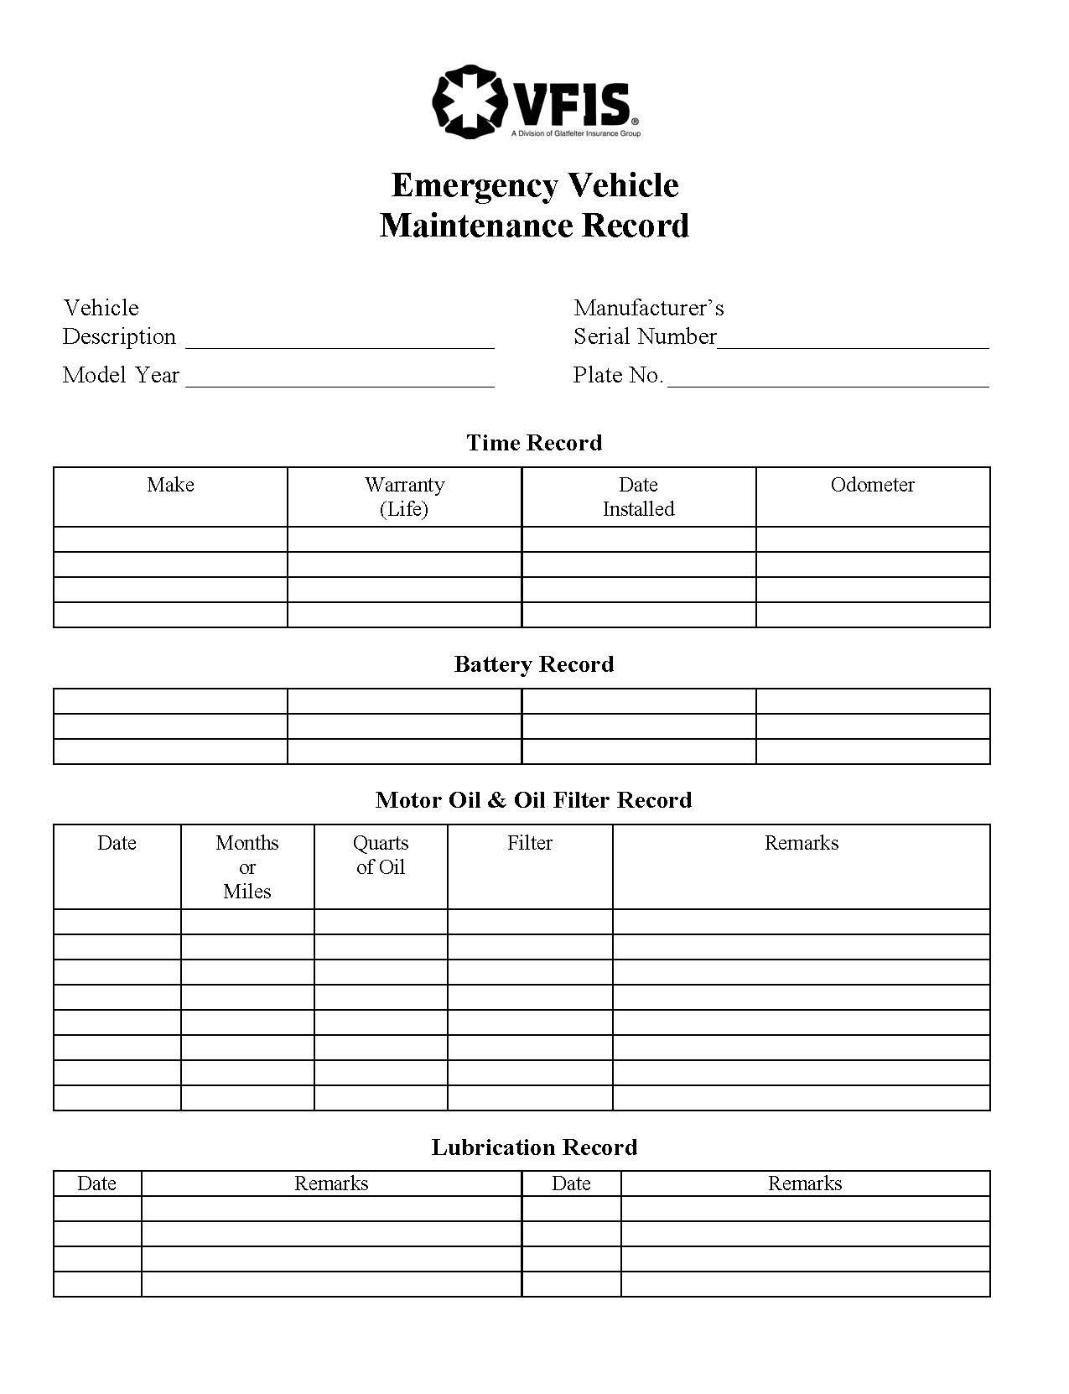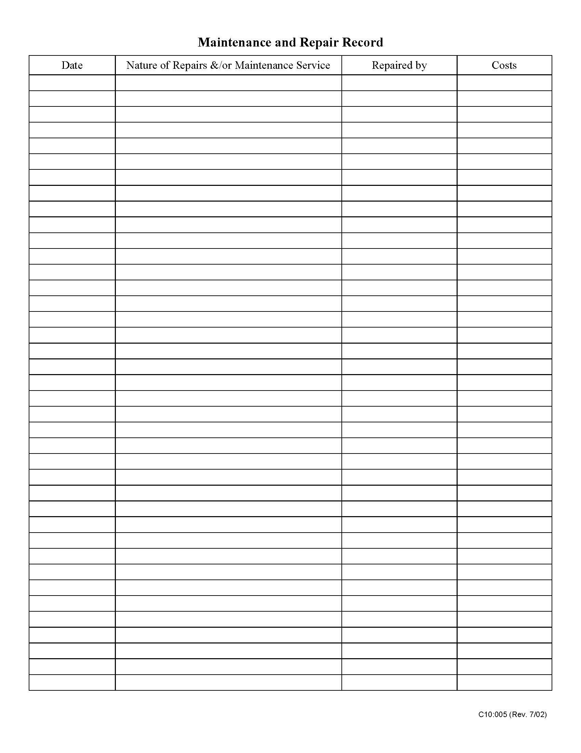

| See the source image | | |
| --- | --- | --- |
| **G** | **SOG Title: EMS Response as First Responder** | |
| **SOG Number:** | |
| **Original Date: 2011** | **Revision Date: 2/7/20** |
| **Granbury Volunteer Fire Department Standard Operating Guidelines** | | |

**EMS Response as First Responder**

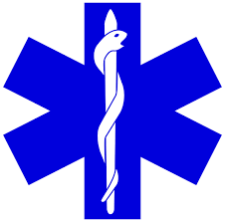

**Purpose:**

The purpose of this document is to establish a guideline for the response of Granbury Volunteer Fire Department personnel and apparatus to EMS calls

**General Information:**

1. Personnel responding to EMS calls will abide by the terms of the first responder agreement between GRANBURY VOLUNTEER FIRE DEPARTMENT and Texas EMS
2. Personnel responding will abide by GRANBURY VOLUNTEER FIRE DEPARTMENT EMS medical protocols as approved by the medical director.
3. EMS response is authorized by this guide provided adequate personnel are available

**Requirements:**

1. Prior to responding personnel will be approved by EMS Coordinators and training captains.
2. Appropriate PPE will be worn on all calls
3. All patient contact should be conducted with 2 personnel present
4. Structural Firefighting gear should not be worn on ems calls not involving fire or rescue
5. Personnel should be identified as GRANBURY VOLUNTEER FIRE DEPARTMENT and level of EMS certification by uniform or by ID badge provided by department.
6. Operations on Roadways and other high hazard or low visibility scene personnel will adhere to policies on reflective garments.
7. Any clothing and equipment exposed to body fluids will be cleaned or taken out of service at the end of the call.  Cleaning will be done with a commercially available cleaner capable of killing viruses and sanitation

**Response:**

1. EMS response will generally be via apparatus from the station.
2. All responding personnel will have a current CPR AED certification on file.
3. At least one responding personnel will have an EMR/ECA, EMT, EMT-I /Advanced, or paramedic.
4. Non certified responders will be limited to CPR and non-skilled assistance to certified personnel (ie: carrying of equipment, lifting assistance)
5. GRANBURY VOLUNTEER FIRE DEPARTMENT may respond to Priority 1 medical and trauma call within response area.
6. GRANBURY VOLUNTEER FIRE DEPARTMENT will stage on any calls involving violence and wait for the scene to be cleared by Law Enforcement
7. GRANBURY VOLUNTEER FIRE DEPARTMENT may respond to specific requests for assistance from EMS providers.
8. GRANBURY VOLUNTEER FIRE DEPARTMENT excludes the following types of facilities from an initial response without direct request for assistance from EMS

    Assisted living, Jails, Skilled Nursing Facilities, Memory Care Facilities, and any other Facility where medical staff are available to assist to EMS.

1. Responses to secure correctional facilities require escort by facility personnel

**Responsibilities:**

1. Highest-ranking GRANBURY VOLUNTEER FIRE DEPARTMENT personnel will be responsible for overall activities and completion of response report, EMS patient report and standard of care will be the responsibility of the highest-ranking certified personnel on scene.
2. Patient reports will be kept secure and out of public view, these reports will be filed and kept in a secure location determined by the Fire Chief.
3. Patient information will be confidential and private. It is not permissible to discuss or divulge information regarding any patient with anyone not directly involved in the care of the patient.  Personnel will be familiar with HIPPA and standards for patient information.
4. Replaceable supplies will be recovered from the ambulance at the time of call.
5. In the event no ambulance is available, responding personnel will remain on scene until transport is available by ground or air as dictated by the needs of the patient.  Under no circumstances will a patient be left without transport or a signed refusal completed and witnessed by parties on scene.
6. Command should be assumed and ICS should be followed on all incidents.

| See the source image | | |
| --- | --- | --- |
| **G** | **SOG Title: Facility Security and Readiness** | |
| **SOG Number:** | |
| **Original Date: 2/10/20** | **Revision Date:** |
| **Granbury Volunteer Fire Department Standard Operating Guidelines** | | |

**Facility Security and Readiness**

**Purpose:**

A large percentage of personnel injuries occur while participating in routine activities at or around the station. Most of these injuries could be prevented by observing proper safety practices and adopting a safety conscious attitude.

1. Operational Readiness – Station officers are to ensure that crews and equipment remain in a state of operational readiness at all times or are returned to a state of operational readiness as soon as possible after an emergency response. Daily activities are to be accomplished from an operationally ready position. The station officer is to ensure that all daily duties, scheduled activities, training, etc., are accomplished during the twenty-four (24) hour shift whenever possible. This may require the assignment of activities after 1700 hours in some situations. When everything is done, the station officers may allow leisure time. Leisure time may include activities of TV viewing, reading, games, etc. Sleep time is limited to after 1700 hours in all cases. Station security is 2200 hours at which time all station doors will be secured and minimal lighting will be required. Personnel staying up longer may do so with doors opened and lights on as long as the area is secured.

1. Security – Security is a matter for everyone. Personal security applies to locking your vehicle, personal locker, etc. Leaving the building requires that lights be turned off. All doors should be secured. Emergency runs leave the station very vulnerable to theft or vandalism. Every attempt should be made to keep security at a maximum at all times, by keeping the public to designated areas, and to accompany the public when they are not in access areas. This may mean closing the apparatus doors during the summer unless fire department personnel are in the area. Personnel are to close apparatus doors while leaving on emergency calls.
2. Station Log – Check the white boards at all the stations to see what write ups have been done and if any tasks need to be completed. If there are any questions, call the station Captains.

**Infection Control in Stations: (cleaning, disinfecting, storage, etc.):**

1. Trash – Station trash should be taken to the dumpster and the trashcans washed out to keep down odors in the station. Accumulative trash for the entire day should be taken care of after the evening meal for health and odor reasons.
2. Mops – Mops should be cleaned before and after each use and put on storage racks to dry. All cleaning supplies should be stored away properly.
3. Bathrooms – Bathrooms could be health hazards if not kept clean. All toilets, urinals, and sinks should be cleaned and disinfected every day. This includes kitchen sinks. Medical equipment should not be washed in kitchen sinks/bathroom sinks.
4. Pest Control – Pest control is a station concern due to the health safety for personnel. The station officer may request the pest control visits. The station officer may contact the City and request a pest control company to come between the regular visits, as he deems necessary, and notify his superior officer.

**STATION MAINTENANCE:**

Many personnel injuries could be avoided through a policy of safety conscious station maintenance. Efforts should be made to keep apparatus floors free from slippery substances and obstructions; water, oil, hydraulic fluid, etc. should be mopped up whenever accumulations appear, especially on the traffic areas around and between apparatus. Station floors also must be free of slippery substances. Traffic route areas, hallways, stairs, etc., should be clear of unnecessary obstacles and obstructions.

1. Station Orderliness - Newspapers and furniture need to be arranged to keep the station appearance looking good. Burned out light bulbs are to be replaced immediately. After these as needed duties are finished, there may be special duties; there may be special assigned duties for a particular day that need to be completed. If something needs cleaning, regardless of the assigned day to clean that area, clean it. Remember, the station is home to you and others.
2. Station Repairs – Repairs of equipment should be handled at the level that they could be properly handled. Members should attempt repairs when possible. If this is not possible, send in a Repair Request to Chiefs and station officers. Upon completion of the repair, the request should be noted as complete and notify the fire department personnel. The request should have name of personnel making the request, and a detailed explanation of what needs to be repaired. Parts should be tagged with proper information.
3. Miscellaneous – Attempts should be made to repair items that are broken around that station. If service calls occur during the day where all personnel are taken away from the station, the overhead bay doors will be closed.

| See the source image | | |
| --- | --- | --- |
| **G** | **SOG Title: Fire Prevention Activity** | |
| **SOG Number:** | |
| **Original Date: 1/27/20** | **Revision Date:** |
| **Granbury Volunteer Fire Department Standard Operating Guidelines** | | |

**Fire Prevention Activity Report**



**Purpose:**

To report fire prevention activities and create public safety awareness fire prevention

**Job Specifics**:

1. Establish and maintain a standard program for public station tours, to be conducted by a firefighter
2. Identify the propose for purchase and maintain appropriate fire prevention handout materials
3. Annually educate all firefighters in the Fire Prevention Program activities
4. Co-ordinate activities with other agencies to eliminate duplication and enhance effectiveness
5. Co-ordinate and manage the annual Fire Prevention demonstration/mall display/Public Safety Day activities

**Procedure:**

This tool will support reporting needs for fire prevention/public education activities by recording:

* Date
* Target audience
* Program conducted
* Number of contacts
* Members involved/hours involved
* Program specifics
* Handout/giveaways provided
* Comments

**Granbury Volunteer Fire Department**

**Fire Prevention Activity Report**

**Date of Activity:** _______________________________

**Target Audience:**

☐ Pre-K Children ☐ Adults

☐ Grades K-4 Children ☐ Business

☐ Grades 5-8 Children ☐ Senior Citizens

☐ Grades 9-12 Children ☐ High Risk Population

☐ Other

**Program:**

**Number of people contacted:**

**Firefighters involved:**

**Program specifics:**

**Handouts/Giveaways provided:**

**Time for event:**

**Comments:**

| See the source image | | |
| --- | --- | --- |
| **G** | **SOG Title: Forced Entry** | |
| **SOG Number:** | |
| **Original Date: 1/30/20** | **Revision Date:** |
| **Granbury Volunteer Fire Department Standard Operating Guidelines** | | |

**Forced Entry**

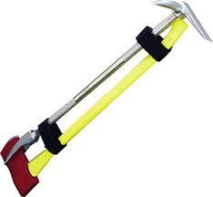

**Purpose:**

To establish procedures for forced entry into secured properties during emergency responses.

**Scope:**

This Standard Operating Procedure will apply to all members of the fire department.

**Procedures:**

General Forcible Entry Considerations

* The primary objective of any forced entry is to gain rapid entry into a secured structure, through an access route that produces the least amount of property damage.
* At times, it may be necessary to sacrifice the objective of minimizing damage to enter a structure with the greatest speed. It should be remembered, however, that the majority of incidents do not justify indiscriminate damage in order to gain entry into a secured structure.
* When forcing entry into secured structures, consideration should be given to; securing the structure after access has been gained.
* Remember to “try before you pry,” in all situations involving forcible entry.
  + Use the Knox Box if applicable.
  + Investigate alternate means of egress.
* Full turnout gear, gloves, and eye protection will be worn by all members involved in forcible entry operation.

Forced Entry at Medical Emergencies

* If upon arriving at the scene of a reported medical emergency, fire department personnel can see or communicate with a patient who is incapacitated inside a secured structure, the following actions should be taken:
  + Notify the dispatcher that forced entry will be initiated to gain access to the patient.
  + Request the response of a police officer.
  + Request the assistance of fire department as needed.
  + Force entry and provide patient care.
* If upon arriving at the scene of a reported medical emergency, fire department personnel cannot see or communicate with anyone inside a secured structure, the following actions should be taken:
  + Contact the dispatcher and confirm the location of the call, and inquire about the location where the 9-1-1 call originated.
  + Request the response of a police officer.
  + Request a callback by the dispatcher for further information. Listen for any phones ringing from inside the structure when this action is taken.
  + Await the arrival of a police officer and/or police supervisor who can authorize forced entry, if the circumstances present reasonable cause for such entry.
  + If it is determined that a reasonable cause for forced entry exists, fire department personnel will be accompanied by police officers when entering the structure and searching for the patient.

Forced Entry at Other Emergencies

* Personnel are authorized to force entry into secured structures to which they have been dispatched, when any of the following conditions are observed:
  + Obvious signs of smoke or fire.
  + Obvious signs of water leaking from under doors, which may indicate sprinkler activation or a broken water pipe.
  + Presence of a hazardous condition that could result in injury or property damage
* Personnel will not force entry into a secured structure to which they have been dispatched to investigate fire alarm activation, unless there are obvious signs of smoke, fire, sprinkler activation, or hazardous condition, such as the smell of gas. The dispatcher will be requested to make every effort to contact a key holder to respond to the scene and open the structure. Company officers should check the exterior of the structure for the presence of a Knox Box or any posted lists of emergency contact persons.

Securing Property Following Forced Entry

Before leaving an incident scene where forced entry was used to gain access to a secured structure, the structure will be re-secured, or turned over to a responsible individual in accordance with the fire department policy.

| See the source image | | |
| --- | --- | --- |
| **G** | **SOG Title: Fuel Tank Security** | |
| **SOG Number:** | |
| **Original Date: 2/10/20** | **Revision Date:** |
| **Granbury Volunteer Fire Department Standard Operating Guidelines** | | |

**Fuel Tank Security**

**Purpose:**

The City of Granbury has fuel storage tanks that are used for filling apparatus. The fuel in these tanks are only used for Granbury Volunteer Fire Department apparatus or by special approval by the Chief, Assistant Chief or officers.

1. The fuel pumps have a meter that is to be read before use and total gallons pumped logged onto a fuel usage record that is kept inside the station. The record is to be filled out completely.

1. Security – The fuel pumps have a power switch inside the station and the pumps should be turned off after filling apparatus.
2. The City of Granbury and the Granbury Fire Department keep track of total fuel used by apparatus. In the event of suspected theft by the public or a member, the Fire Department may conduct an internal investigation with the City. The results of the investigation may be turned over to the City of Granbury Police Department, charges may be filed, and reimbursement of fuel required if proven guilty.

| See the source image | | |
| --- | --- | --- |
| **G** | **SOG Title: Fundraising and Solicitation of Funds** | |
| **SOG Number:** | |
| **Original Date:1/25/20** | **Revision Date:** |
| **Granbury Volunteer Fire Department Standard Operating Guidelines** | | |

**Fundraising and Solicitation of Funds**

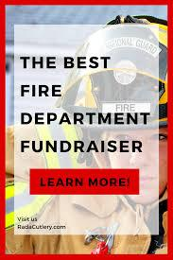

**Purpose:** Addresses income-producing activities, public solicitations, grant applications, special requirements and activities, managing donations.

**Procedure for membership:**

1. All fundraiser activities must be requested and approved by the Fire Chief at least two weeks prior to the beginning of the fundraiser activity. This is to ensure that adequate information is gained to deter any activity that may be deemed questionable or not within compliance of this policy. All fundraiser activities where the name of Granbury Volunteer Fire Department is used are subject to and must request use of Granbury Volunteer Fire Department, from the Granbury Volunteer Department or City of Granbury. This includes the wearing of any article of clothing or the use of any apparatus, which displays the name, and/or insignia of Granbury Volunteer Fire Department.
2. All fund raising activities being conducted through a non-profit organization will also be bound by the above policies.
3. Equipment purchased by any organization other than Granbury Volunteer Fire Department or City of Granbury, the official insignia will not be placed on any apparatus or be made a permanent part of any building owned by the City of Granbury unless written authorization is obtained by the Granbury Volunteer Fire Department Chief. Equipment purchased by any organization other than Granbury Volunteer Fire Department will not be maintained, repaired, or replaced by Granbury Volunteer Fire Department unless written authorization is obtained by the Granbury Volunteer Fire Department Fire Chief.
4. Granbury Volunteer Fire Department will not take a “Loan” or temporarily accept equipment and have it issued to members or placed on apparatus unless:
   1. The owner of the equipment signs a release of ownership and deeds the equipment to Granbury Volunteer Fire Department. Thus, no longer having any owner ship in the equipment and Granbury Volunteer Fire Department does with the “Loaned” equipment as seen fit.
   2. The owner gives Granbury Volunteer Fire Department enough time to adjust for the return of the equipment, order the replacement, have the replacement in service and ultimately the equipment is placed in service.
5. Public Solicitations: Granbury Volunteer Fire Department members are encouraged to participate and found “Fundraising Events.” The money raised from fundraising must be announced two weeks prior to the event and the appropriate permissions must be given from the City of Granbury, Hood County and the property owner. Fundraising monies must also be dedicated to a predetermined item, equipment or need. The Granbury Volunteer Fire Department membership must be made aware of the item they are fundraising for and must agree to the fundraising event being held.
6. Grant Applications
7. Managing Donations

| See the source image | | |
| --- | --- | --- |
| **G** | **SOG Title: Funeral Service Guidelines** | |
| **SOG Number:** | |
| **Original Date: 2/10/20** | **Revision Date:** |
| **Granbury Volunteer Fire Department Standard Operating Guidelines** | | |

**Funeral Service Guidelines**

**PURPOSE:** This guideline is intended to assist families of our fallen/deceased firefighter brothers/sisters in providing consistency in paying final respects and honors.

**SCOPE:** This guideline will define different levels of honor with options and variations that are available. Before any plans can be made, the family must be consulted and agree on the participation of the Granbury Volunteer Fire Department. The surviving family’s wishes are paramount in funeral planning.

**TYPES OF SERVICES**:

1. Level 1: Death in the line of duty from a job related traumatic injury. This may include an inactive member whose death is directly related to an injury sustained during active duty.
2. Level 2: Death of an active member, either job related non-traumatic injury or non-job related.
3. Level 3: Death of an inactive member.

Level One Level Two Level Three

American Flag* X x x

Badge Shrouds X

Bagpipers X

Bell Service X

Color Guard X

Crossed Ladders X

Eulogy X x

Fire Service Flag X x

Old Engine 4 Hearse x x x

Honor Guard X x

Honor Detail X x

Pall Bearers X X X

Station Bunting X

* Used only if the deceased was a military veteran.

**DEFINITIONS:**

Line of Duty: The death must be the result of a traumatic injury suffered by an on duty, active member of the Granbury Volunteer Fire Department.

Job Related Traumatic Injury: A blow to the body by an outside force, i.e., crushing injuries suffered in a building collapse, apparatus accident or fall. Burns, smoke inhalation and such climatic injuries as heatstroke or frostbite are considered traumatic injuries.

Job Related Non-Traumatic injury: Stress, heart attacks, stroke, diseases and mental illness (suicide).

Non-Job Related Death: Natural and traumatic deaths that occur while not on duty.

Active Member: A current, working member of the Granbury Volunteer Fire Department.

Inactive Member: A retired or disabled member of the Granbury Volunteer Fire Department

| See the source image | | |
| --- | --- | --- |
| **G** | **SOG Title: Ground Ladder Testing** | |
| **SOG Number:** | |
| **Original Date: 1/27/20** | **Revision Date:** |
| **Granbury Volunteer Fire Department Standard Operating Guidelines** | | |

**Ground Ladder Testing**

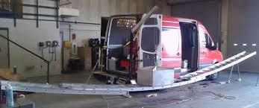

**Purpose:**

To establish guidelines for proper cleaning, inspection, maintenance, and testing of all

department ground ladders. This applies to all department ground ladders used for purposes

such as; fire fighting, rescue operations, HazMat incidents, training, and maintenance on

department grounds.  This will ensure all ground ladders are ready for use and/or properly

taken out of service.

**N.F.P.A. 1932 – Standard on Use, Maintenance, and Service Testing of In‐Service Fire Department Ground Ladders.**

**INSPECTION OF DEPARTMENT GROUND LADDERS**

1. All department ground ladders will be cleaned, visually inspected, and operationally

inspected on quarterly basis.  These inspections will also be conducted on new ground

ladders prior to being placed in‐service, after each use, and after a repair is made.

1. Visual and operational inspections should include, but not limited to:
   1. Heat sensor labels for a color change indicating heat exposure (Note: if any heat sensor label becomes black, remove the ladder from service at once).
   2. Rungs for snugness and tightness.
   3. Bolts and rivets for tightness.
   4. Welds for any cracks or apparent defects
   5. Beams and rungs for cracks, breaks, gouges, wavy conditions or deformation.
   6. Check for snugness of the halyard/cable when ladder is in the bedded position.
   7. Assure dog assemblies work properly.
   8. Assure pulleys turn freely.
   9. Check the condition of the ladder guides and for free movement of the fly

section.

* 1. Check the halyard/cable for fraying, burns, kinks, uneven wear, or other

condition requiring replacement.

* 1. Assure roof hooks rotate and lock in‐place properly (if applicable to the ladder).
  2. Butt spurs and/or rubber boots for excessive wear or damage.

1. A visual and an operational inspection will be conducted on a ladder, which is suspected of being unsafe, it will be tested in accordance with NFPA 1932: Standard on Use,

Maintenance, and Service Testing of InService Fire Department Ground Ladders.  Such

ladder will immediately be taken outofservice until such inspection has been

completed and successfully passes such inspection.

1. Any signs of failure during a visual and operational inspection will be deemed grounds to remove the unsafe ladder from service until necessary repairs are made.

**MAINTENANCE:**

1. Ladders will be kept free of moisture and dirt as much as possible.
2. Ladder parts are to be wiped with candle wax/paraffin. Use wax at contact points

between rungs, guides and rails, particularly in the fly sections. Add additional wax as

needed on the bottom side of lock, to allow them to slide easily over the rungs.  a. Candle wax/paraffin is the only lubricant to be used on moving parts of a ladder (i.e.: no oil or silicone spray lubricant).

1. For cleaning purposes, use only a mild detergent to wash ladders. It is permissible to use brake cleaner on stubborn, oily and greasy areas. Once the ladder is inspected,cleaned and dried thoroughly, apply wax to all parts of the ladder following instructions for application.  On extension ladders, the areas that the guides slide over

should be double checked to be sure they are clean.

1. Extension ladders with ropes and/or wire cables that become frayed or kinked will be removed from service and replaced in accordance with the manufacture’s

recommendations.

1. All ladders have identification numbers attached. Extension and single ladders will have reflective tape on the top potion of the rails to assist with visibility during the night and/or smoky conditions. If reflective tape is damaged or missing, it will be

replaced immediately.

1. A permanent record will be kept on ladder testing and when an inspection is conducted and damage is found.

**CLEANING:**

1. Cleaning of department ladders should be in accordance with the manufacture’s

recommendations.  Clean should be done using warm soapy water with a soft bristle

brush.

1. Materials such as grease, slim, tar, sap, etc. may be cleaned off using safe solvents.

Alwaysrefer to the manufactures recommendations before using harsh cleaning chemicals on department ground ladders.

1. Once the ladder has been washed, rinse the ladder off and wipe it dry. 4. All department ladders will be cleaned each month during monthly inspections and after each use.

**TESTING**

1. All department ground ladders will be tested annually. Test procedures must meet NFPA Standard 1932, Fire Service Ground Ladders in order to remain in operation.   In addition to annual testing, any ladder meeting the following criteria will be removed from service and tested: • At any time a ladder is suspected of being unsafe.  After a ladder has sustained a fall.  After the ladder has been subjected to overloading • After the ladder has been subjected to impact loading or unusual conditions of use • After heat exposure.
2. All ladder testing and repair will be conducted under the direction of the designated “Ladder Inspections Officer”.  The ladders will be prepared in accordance with

Operations Policy “Ground Ladder Inspection and Maintenance” prior to the testing date.

1. All findings exposed during testing and visual & operational inspections will be documented in the GranburyVolunteer Fire Departments “Ladder Inspection Log Book” for

records keeping.

**REPAIR:**

All repairs will be in accordance with the manufacture’s recommendations and N.F.P.A.

Standard 1932.  Before any department ladders are repaired, the member must consult these

standards. The Chiefis ultimately responsible for ensuring ladder inspection are conducted.

| See the source image | | |
| --- | --- | --- |
| **G** | **SOG Title: Health and Safety** | |
| **SOG Number:** | |
| **Original Date: 2011** | **Revision Date:1/25/20** |
| **Granbury Volunteer Fire Department Standard Operating Guidelines** | | |

**Health & Safety**

**Objective**: It is the policy of the Granbury Volunteer Fire Department to provide the highest level of safety and health for all members. The Department and its membership will make every reasonable effort to provide a safe and healthy work environment, with the goal of the prevention and reduction of accidents, injuries and occupational illnesses. Appropriate training, supervision, procedures, program support and review will be provided to achieve specific safety and health objectives in all functions and activities. Everyone is responsible for not only his or her safety but also the safety of the people around them. Health and safety concerns have no rank and no specific location; any concerns should be communicated immediately to prevent an incident, accident, injury or death.

**While on emergency scene**: Health and Safety issues should be reported to a senior crewmember and/or officer and/or Incident Command. Notification can be achieved with radio contact or verbal contact. The Health and Safety concern has not been communicated until it is repeated back to whoever is making the initial report. Future actions on scenes will then be determined by that senior crewmember and/or officer and/or Incident Commander.

**Non-emergent scenes / at the Fire Station**: Health and Safety issues should be reported to a senior crewmember and/or officer and/or Chief/Assistant Chief. Notification can be achieved with a phone call, text message and or in person. The Health and Safety concern has not been communicate, until it is repeated back or received a reply to whoever is making the initial report. Future actions regarding the Health and Safety issue will then be determined by that senior crewmember and/or officer and/or Chief/Assistant Chief.

**Incident Safety Officer:** When Incident Command determines it is necessary for an Incident Safety Officer for an emergency scene, the Incident Safety Officer is expected to help monitor and if need correct the following:

**Job Specifics**:

A. Incident Safety Officer should meet the following requirements:

1. Will have the knowledge, skill and ability to manage incident scene safety

2. Will have and maintain a knowledge of safety and health hazards involved in emergency operations

3. Will have and maintain a knowledge of building construction

4. Will have and maintain a knowledge of the Departments Personnel Accountability System

5. Will have and maintain knowledge of incident scene rehabilitation.

B. The Incident Safety Officer will have the authority at an emergency incident where activities are judged by the Officer to be unsafe or to involve an imminent hazard, have the authority to alter, suspend, or terminate those activities. The Incident Safety Officer will immediately inform the Incident Commander of any actions taken to correct imminent hazards at the emergency scene.

C. At an emergency incident where an Incident Safety Officer identifies unsafe conditions, operations, or hazards that do not present an imminent danger, the Incident Safety Officer will take appropriate action through the Incident Commander to mitigate or eliminate the unsafe condition, operation, or hazard at the incident scene.

D. Functions of the Incident Safety Officer will include, but not be limited to:

1. Be integrated with the incident management system as a command officer

2. Will monitor the scene and report the status of conditions, hazards and risks to the Incident Commander

3. Will ensure that the Departments Personnel Accountability System is utilized

4. Ensure that established safety zones, collapse zones hot zone and other designated hazard areas are communicated to all members present on scene

5. Will evaluate motor vehicle scene traffic hazards and apparatus placement and take appropriate actions to mitigate hazards

6. Monitor radio transmissions and stay alert to transmission barriers that could result in missed, unclear or incomplete communication

7. Where a fire has involved a building or buildings, will advise the Incident Commander of hazards, potential collapse and any fire extension in such building(s)

8. Will evaluate visible smoke and fire conditions and advice the Incident Commander, and company officers on the potential for flashover, backdraft, blow-up or other fire event that could pose a threat to operating teams

9. Monitor accessibility of entry and egress of structures and the effect it has on the safety of members conducting interior operations

10. Assist with safety management of Hazardous Materials events

**Incident Action Plan (IAP):** weighs the risk and benefits of emergency response and fire ground tactics to provide clear direction for effective operations while maximizing the safety of both first responders and people on the scene. Planning saves lives, property, and resources. IAP’s should address; risk management, member safety, goals and objectives

**Injury and Illness Reporting:** If any member suffers an injury or illness, as a result of his or her duties while serving as a member of the Granbury Volunteer Fire Department, his/her medical expenses may be covered by the provisions of the Worker’s Compensation Act. An injured or ill member must immediately notify his/her Commanding officer or Fire Chief of the injury/illness and incident and complete appropriate paperwork.

**Physical and Mental Capabilities:** Any fire fighter with heart disease, epilepsy, or emphysema, etc. will make this information known to the Chief and will not be expected to perform tasks that may potentially harm them. Any fire fighter that is claustrophobic, has a fear of heights or small spaces, etc. will make this information known to the Chief and will not be expected to perform tasks that they do not feel safe doing.

**Member Assistance Referral Program:** The Granbury Volunteer Fire Department has a fire fighter referral program. Members may contact them at 847-209-8208 or 888-731-3473 to assist any with alcohol or substance abuse, stress, self-harm and personal problems.

| **See the source image** | | |
| --- | --- | --- |
| **G** | **SOG Title: Helicopter Landing Zone** | |
| **SOG Number:** | |
| **Original Date:2011** | **Revision Date: 1/25/20** |
| **Granbury Volunteer Fire Department Standard Operating Guidelines** | | |

**Helicopter Response**

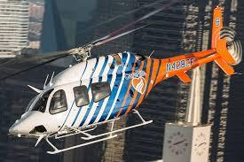 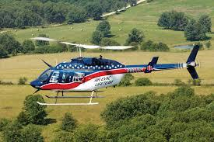

**Purpose:**

To provide all personnel with guidelines concerning requesting, communicating and the landing of aero medical helicopters.

**Procedure:**

**Requesting Response**

* If the person responsible for patient care determines that a helicopter response is required, the incident commander will provide the emergency communications center with basic patient information and request a medical transport helicopter.
* An engine company will be requested to respond if not on scene to provide fire protection for the helicopter.
* Once the status of the helicopter service (e.g., available or unable to fly) has been determined, the emergency communications center will notify the incident commander with such information.
* The incident commander will provide dispatch and/or the helicopter service with the following:
  + Major land marks
  + Initial landing zone obstacle information
  + Roads, intersections and/or businesses
  + GPS location if available
  + Grid map information if available
  + Contact person on ground

**Landing Preparation**

* A Landing Zone needs to be selected using the following criteria:
  + Locate all wires, power lines, light poles, trees, chimneys, etc. that may be a potential hazard to landing the helicopter.
  + Isolate a 100-foot-by-100-foot area that is relatively flat and free of overhanging obstacles and designate it as the Landing Zone.
  + The Landing Zone needs to be marked with one light in center or one light in each corner of the Landing Zone (lights from rescue vehicles may be used outside the perimeter).
  + Flares should never be used to indicate the Landing Zone and lights should never be pointed towards the helicopter.
  + The Landing Zone needs to be kept free of spectators, debris and vehicles.
  + The Landing Zone should be located adjacent to the scene to prevent the need for ground transport to the helicopter. If this is not possible, an ambulance must be requested if not on scene to provide ground transport
* The incident commander will assign the engine company to the landing zone and designate a Landing Zone Officer (the incident commander will not act in this capacity).
* The engine company will remain ready to respond if the helicopter has an emergency remote from the Landing Zone.
* The Landing Zone Officer is responsible for all communications with the pilot of the helicopter.
* The medical helicopter will be provided with the frequency for the Granbury Volunteer Fire Department by the emergency communications center.
* Emergency personnel will, be positioned at a minimum of 100 feet from the Landing Zone and spectators will be at least 200 feet from the Landing Zone.
* Full protective clothing including eye protection will be worn and secured (e.g., chin straps) when operating near the Landing Zone.

**Helicopter Landing**

* The pilot usually contacts the Landing Zone Officer when the helicopter is less than 5 minutes from the Landing Zone.
* Once the Landing Zone Officer has visual contact with the helicopter, he/she will direct the aircraft with directions such as “out left door (pilot left side) or “out right door” (pilot right side) or by the clock method such as “10 o’clock (in regards to the position of the pilot).
* The Landing Zone Officer should provide strong, direct and simple communication.
* The pilot should listen for information from the Landing Zone Officer
* The officer will provide the pilot with pre-landing information (e.g., grade, slope, surface and reference to hazards to emergency equipment on ground).
* The Landing Zone Officer needs to be aware of and listen for abort communication from pilot.
* When the helicopter is in its final landing approach, no communication should occur with the pilot unless there is a safety issue or a hazard to safe operations.
* In the absence of radio communication, the Landing Zone Officer will indicate an emergency wave off by vigorous overhead crossing of the hands.

**Helicopter Operations**

* All personnel will remain at the perimeter of the Landing Zone.
* The pilot will remain in the aircraft with the engine rotors running until a determination of a HOT (helicopter engines running) or a COLD (helicopter engines off) loading of the patient has been made.
* No smoking or open flame is not permitted within 100 feet of the aircraft.
* Helicopter personnel will direct ground personnel on all loading procedures. Never leave the immediate area of the flight crew if assisting with patient loading.
* All personnel that approach the helicopter from the front, standing upright and maintaining eye contact with the flight crew at all times unless otherwise directed by the flight crew. Ground crew that approaches the aircraft should be kept to a minimum.
* Once the patient is loaded, the Landing Zone Officer should make certain that no ground crew personnel remain in the Landing Zone.
* The Landing Zone engine company will remain in place until the helicopter has taken off and is in flight. At that time, the Landing Zone can be terminated.

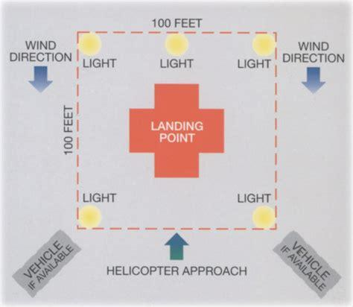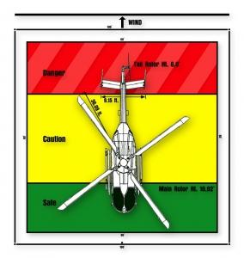

| **See the source image** | | |
| --- | --- | --- |
| **G** | **SOG Title: Hose Loading** | |
| **SOG Number:** | |
| **Original Date:2011** | **Revision Date:1/25/20** |
| **Granbury Volunteer Fire Department Standard Operating Guidelines** | | |

**Hose Loading Policy**

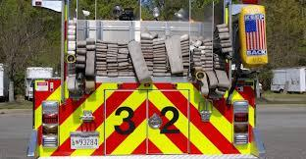

**Policy:**

Hose loading operations can be very hazardous and have contributed to a number of deaths and serious injuries. This policy addresses hose loading operations, which should also be reinforced in training.

Hose loading

Emergency vehicle drivers should never move the apparatus until he/she is certain of the whereabouts of all personnel. Personnel involved in hose loading operations can be permitted to ride on the moving apparatus so long as the following conditions are met:

* There will be an individual, other than those loading hose, assigned as a safety observer. The safety observer should have an unobstructed view of the hose loading operation, be in visual, and voice contact with the apparatus operator.
* Non-fire department vehicular traffic should be excluded from the area or should be under the control of authorized traffic control persons.
* The fire apparatus should only be driven in the forward direction and no more than 5 mph.
* Personnel are allowed to stand on the tail step, sidesteps, running boards, or any other location on the apparatus while it is in motion, if the above criteria is met.
* Personnel may be in the hose bed but should not be standing while the apparatus is in motion.

**Specific Hose Loads:**

1. Bumper Lines – Double Donut
2. Cross Lays – Trifold
3. Top Bed Pre Connects – Flat lay with couplings pulled forward
4. Supply Line – Flat lay with couplings pulled forward.

| See the source image | | |
| --- | --- | --- |
| **G** | **SOG Title: Incident Management at HazMat** | |
| **SOG Number:** | |
| **Original Date: 1/30/20** | **Revision Date:** |
| **Granbury Volunteer Fire Department Standard Operating Guidelines** | | |

**Incident Management on HazMat Scene**

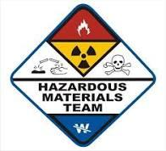

**Purpose:**

To satisfy the assignment of the Granbury Volunteer Fire Department in a most proficient method, a structure of incident management must be established. The Hazardous Material Standard Operating Guideline will be the foundation for all operations and additional alterations and/or corrections will be implemented as necessary.

**Procedure:**

***At this current time, the Granbury Volunteer Fire Department does not train beyond HazMat Awareness, for any current. When arriving on scene and it is determined, that it is a HazMat scene: the Chief’s, Officers or Senior Members will contact dispatch and request Ft Worth HazMat or if it is a spill, to contact Texas Department of Transportation.***

***THE COMPANY WHO HAD THE SPILL IS RESPONSIBLE FOR ANY COST***

**Responsibilities and Structure**

* Management of a hazardous materials incident is the responsibility incident commander.
* It is the incident commander’s responsibility to comply with the procedures defined in this guideline.
* The incident commander structure will be followed as described in the incident command System S.O.G.
  1. Immediately and safely as possible, the incident commander will attempt to identify all hazardous materials and conditions that exist using all methods available.
  2. The incident commander will commence appropriate emergency operations to control the situation based on the conditions and materials present.
  3. If resources are inadequate or not present, the incident commander will order the next level of response.
* The incident commander will ensure the following:
  1. At minimum, full protective clothing, including positive pressure SCBA is worn at all, times when exposure is present.
  2. That all PPE is appropriate for the hazards or conditions that exist.
  3. Order additional levels of protection or special PPE when required.
  4. That protection level is decreased only after adequate monitoring has determined the incident safe.
* At all Level II and III emergencies, the incident commander will assure that when emergency personnel enter the hazardous (hot zone) area that:
  1. The number of personnel operating in the area is limited to the minimum required to accomplish the objective.
  2. The “buddy system” is utilized when performing operations.
* Under no circumstances will a single individual enter a high hazard area.
  1. A rapid intervention team protected at the same level as entry personnel will stand by to provide rescue or assistance.
  2. An ambulance should be on standby to provide emergency medical care as required for each entry team.
* At all Level II and III emergencies, a safety officer will be designated. The safety officer will report directly to the incident commander and have the authority to suspend, alter or terminate operations that pose an immediate threat to the life and health of emergency personnel performing those operations. Whenever possible, the safety officer will notify the incident commander of any unsafe procedure or operation.
  1. The safety officer must be a certified safety officer and trained to the minimum of first responder operational level

| **See the source image** | | |
| --- | --- | --- |
| **G** | **SOG Title: Initial Arrival Policy** | |
| **SOG Number:** | |
| **Original Date:2011** | **Revision Date:1/25/20** |
| **Granbury Volunteer Fire Department Standard Operating Guidelines** | | |

**Initial Arrival Guideline**

**Purpose:** Establish a procedure for providing dispatch and incoming crews with the information from the scene as to the conditions of the scene and the needs required. This guideline may not cover all situations and deviation from it may be required to ensure all the relevant information is provided to incoming crews.

**Procedure:**

1. Upon arrival at the scene, the officer of the first in apparatus should provide the following information via radio to dispatch and other incoming crews:

| **See the source image** | | |
| --- | --- | --- |
| **G** | **SOG Title: Cadets Program** | |
| **SOG Number:** | |
| **Original Date:** | **Revision Date: 1/25/20** |
| **Granbury Volunteer Fire Department Standard Operating Guidelines** | | |

**Cadet Member Program**

**Policy:** Encouraging young people to participate in Cadet member programs is an excellent way to encourage interest in emergency service provided by Granbury Volunteer Fire Departments. Early participation often leads Cadet members to continue with the emergency service agency as adults. However, because explorer and Cadet members are minors, they present a unique set of circumstances

**Procedures:** Unfortunately, it is possible for situations that can develop where adult advisor can violated the trust of the Cadet Member and have caused injury or harm to Cadet member(s). To help protect the Granbury Volunteer Fire Department, adult advisors, individual members and the program participants, it is important to have safeguards in place. Safety policies, ethics, child labor laws, rules of participation, background checks, written guidelines and enforcement of those policies are issues for emergency services provided by Granbury Volunteer Fire Departments.

**Operating Guidelines for the Cadet Program**

**Purpose**

**The Granbury Volunteer Fire Department (GVFD) Cadet Program has been developed**

**to instill in each Cadet, a sense of character, confidence, and self-esteem. The program will also**

**teach fire/rescue skills, self-discipline and respect. This program is free and targeted to the age group**

**of 16- to 18-year-old candidates. Cadets will participate in training related to fire prevention, control,**

**and emergency medical services. The program will include formal training and developmental**

**assignments.**

**REQUIREMENTS**

**Cadet applicants must:**

* **Be 16 to 18 years of age at the time of application.**
* **Submit an application and appropriate forms (with parental/guardian approval) to the**
* **Obtain GVFD Cadet Committee approval.**
* **Submit medical information that includes written consent to treat, medical history, current conditions, medications and allergies.**
* **Be sponsored by an "active" member of GVFD, who will be accountable for the training and discipline of that Cadet.**
* **Reside in Granbury Texas.**
* **Maintain a grade of "C" or better in all school classes. Turn in report card to mentor.**
* **Parents may request higher gpa be maintained for participation**

**STANDARD OPERATING GUIDELINES**

**At no time will Cadets be allowed to participate or be exposed to hazardous conditions. Hazardous**

**conditions may include, but are not limited to physical, chemical, environmental, or emotional (high**

**stress) hazards.**

**Cadets will not be allowed to assist on the active scene of emergency incidents.**

**Cadets will participate in an assortment of training activities such as proper techniques of handling**

**ladders, working with fire hose and nozzles and many of the various rescue techniques, along with**

**basic First Aid training and CPR. The Cadets will learn about the organizational structure of the**

**GVFD, and what it takes to become a firefighter and/or EMS provider.**

**At no time will a Cadet be allowed to ride on fire/rescue apparatus that is "running code" to a call.**

**Equipment Provided**

**All Cadets will be provided the following equipment.**

* **Helmet**
* **Yellow Fire Suit**
* **Gloves**
* **Flash Hood**
* **Cadet Shirt**

**Program Rules**

* **No Cadet is permitted in the fire house at any time without a senior member. (Unless cleared by an officer)**
* **When a Cadet is addressing a senior member, they will do so in a respectful manner**
* **Cadets must always conduct themselves in a proper manner.**
* **Cadets are to be always neat and clean in appearance.**
* **There will be no back talk to senior members or association members.**
* **Cadets are not permitted in the firehouse after 9:00 pm unless permission is given by a senior member.**
* **All grievances will be passed by chain of command. First brought to attention of mentor, if a resolution cannot be found then to station lieutenant, captain, assistant chief, then chief.**
* **Cadets are not allowed to ride on emergency vehicles or to remove any equipment from fire apparatus without permission.**
* **Cadets are not allowed to follow any emergency equipment for any reason.**
* **Cadets may not travel by personal vehicle to the scene of an emergency incident.**
* **No profanity will be used by any Cadets in or around the firehouse at any time.**
* **No tobacco use will be allowed in or around the firehouse by any Cadet.**
* **No horseplay is allowed in the firehouse or on GVFD grounds at any time or in training**
* **Cadets are not allowed to use anyone's turnout gear without permission**
* **Cadets must keep up with work at the firehouse as assigned**
* **Cadets to be mentored by member of the same sex**
* **Cadets are required to attend GVFD rookie schools until they become active members**
* **Cadets are required to attend 1 meeting quarterly and 12 trainings per year**

**I have read and understand this document**

**Cadet signature: __________________________________ Date: __________________**

**Parent or Guardian signature: _______________________ Date: ___________________**

**Cadet Mentor: __________________________ Date: __________________**

**Granbury Volunteer Fire Department**

**1701 W. Pearl St Granbury, TX 76048**

**CADET PROGRAM**

**Application for Membership**

Name___________________________________________Date______________

Address________________________________________________________

Home Phone (_________________) - Email_______________________

Date of Birth____________________________________

Present Age___________________

School _________________________________________ Grade_______

Name of Parents or Guardian______________________________ _____

Work (________________________ ) - Alternate (_______________________)

Acceptance Date _______________________________________________

I have read and understand the rules and regulations of the Granbury Volunteer Fire

Department Cadet Program and promise to abide to these. I will conduct

myself with self-discipline and respect to my community.

Signature of Applicant_____________________ Date__________________________

I the below signed legal parent or guardian of the above-named applicant, do hereby give

my permission for the applicant to become a member of the Granbury Volunteer Fire

Department Cadet Program

Signature of Parent_______________________________ Date_________________________

Interview Date:_____________ Interviewers:___________________-__________________

**Granbury Volunteer Fire Department**

**1701 W. Pearl St Granbury, TX 76048**

**CADET PROGRAM**

**MEDICAL INFORMATION**

Name___________________________________________Date______________ __________

Address________________________________________________________ ____________

Home Phone (______) _ - Date of Birth__________________

General Health Condition ______________________________________________________

Current Medications___________________________________________________________

Allergies:____________________________________________________________________

Food Bee Stings

Drugs Insect Bites

Other: ____________________________________________________________________

Chronic or Recurrent Problems: ________________________________________________

Prior Major Illnesses: ________________________________________________________

Restricted Activities: _________________________________________________________

Last Tetanus: __________________

Any Physical Disability or Limitation of Activity: ____________________________________

Physicians Name Phone Number: _______________________________________________

Physicians Address: __________________________________________________________

This health history is correct so far as I know, and the person described has permission to

engage in all prescribed activities, except as noted by me. In the event of illness or accident

in the course of such activity, I request that measures be instituted without delay as the

judgment of medical personnel dictates.

Signature of Parent or Guardian :____________________Date:_______________

| See the source image | | |
| --- | --- | --- |
| **G** | **SOG Title: Line of Duty Death Notification** | |
| **SOG Number:** | |
| **Original Date: 2/10/20** | **Revision Date:** |
| **Granbury Volunteer Fire Department Standard Operating Guidelines** | | |

**Line of Duty Death Notification**

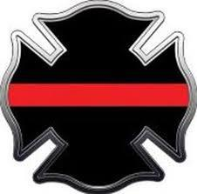

**PURPOSE:** The purpose of this guideline is to set forth responsibility and procedures in the event of line of-duty death or death of an active member or retiree of the Alton Fire Department

**RESPONSIBILITIES OF NOTIFICATION**

1. Line of Duty Death
   1. Upon the death of a member in the line of duty, the Officer in Charge will notify the Fire Chief or in his absence, the Assistant Chief as well as a department Chaplain if available.
   2. The Chief, Assistant Chief and a designated representative, the Department Chaplain if available, will notify the next of kin as soon as possible. No radio traffic should be aired concerning the death.
   3. The Chief or a designated representative should officially notify the City of Granbury Manager, Mayor and other appropriate officials.
   4. If possible and the scene allows, the Officer in Charge should relieve the immediate coworkers (those in immediate proximity or those responsible for attempted rescue and/or removal of the deceased) from the scene to return to station.
   5. Defusing by the Chaplain and notification of a CISD Team is to be done as soon as possible. This to be followed by general information of how notification is being done, and what is to be expected in the next few hours.
   6. Public Information Officer should be notified or a person designated to handle any public news as soon as possible so that information is disseminated promptly. A detail should be placed at family residence to prevent media interference with the family and should remain posted as long as necessary.
   7. Within 72 hours of the death, there should be a debriefing, Critical Incident Stress.
   8. The Chief will designate an Officer-in-Charge who will be responsible for the department's involvement in the funeral procedures.
   9. It is suggested that upon receipt of a notice of a member killed in the line of duty and following the proper notification of the next of kin, station flags be lowered to half-mast and to fly half-mast for seven days after the funeral. A request to The City of Granbury can be made also.

| See the source image | | |
| --- | --- | --- |
| **G** | **SOG Title: Maneuvering at an Incident Scene** | |
| **SOG Number:** | |
| **Original Date:1/25/20** | **Revision Date:** |
| **Granbury Volunteer Fire Department Standard Operating Guidelines** | | |

**Maneuvering at an Incident Scene**

**Purpose:**

To establish safe practices that address when maneuvering an emergency vehicle at an incident scene.

**Procedure:**

Drivers will exercise extreme caution while maneuvering emergency vehicles at an incident scene; other drivers and pedestrians may be distracted or preoccupied by events and a variety of hazards (e.g., downed or low-hanging wires, limited visibility, hazardous materials, etc.) may be encountered. Vehicles will be moved slowly and cautiously, with spotters assigned to guide the driver in tight and limited visibility situations.

When streets have been closed to regular traffic, the emergency vehicle driver remains responsible for the safe and prudent operation of the vehicle at all times.

When operating at an incident scene where the streets have not been closed to regular traffic, fire department vehicles will be positioned, parked, or staged in a manner that considers safety as a primary factor. Ensure the vehicle is properly parked (i.e. wheel chocks, traffic cones and shut down the motor if not needed).

Check for Unsecured Personnel: Before moving an emergency vehicle in any location, the driver will ensure that all occupants are seated and properly secured in approved riding positions. The driver will also ensure that no one is in the process of mounting, dismounting, standing on top of, or on the outside of, the vehicle.

Under no circumstances will members be allowed to ride on the outside of a moving apparatus, including the tailboard, roof, aerial platform/bucket, or a top-mounted pump panel.

| See the source image | | |
| --- | --- | --- |
| **G** | **SOG Title: May Day - Firefighter Down** | |
| **SOG Number:** | |
| **Original Date:** | **Revision Date:** |
| **Granbury Volunteer Fire Department Standard Operating Guidelines** | | |

**May-Day**

**Purpose:**

The purpose of this guideline is to identify the roles and responsibilities of all parties involved at an incident where a "May-Day" has been transmitted.

**Scope:**

This applies to all personnel.

**Guideline:**

The radio message "May-Day" will be used by firefighters to report their status as being lost, trapped or injured and in need of rescue. Any member may use a "May-Day" to report a lost firefighter. Any report of "May-Day" will receive priority radio traffic. The term "May-Day" will be reserved only to report a lost, trapped or injured firefighter.

**Procedure:**

In the event of a firefighter(s) becoming trapped, lost, entangled, disoriented, and injured or in need of other assistance, the firefighter(s) will remain calm. The firefighter should call on the operations or dispatch channel and state "May-Day May-Day May-Day" to clear the radio traffic on that channel once the IC has acknowledged the “May-Day”. The member in distress transmits:

1. Radio number
2. Crew's designation
3. Status in regard to any injuries or entrapments
4. Fire and smoke conditions are
5. Point of entry into the structure
6. Last know position
7. Air supply status

Member in distress should move to a safe location if possible, activate their PASS alarm, and remain in radio contact with command and the RIT team as long as possible. Stay in one location so that the RIT can find you. Try not to move around they will have to chase you so please remain in one location.

The guidelines outlined on the following pages will be followed at ANY incident involving the use of a "May-Day".

Command Responsibilities

Command will maintain an awareness of the location of firefighters on the fire ground primarily through assignments and the personnel accountability system. In the event that a firefighter cannot be located through a PAR (Personnel Accountability Record), or any other time a firefighter is missing. Any member can announce a "May-Day". The term "May-Day" will indicate a lost, trapped or injured firefighter. Command will respond to a "May-Day" by implementing a rescue plan for the firefighter(s) through communication with the leader of the Rapid Intervention Team (RIT).

Missing Firefighter

Company Officers and individual firefighters who suspect a firefighter is missing must notify the Incident Commander (IC) immediately. The IC MUST ALWAYS assume that the missing firefighter is lost in the building until the member is located and accounted for. The system must include the ability to identify when a firefighter is going to be delayed beyond their SCBA air supply. The plan should include:

* Fire operations during rescue efforts
* Expanding organization
* Establishing/deploying RIT
* Assign an Officer to manage the rescue I RIT
* Medical Operations
* Safety
* Support Activities

Change the Strategy and Plan to a High Priority Effort

The IC must restructure his/ her strategy and action plan to include a firefighter rescue effort. This may seem obvious to most. However, incident commanders can become overwhelmed by the emotion related to the crisis at hand and may react to tasks rather than looking at the whole scene picture. This can lead to disorganization and delays that can be fatal for the missing firefighter.

Accurate information must be immediately obtained. Rapid commitment of the RIT must occur. These resources must be organized and controlled. The command organization must expand. The strategy, incident action plan, and objectives must be quickly communicated to the command officer and division/group officers. The plan and rescue activities must be continually monitored and revised as necessary.

Conditions and updated information cause changes in plan and objectives. The IC must communicate any changes to the command officer and division/group officers.

Immediately Request Additional Alarms

In many situations, all resources on-scene may already be committed to firefighting positions. Some firefighters may already be approaching physical exhaustion; their SCBA's may be nearly empty. Relocating committed forces is difficult and slow. At least one additional alarm with an EMS unit and an additional RIT should be immediately requested upon report of a lost, trapped, or injured firefighter. Additional resources may be requested based on circumstances and potential. There should be no hesitation in requesting additional resources and this function is included into the May Day policy.

Include EMS when Requesting Additional Resources

Medical personnel will be needed to treat and assist rescued firefighters. The IC must ensure that an adequate number of paramedics are responding as well as an adequate number of ambulances and/or medical helicopters to transport injured firefighters. The IC should understand that the situation is critical, and that firefighters tend to overexert themselves when searching for a missing firefighter, resulting in additional firefighters being injured. Adequate medical resources must be ready and available and on site.

Commit the Rapid Intervention Team (RIT)

All working structure fires will have a Rapid Intervention Team (RIT) assigned. This team will be fully outfitted with protective clothing, SCBA, etc., and monitoring all radio traffic. Upon report of a missing firefighter, the IC has a completely fresh crew fully outfitted, available for commitment to an immediate search and rescue of the last known area of the missing firefighter(s). The RIT must be immediately sent to the rescue are. Once the RJT is mobilized, another RIT must be started to take their position in waiting.

Withdraw Crews from the Affected Area, if Appropriate, to obtain a PAR and Reconnaissance Information

In some situations, such as a collapse or explosion, crewmembers may be separated. The only practical method to obtain an accurate PAR of effected crews may be to withdraw them to the exterior. In addition, withdrawal may be the only way to quickly obtain accurate information and reconnaissance on exactly where trapped members may be, routing to victims, debris locations, and the type of rescue equipment that may be needed for extrication. Once the roll call and reconnaissance information is quickly obtained, crews can be re-assembled into a more organized rescue effort.

Withdrawal is a judgment call based on circumstances at the time, information available, and resources. It may not be practical or possible to do so. However, the absolute need for an accurate roll call and information on missing firefighters remains a critical priority. If it is determined not to withdrawn, a detailed roll call must be obtained from each division for all crews operating under his I her direction.

Do not Abandon Firefighting Positions – Hold Positions and Prevent Fire Spread

The reasons for the RIT and the immediate request for additional resources, becomes very clear with this critical fire ground need. If a missing firefighter(s) is to survive, the IC must keep firefighters out of the rescue area. With a RIT in place, the IC can initiate an immediate rescue effort without withdrawing or relocating fire combat crews.

In most situations, the IC cannot allow fire spread. If anything, these fire combat positions need to be reinforced. Additional crews should be sent to priority positions to keep the fire out of the rescue area.

Individual Responsibilities

* To follow directions from superiors
* To continue with assignment unless otherwise directed
* To keep your cool

Every incident commander and all members on the scene should listen specifically for a "May-Day" as fire ground noise could cover a call for the "May-Day".

Dispatch Center Guideline

When an emergency responder identifies that he/she, or a member of his/her team, is lost, entangled, trapped, disoriented, injured or in need of assistance, he/she will (if possible) transmit a verbal message on the tactical channel to incident command and state: "MAY-DAY, MAY-DAY, MAY-DAY"

Upon receipt of a "MAY-DAY" from incident command, communication center **will** immediately close the channel down for emergency traffic from incident command.

All fire channels will be monitored closely for any transmissions by the missing firefighter(s). If the missing firefighter(s) transmits on another channel other than the assigned operations channel, the tele communicator will remain in contact with that firefighter and communication center notify incident command. It is essential that once communications have been established, they not be lost.

If crews are providing protection to the downed firefighter(s) or protecting the building occupant(s) the attack positions must be protected, if possible. A MAY DAY DOES NOT MEAN THE BUILDING/HAZARD ZOME IS EVACUATED WITHOUT THE ORDER OF THE INCIDENT COMMANDER.

At the time incident command advises the "MAY-DAY" situation is clear, the tele communicator will advise on the dispatch and operations channel (Fire 1, Fire 2, State Fire) **"MAY-DAY CLEAR, ALL UNITS RESUME NORMAL RADIO TRAFFIC"**

**Sample May-Day Check List**

1. Confirm “MAYDAY” has been transmitted (identify exact problem)
2. Command makes fireground/incident wide radio announcement
3. Notify Emergency Communication Center (Dispatch) of the event
4. Command requests additional assistance (next alarm)
5. Location of May-Day (Lunar)
6. Unit with May-Day (lunar)
7. Name of member(s) (lunar)
8. Air status of member(s) (lunar)
9. Resources needed to rescue distressed member(s) (lunar)
10. Deploy rapid intervention team – develop rescue action plan
11. Maintain and/or bolster fire attack operations (hold or stop the fire)
12. Conduct toll-call or personnel accountability report (PAR)
13. Assign May-Day Branch Director – works at command post)
14. Assign rapid intervention safety officer (close to the action)
15. Maintain personnel accountability for all others
16. Stage and maintain advance life support transport resources
17. Consider Aero-Ambulance (helicopter)
18. Develop a defensible space to protect lost, trapped or missing members(s)
19. Develop alternate strategies (“Plan B”)
20. Control unassigned resources (no freelancing)
21. Control risks (maintain risk management analysis)
22. Control release of information (notify firefighter families first)
23. Notify all units and communications center when May-Day has been cleared (member(s) rescued)
24. Support transported members and their families

| See the source image | | |
| --- | --- | --- |
| **G** | **SOG Title: Mission Statement** | |
| **SOG Number:** | |
| **Original Date:2011** | **Revision Date: 1/25/20** |
| **Granbury Volunteer Fire Department Standard Operating Guidelines** | | |

**Mission Statement**

**Purpose:**

The Mission Statements defines our Granbury Volunteer Fire Department’s purpose, identifying the goal of its operations. What kind of service we provide our primary customers or market and its geographical region of operation. To includes a short statement of such fundamental matters as the Granbury Volunteer Fire Department’s values or philosophies, a business’ main competitive advantages, or a desired future state – the “vision”.

The intent of the Granbury Volunteer Fire Department is to perpetually respond to Fire and Rescue emergencies within the City of Granbury, ETJ of Granbury and Mutual Aid requests in order to protect lives and property. It is also our assumed responsibility to assist our citizens and neighbors in any philanthropic actives, fund raising and preserve the environment through approved contracts with the City of Granbury, Hood County and any other entity that would make a request.

|  | **Mission Statement** | **Vision Statement** |
| --- | --- | --- |
| **About** | A Mission statement describes HOW you will get to where you want to be. Defines the purpose and primary objectives related to your customer needs and team values. | A Vision statement outlines WHERE you want to be. Communicates both the purpose and values of your business. |
| **Answer** | It answers the question, “What do we do? What makes us different?” | It answers the question, “Where do we aim to be?” |
| **Time** | A mission statement talks about the present leading to its future. | A vision statement talks about your future. |
| **Function** | It lists the broad goals for which the organization is formed. Its prime function is internal; to define the key measure or measures of the organization's success and its prime audience is the leadership, team and stockholders. | It lists where you see yourself some years from now. It inspires you to give your best. It shapes your understanding of why you are working here. |
| **Change** | Your mission statement may change, but it should still tie back to your core values, customer needs and vision. | As your organization evolves, you might feel tempted to change your vision. However, mission or vision statements explain your organization's foundation, so change should be kept to a minimum. |
| **Developing a statement** | What do we do today? For whom do we do it? What is the benefit? In other words, Why we do what we do? What, For Whom and Why? | Where do we want to be going forward? When do we want to reach that stage? How do we want to do it? |
| **Features of an effective statement** | Purpose and values of the organization: Who are the organization's primary "clients" (stakeholders)? What are the responsibilities of the organization towards the clients? | Clarity and lack of ambiguity: Describing a bright future (hope); Memorable and engaging expression; realistic aspirations, achievable; alignment with organizational values and culture. |

| See the source image | | |
| --- | --- | --- |
| **G** | **SOG Title: Mutual Aid** | |
| **SOG Number:** | |
| **Original Date: 02/1/20** | **Revision Date:** |
| **Granbury Volunteer Fire Department Standard Operating Guidelines** | | |

**Mutual Aid**

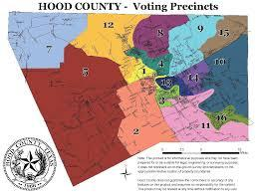

**Purpose:**

This standard operating procedure/guideline addresses resources available for different types of emergencies, requesting or responding to requests for aid, interacting with mutual/automatic aid agencies, documentation and reporting, cost/ resource recovery.

**Procedure:**

Minimum dispatch to a mutual aid request will be what apparatus the Senior Member, Officer of Chief designate at that time. Fire crews will operate only within a recognized Incident Management System. If a Command System does not exist with the on-scene mutual aid crews, the first arriving company or Command officer will implement the incident management system.

Crews and personnel will not be separated or fragmented about the incident scene. A direct communication link must be established between the on-site incident commander and the mutual aid crews. Mutual aid units will use every effort to support the on-site commander in a positive manner while adhering to recognized safety requirements and the Incident Management System.

Command will maintain a communications link with the Dispatch Center. Dispatch or the Command vans emergency traffic notification will be made available for use for Granbury crews. Dispatch will maintain the elapsed time notification if appropriate. Command and company officers will use the risk management profile to determine the safety of the building or situation, and the mutual aid commander's plan of attack, and will proceed only if it is determined safe to do so. If it is unsafe to proceed, fire crews will advise the incident commander of their concerns while adopting and maintaining a safe operating position or strategy. SCBAs will be refilled by utility crews from automatic aid cities only. Injured or ill fire fighters will be transported by fire department rescues whenever possible.

The Command officer in charge will update Dispatch with radio progress reports upon arrival and at appropriate points during the incident.

| **See the source image** | | |
| --- | --- | --- |
| **G** | **SOG Title: Non-Mask / No Interior members** | |
| **SOG Number:** | |
| **Original Date:2011** | **Revision Date:1/25/20** |
| **Granbury Volunteer Fire Department Standard Operating Policy** | | |

**Non-Mask / No Interior Members on Apparatus**

**Purpose:** Define and explain the requirements and responsibilities for riding on apparatus as a non-mask / no interior ability. This guideline may not cover all situations and the decision to deviate from it rests with the senior member or officer on the apparatus.

**Procedure:**

1. The term “Non-Mask” or “No interior ability” identify personnel riding an apparatus with the senior member or officer knowing that the individual is not expected to do interior operations with a SCBA.
2. Only qualified members or officers should ride as the officer seat for emergency calls.
3. The senior member or officer will make the decision as to whether personnel may ride the apparatus as “non-mask” personal.
4. A “non-mask” personal must notify the senior member or officer of their capabilities on scene.
5. All “non-mask” personal will yield their seat or spot on apparatus if qualified individuals arrive to the station before departing for a call.

| See the source image | | |
| --- | --- | --- |
| **G** | **SOG Title: Non-Members Riding in Apparatus** | |
| **SOG Number:** | |
| **Original Date:1/25/20** | **Revision Date:** |
| **Granbury Volunteer Fire Department Standard Operating Guidelines** | | |

**Non-Members Riding in Apparatus**

**Purpose:** Parades, Fire Prevention Week, citizen ride-along programs and similar public relations events provide great opportunities for Granbury Volunteer Fire Department to promote their organization's activities. These events can assist in fostering positive relationships with local citizens. There are also times when our assistance is required in helping citizens in non-emergencies but still require help. An example would be, “Two flat tires and need a ride into town.” There are many scenarios or instances where non-members are allowed to ride in department vehicles. While these activities are an important part of public service activities for the Department, there are inherent risks associated with non-members/untrained individuals riding in apparatus.

**Procedure:** To help reduce the risk of accident and injury to a non-member riding in apparatus:

For community type events (e.g., parades):

1. Designated vehicles used for these events and designate the maximum number of non­members allowed riding the apparatus at any given time.
2. **Do not exceed the designed occupancy of the vehicle and ensure that all passengers are properly seated and utilizing a seat belt.**
3. Do not allow individuals to ride on the tailboard, hose beds or any other area outside of the cab.
4. Limit exposures to the planned event only. Do not allow non-members to ride along in emergencies unless prior authorization is provided (see below).
5. Formalize procedures for unloading and loading non-members into and out of the vehicle.
6. Perform a walk around to ensure the vehicle is safe to move after the boarding and departing process.

For ride-alongs, where an emergency response may be undertaken:

1. The minimum age requirement for non-members is 16 years old.
2. Explain the privacy of patients and members of the public.
3. Outline rules to be followed by the non-member.
4. A release/waiver for non-members who will ride and require the waiver be signed prior to allowing the individual to ride. All minors must have a waiver signed by a legal guardian.

A sample release/waiver is attached. Have this reviewed by legal counsel to assure that it provides adequate protection in the operational jurisdiction. By understanding the importance of formalizing department ride along policies and adopting these or similar best practices into Granbury Volunteer Fire Department's procedures, ESOs can help reduce the risk of potential injury to non-members riding in department vehicles.

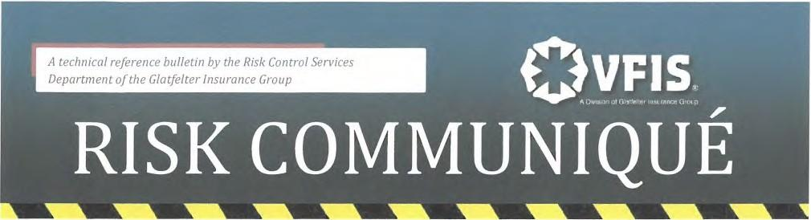

(Sample Riding Policy)

RELEASE AND IDEMNIFICATION AGREEMENT

I, _______________________________________ fully understand that riding in an ambulance/fire apparatus is a dangerous activity which can result in personal injury and property damage. I realize that the risks inherent in riding in an ambulance/fire apparatus and observing emergency procedures include, but are not limited to, injury from collision, the administration of medical treatment to ambulance patients, firefighting activities and the proximity to medical ailments. I expressly assume all risks, including all personal injury and property damage, which may occur.

In consideration for permitting me to ride in the ambulance/apparatus, hereby release ______________ its directors, officers, shareholders, members, agents, successors and assigns from any and all rights, claims, demands, action and causes of action of any nature whatsoever, whether arising in law or in equity, by reason of any matter, cause,happening, thing,act or omission and, in particular, but without limiting in any way the generality of the foregoing, I do hereby release its directors, officers, shareholders, members, agents, successors and assigns from any liability for personal injuries or property damage suffered or sustained by me, whether caused by the inherent risks involved in riding in an ambulance/apparatus or caused either wholly or in part by the intentional or negligent act of its volunteers, members, agents or representatives.

Furthermore, in consideration of permitting me to ride in the ambulance/fire apparatus, I agree to indemnify, defend and hold harmless ______________________ for all liability caused either wholly or in part by me which results in personal injury or property damage including all losses, costs and attorney's fees, claims and judgement. In addition, I agree to indemnify, defend or hold harmless _______________ its directors, officers, shareholders, members, volunteers, agents, successors and assigns for all liability for any acts of omissions which result in personal injury or property damage including all losses, costs, attorney's fees, claims and judgments whether committed either wholly or in part by the intentional or negligent acts or omissions of agents of _________________ or any other person. Ialso agree to pay all costs and attorney's fees incurred in enforcing the terms of the release and indemnity agreement.

This release and indemnity agreement willbe binding upon me, my assigns, heirs and successors.

Signature

Name (Please Print)

Street Address

City, State, Zip Cose

Date

| See the source image | | |
| --- | --- | --- |
| **G** | **SOG Title: Grooming and Personal Appearance** | |
| **SOG Number:** | |
| **Original Date: 2/8/20** | **Revision Date:** |
| **Granbury Volunteer Fire Department Standard Operating Guidelines** | | |

**Grooming and Personal Appearance**

**PURPOSE:**

The Fire Department has a public expectation; therefore, a neat, well-groomed professional appearance is fundamental to the Department and is a vital ingredient for positive public relations and morale. It is the responsibility of each member to take pride in his or her appearance at all times.

**POLICY:** All personnel are to adhere to the following:

* JEWELRY
  + Safety: Wearing jewelry of any kind represents a source of possible injury and presents a safety hazard.
  + Necklaces, earrings, as well as any body piercing that is visible while wearing the uniform, are strictly prohibited.
  + One finger ring may be worn on each hand. A wristwatch and/or medic alert bracelet is acceptable.
* FINGERNAILS
  + Fingernails will be clean and neatly trimmed. The wearing of fingernail polish is acceptable; however, ornamentation or extreme colors that call attention to the nails are not acceptable.
* COSMETICS
  + Female personnel may wear appropriate daytime cosmetics. The wearing of excessive perfume or cologne by all personnel is prohibited.
* HAIR
  + Safety: When operating with an S.C.B.A. during firefighting activities, no hair will be exposed and must be covered by a Nomex hood.
* HAIR GUIDELINES FOR ALL MALE PERSONNEL: Hair will be worn to the general shape of the head and may not to extend beyond the top of the shirt collar.
  + Sideburns will be closely trimmed and not extend below the bottom of the lobe of the ear.
  + Safety: The face will be clean-shaven so as not to interfere with the seal of the S.C.B.A. A mustache is permissible. Full beards, goatees, or other growths of hair on the chin, lower jaw, neck, or cheek are prohibited. However, a small amount of facial hair is permissible under the lower lip, but not to extend to the chin, and no more than 1½” in width.

* HAIR GUIDELINES FOR ALL FEMALE PERSONNEL:
  + Hair will be worn to a maximum length that does not extend below the shoulder under any condition. The style of grooming will present a neat appearance and will not interfere with the proper wearing of regulation headgear nor impede the donning / utilization of any equipment, and or accomplishing any function that a firefighter may be required to perform.
  + Hair ornaments such as ribbons will not be worn. Pins, combs, or barrettes may be worn as long as they are of black or dark blue in color.
  + Grooming Hair will be neatly shaped and arranged. Hair will be styled in a manner so as not to interfere with the proper wearing of the uniform cap, S.C.B.A. face piece, helmet, or hood. The uniform cap will fit snugly and comfortable around the largest part of the head.
* CLOTHING WORN BY PERSONNEL
  + Granbury Volunteer Fire Department issues various class B uniform, tee shirts, jackets, pants, boots and members are expected to wear these items for the appropriate occasions.
  + If a member plans on spending time at the station that member is expected to be dressed according to public expectations. Cloths that are faded, have holes, vulgar language, offensive language or obviously dirty, that member may be asked to leave the station and do not return until they have changed their cloths. It is also understood that we are volunteer and members might be responding to a call from work or while doing work. A best effort will be made by the membership to dress appropriately.
  + For members that are responding from home or work they are requested to take into consideration if they are wearing the appropriate clothing for response and meet the public expectation of the department.

| See the source image | | |
| --- | --- | --- |
| **G** | **SOG Title: Personal Accountability** | |
| **SOG Number:** | |
| **Original Date: 2011** | **Revision Date: 1/25/2020** |
| **Granbury Volunteer Fire Department Standard Operating Guidelines** | | |

**Personal Accountability Procedure**

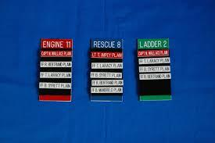

**Purpose:**

To guarantee that all members operating at an emergency scene can be located or identified at any time during an incident.

**Procedure:**

* Each member of the Granbury Volunteer Fire Department will receive two Velcro PAR tags, with their name on the tag, to be worn on their helmet. Each member is responsible for his or her PAR tags.
* Each apparatus will have at the minimum, their PAR tags affixed to the Passports.
* All members assigned to any apparatus i.e. stand-by assignment, riding, or responding will place one PAR tag from their helmet onto each PASSPORT for that apparatus.
* The white Passport will be turned into Command and the red Passport will be left in the apparatus.
* The PAR tags will be removed from the Passport upon completion of the assignment and gathered from IC.
* All personnel not on apparatus that arrive on scene must report to IC and place their PAR tags on the respective Passport.
* The PAR tag will be utilized for all exterior type fires and all non-fire type calls unless specified in a particular standard operating guideline.
* On all interior structure fire calls, the initial attach, rescue, ventilation, and back-up crews will be considered tagged in as long as one PAR tag is with command.
* As soon as manpower requirements allow, the incident commander or safety officer will assign an individual to track all crews entering the fire building:
  + This individual will be stationed near the fire building
  + Crews will report PAR (Personal Accountability Report) to this individual upon entering the fire building.
  + Crews will report PAR when they leave the fire building
* Any crew that has not reported within 20 minutes of entering a fire building will be contacted and located.

**PAR – Personal Accountability Report** - A term that is commonly used in a properly implemented accountability system. It is saying, “Is everyone OK?

**PAR tag**- A plastic tag backed with Velcro that contains the firefighter’s name used for accountability purposes. Typically found on the back of the firefighter’s helmet.

**Passport**- A large plastic tag backed with Velcro designated to every apparatus. Each apparatus will contain one red, and one white passport.

**Incident Command**- Person in charge of a scene, usually a department officer, they define the incident goals and how to perform operations to accomplish the objective of a scene.

| See the source image | | |
| --- | --- | --- |
| **G** | **SOG Title: Personal Vehicles** | |
| **SOG Number:** | |
| **Original Date:2011** | **Revision Date:1/25/20** |
| **Granbury Volunteer Fire Department Standard Operating Guidelines** | | |

**Personal Vehicle Safety Checklist**

**Purpose:** This safety checklist is provided for you to conduct a basic safety survey of Granbury Volunteer Fire Department members’ personally owned vehicles. This is not intended to be a mechanical inspection and is not a substitute for one.

**Procedure:** This checklist reviews some of the basic components that should be well maintained to provide a vehicle that is in safe working order. Anyone with basic knowledge of a vehicle’s operating components should be able to conduct the survey. This survey should be completed on an annual basis.

**Required Documents**: Verify that listed documents are present, current, and appropriate.

Tires: Tires should be checked to determine if there are any obvious conditions that would make them unsafe, e.g., cuts, bulges, uneven tread wear, questionable inflation level and inadequate tread depth. Tires should generally be of the same size and style. Any questionable items should be evaluated and repaired by a qualified automotive technician.

**Lights**: All lights should be checked to determine if they operate properly, have the proper lens covering, clearly visible, and are properly adjusted. Any questionable items should be evaluated and repaired by a qualified automotive technician.

**Body**: The body of the vehicle should be checked to determine that all required components are on the vehicle e.g. fenders, hood, bumpers, etc. Any damaged component should be checked to determine if it would interfere with the safe operation of the vehicle or present a safety hazard for pedestrians or other vehicles.

**Glass**: All glass should be checked to determine if it is in good condition, free of chips, cracks, and breaks. Windows should also be free of obstructions that would inhibit the driver’s ability to see out of the vehicle when driving. Door windows should be operational, in particular the driver’s door.

**Accessories**: Windshield wipers should be checked to determine if they are functional. The blades themselves should be in good condition, free of loose or missing blade surface. The vehicle’s washer system should also be tested to determine if it is functional.

Approved warning/courtesy lights should be checked to determine if they are properly installed and operational. The vehicle operator should have the proper permits and documentation for the warning/courtesy lights.

**Repairs Needed**: This section should be completed for any item that is suspect or in need of replacement or repair. The section should be torn off and given to the vehicle owner/operator to take to the appropriate qualified party for inspection, replacement, or repair. Upon successful completion, this section, along with a work order/repair bill, should be returned to the Granbury Volunteer Fire Department as proof that the hazardous condition has been eliminated. Discretion should be used by the Granbury Volunteer Fire Department as to whether an observed condition would warrant prohibiting the vehicle’s use in conjunction with the emergency service Granbury Volunteer Fire Department until the repair and/or replacement is made.

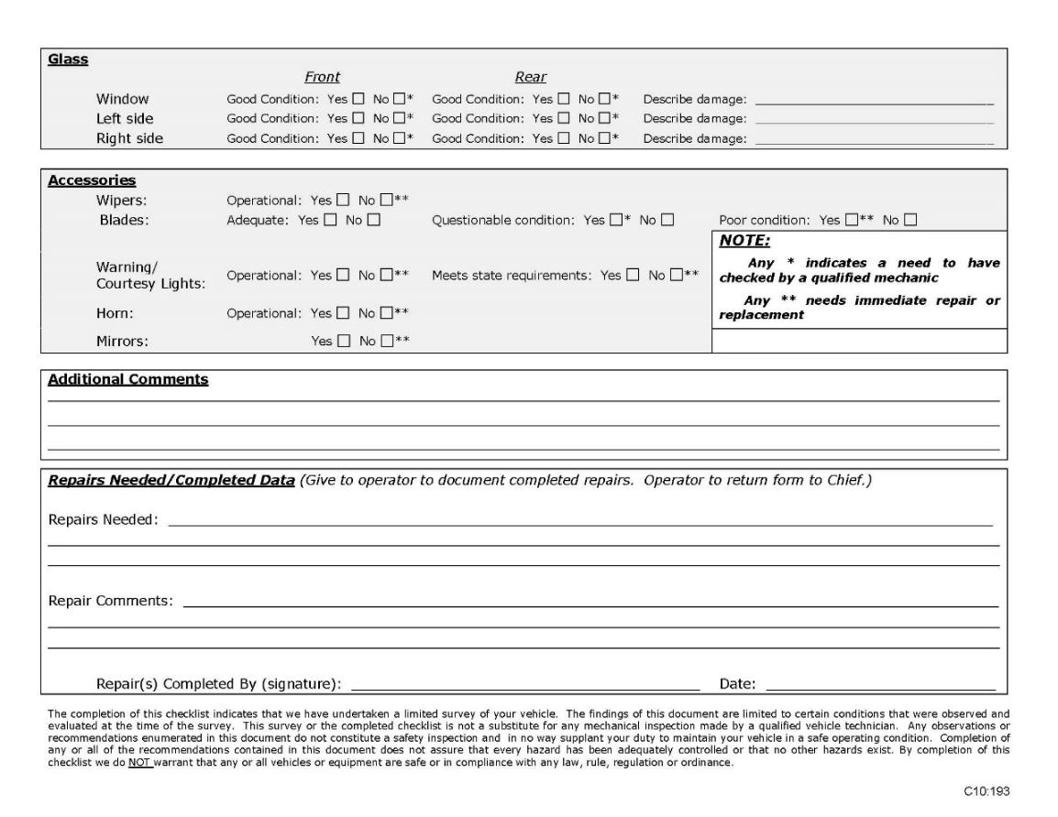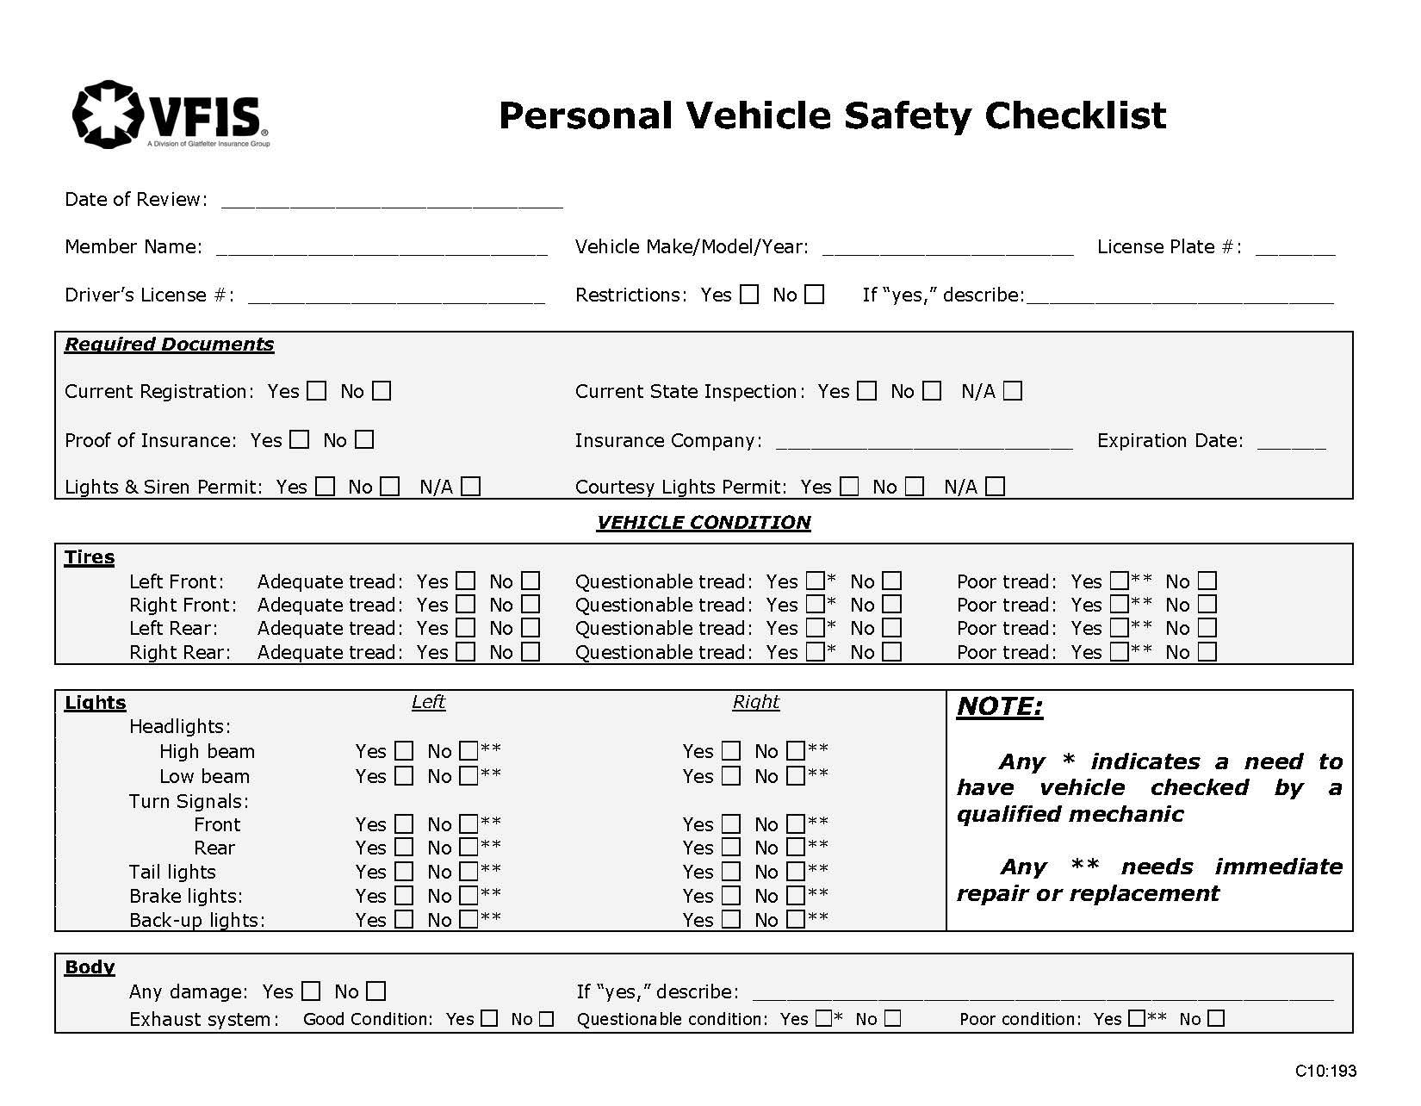

| See the source image | | |
| --- | --- | --- |
| **G** | **SOG Title: Job Descriptions** | |
| **SOG Number:** | |
| **Original Date: 2/8/20** | **Revision Date:** |
| **Granbury Volunteer Fire Department Standard Operating Guidelines** | | |

**Job Descriptions**

***Addition information can be found in the Constitution and By-Laws of the Granbury Volunteer Fire Department***

**Chief**

The Fire Chief provides administrative direction and leadership for all Fire Department functions, operations, and personnel through the supervision of member and a review of their activities. Responsibilities include reviewing the general operation of the department to determine efficiency, providing direction on major projects or problem areas, planning for the future, developing and implementing policies and procedures, and providing policy guidance. In addition, the Fire Chief is responsible, through study and consultation with municipal officials, for developing recommendations for the protection of life and property in the municipality.

**Assistant Chief**

Under direction of the Fire Chief, the Assistant Chief plans, organizes, directs, commands emergency response scenes and administers all operations of the fire department assigned to him/her by the Fire Chief within the authority delegated. In addition, in the absence of the Fire Chief, the Assistant Fire Chief will perform ALL applicable duties of the Fire Chief in a sufficient manner until arrival/return of the Fire Chief. The Assistant Chief may also perform the same duties as a firefighter.

**Captain**

Under direction of the Assistant Chief, plans, organizes, coordinates and directs the emergency and non-emergency activities of a fire suppression company; commands emergency response scenes; directs and performs a variety of member support functions; plans, organizes, coordinates and directs training, recruitment, fire inspection, and prevention programs; and performs related work as assigned. A Captain may also perform the same duties as a Firefighter.

**Lieutenant**

Under direction of the a Chief or Captain, deploys, supervises and reviews the work of Firefighters, takes command of fires and other emergency incidents within the city unless relieved by a Captain or Chief. Performs the full range of emergency response duties as a member of a response team; coordinates and participates in non-emergency inspection, training, maintenance and related activities; assists Fire Captains in providing administrative support for specified departmental programs; and performs related work as assigned. A Lieutenant may also perform the same duties as a firefighter.

**Firefighter**

Under direction of a Lieutenant, Captain, or Chief, provides direct services, individually and as a member of a team in response to fire, rescue, hazmat and other incidents.

**Firefighter Probationary**

Under direction of a Firefighter, Lieutenant, Captain, or Chief, provides direct services, individually and as a member of a team in response to fire, rescue, hazmat and other incidents. The Probationary Firefighter has not completed entry-level firefighter academy and may not be permitted to participate in structural firefighting activities, which require the individual to enter or be in close proximity to the building, enclosed structure, vehicle or vessel.

**Probationary Period**

All new recruits of the Granbury Volunteer Fire Department are subject to a minimum of a 6-month probationary period. Each probationary member will be required to complete the Hood County Firefighter Academy courses. Probationary members are also required to attend in-house trainings.

| See the source image | | |
| --- | --- | --- |
| **G** | **SOG Title: Probationary Firefighter Training** | |
| **SOG Number:** | |
| **Original Date: 1/25/20** | **Revision Date:** |
| **Granbury Volunteer Fire Department Standard Operating Guidelines** | | |

**Probationary Firefighter Training Requirements**

Granbury Volunteer Fire department will provide training to any new member who is voted on by the membership of Granbury Volunteer Fire Department. The training guidelines and source material will be from State Firefighters’ & Fire Marshals’ Association of Texas (SFFMA) and or Texas A&M Engineering Extension Service (TEEX).

Probationary training dates will be held according to student and instructor availability.

The training minimums for a probationary firefighter are:

1. Completion of Firefighter 1
2. Introduction of Firefighter 2 materials
3. Familiarization of all firefighting equipment and apparatus
4. Familiarization of Department SOP/SOG’s
5. Familiarization of Department Constitution and By-Laws
6. *COMPLETING THE SFFMA SKILLS AND PROFICENCY TEST FOR FIREFIGHTER 1 ADMINISTERED BY A SFFMA OR TEEX PROCTOR*

Upon completion of training, a probationary member is then eligible for Active Membership and will be expected to operate as an Active Member of GRANBURY VOLUNTEER FIRE DEPARTMENT. No probationary member can be considered for Active Membership until the above requirements have been met.

| See the source image | | |
| --- | --- | --- |
| **G** | **SOG Title: Non-Emergent Response** | |
| **SOG Number:** | |
| **Original Date: 1/30/20** | **Revision Date:** |
| **Granbury Volunteer Fire Department Standard Operating Guidelines** | | |

**On-The-Quiet Response**

**(Non-Emergency Response)**

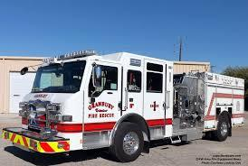

**Policy:**

There are specific types of incidents that, by their nature, are not threatening to life or property.

These types of incidents are to utilize an "on-the-quiet" response (also known as reduced speed or non-emergency responses).

**Purpose:**

To establish a procedure to follow for non-emergency events and provide a safer working environment by limiting emergency responses to emergencies only.

**Scope:**

All personnel.

**Procedure:**

“On-the-quiet” (also known as reduced speed or non-emergency) responses are to be used in compliance with local jurisdiction regulations, which range from automatic alarm system activations to vehicles leaking fuel and other incidents where local experience suggests a response is necessary, but not using emergency response procedure. The types of incidents to which an "on-the-quiet" response are recommended are very dependent upon local decision.

No audible or visual warning signals are to be used. Upon notification that the incident is indeed an emergency, proceed in standard emergency response fashion.

| **See the source image** | | |
| --- | --- | --- |
| **G** | **SOG Title: Communications** | |
| **SOG Number:** | |
| **Original Date: 2011** | **Revision Date: 1/25/20** |
| **Granbury Volunteer Fire Department Standard Operating Guidelines** | | |

**Communications**

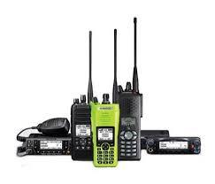

**Purpose:**

To standardize and provide a guideline for the use of communications within the Granbury Volunteer Fire Department.

**Procedure:**

**Radio Frequencies**

* Dispatch — Primary dispatch channel. All mobile radios are customarily assigned to this frequency.
* Tactical — Channel utilized at individual incidents for communications between command, on scene personnel and apparatus. The use of this channel allows minimal radio traffic on the dispatch frequency.
* Mutual Aid Frequencies — Channels utilized by surrounding departments that provide mutual aid to Hood County. These channels may be utilized by the incident commander, communications center and/or assigned to the staging officer.

**Unit Designations**

* Officers will be designated by their mobile radio number. Officers that are operating in the position of incident commander will be designated as such, e.g. “Engine 1 Command”.
* Pump Operators will be designated by their apparatus number followed by the word pump, e.g., “engine pump”.
* Firefighters will be designated by the apparatus in which they responded to an incident on followed by a letter:
* Crews forming on a scene not assigned to a specific apparatus will assigned to an apparatus crew.
* Apparatus at an incident other than Granbury Volunteer Fire Department will be designated as their unit name or number.
* Member positions within the Incident Command System will be identified by the function they are responsible for:
  + Safety - “Safety”
  + Public Information Officer — “Information”
  + Operations Officer — “Operations”
  + Planning Officer — “Plans”
  + Logistics Officer — “Logistics”
  + Liaison Officer — “Liaison”
  + Staging Officer — “Staging”
  + Sector Officers — “Division” (Alpha, Bravo, Charlie and Delta is used for clarity).

**Types of Radios**

* Dispatch
  + The base station is located at the communications center.
* Mobile Radios
  + The mobile radios are located in apparatus and in personal vehicles.
* Portable Radios
  + Portable radios are located in apparatus and in Officers personal vehicles.
  + Portable radios can have several channel configurations. The following are utilized by Hood County Fire Departments:

**Channel No. Use:**

1

2

3

4

5

6

7

8

9

10

**Incident Communications**

* Dispatching
  + All dispatching will occur on the Dispatch channel
  + Units will transmit all responding, arrival, available and administrative communications on the Dispatch channel
  + Incident updates will be transmitted to the communications center on the dispatch channel by the incident commander
* En Route
  + All units will transmit on the Dispatch channel while responding to an incident
  + Command vehicles and Officers or members riding in the front passenger seat of apparatus will turn on portable radios and set them to the tactical channel
  + Monitoring the Tactical channel permits for communication between units for operational or incident information
* Arrival:
  + The first arriving units will transmit their size up and assume command on the dispatch channel using a mobile radio
  + The first arriving officer will make all on scene transmissions on the tactical channel
  + Transfer of command will be transmitted to the communications center on the dispatch channel and repeated on the tactical channel
  + The incident commander will monitor both the dispatch and the tactical channels
  + Portable radios with a scan option or two radios, each set to dispatch and tactical channels, must be available for this to effectively occur
  + All units arriving after the first arriving unit will announce their actions on the tactical channel This will include water supply, staging and other actions

**General Communications**

* Communications Center
  + The communications center will repeat all transmissions from the incident commander
  + The communications center will only repeat the first arriving crews report and the incident commander’s transmissions. all other crews arriving on scene will direct communications to the incident commander on the tactical channel
  + The communications center will use the proper identification number the incident commander, e.g., “location” incident commander
  + The communications center will acknowledge all responding, arrival and available communications by repeating them
* Only the Incident Commander will transmit directly to the Communications Center from the scene unless it is an emergency transmission from the incident.

| See the source image | | |
| --- | --- | --- |
| **G** | **SOG Title: RIT Practice** | |
| **SOG Number:** | |
| **Original Date: 1/30/20** | **Revision Date:** |
| **ABC Fire Department Standard Operating Guidelines** | | |

**Recommended Practice for Rapid Intervention Team (RIT) Deployment**

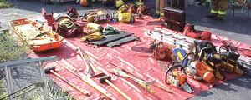

**Purpose:**

The purpose of this Recommended Practice is to provide a standardized protocol for training and operations for rapid intervention.

**Scope:**

This recommended practice applies to all units that respond and operate as a RIT to fire and/or rescue incidents that members respond too. This procedure will define the RIT concept, outline the requirements for a unit intending to fulfill the role of a RIT, and discuss procedures regarding the dispatch, staging, operation and management of a RIT.

**Definitions:**

**RAPID INTERVENTION TEAM (RIT)**

The RIT is a team of firefighters specially trained and equipped to perform the rescue of a firefighter in distress. The sole purpose of the RIT is to be immediately available to assist a firefighter who becomes trapped, lost or incapacitated.

**RIT EQUIPMENT**

All RIT members should have donned SCBA's with their face piece in the standby position. The RIT should be prepared to make entry with the appropriate equipment for different types of structures encountered. This equipment should include life belts, rope, hand tool s for cutting and breaching walls, portable radios, forcible entry tools, hand lights ("sling" mode to allow for use of hands), and a Stokes basket, which may be used to carry the RIT equipment to the RIT staging area. If the opportunity permits, RIT equipment may be laid out onto a salvage cover, etc., for easy access and identification.

**"MAYDAY – MAYDAY - MAYDAY" RADIO TRANSMISSION**

This term will be used ONLY to report a firefighter who is in distress, lost, trapped, out of air, or down; when a collapse has occurred or is imminent; or where any other circumstance that can seriously injure or kill the firefighter is present.

**EMERGENCY EVACUATION SIGNAL**

If the incident commander (IC) determines a need to evacuate the incident, fire building, etc. due to incident scene conditions that dictate the urgent need to order the immediate departure of all firefighters from the area of imminent danger, the IC will:

* Announce over the fire ground channel the order to “evacuate”
* Three air horn blasts from fire ground apparatus
* Notify personal to evacuate the incident
* Call for a personal accountability report (PAR)

Once the order to evacuate is announced, each on-scene apparatus will activate their air horn for two seconds, with a one-second break and repeat for three total times

**Procedure:**

**COMMUNICATIONS**

* The RIT should operate on the designated emergency scene frequency and remain in direct contact with the incident commander and/or the operations sector. If deployed, the RIT officer should attempt to establish radio contact with the firefighter in trouble. If this is not possible, the time and place in which the firefighter in distress was last seen should be determined.
* For clarity, emergency scene designation should be "RIT" followed by the company designation, “Command to RIT – Engine 1."
* Although the unit's primary mission is to rescue a trapped or lost firefighter, team members must remember their personal safety is a top priority and proper communications are essential to safe operations. The members included in the search should be in constant communication with the Incident Commander or his/her designate, and provide frequent progress reports on:
  + Hazards encountered
  + Barriers/obstructions
  + Victim location and condition
  + Any needs

**"MAYDAY – MAYDAY - MAYDAY" RADIO TRANSMISSION**

* It is strongly recommended that all fire crews/units should be aware of and adhere to Granbury Volunteer Fire Department Mayday procedures as outlined in the training and received by the membership.
* Any member may use the "MAYDAY" transmission to report a lost or trapped firefighter. This report should occur as soon as a firefighter perceives that a situation is rapidly developing, which is a direct threat to his/her life or the life of another firefighter. Ideally, the transmission should occur on the fire ground frequency. However, the incident commander must be aware that circumstances may dictate that the transmission could occur on another channel. Upon receiving this report, the Incident Commander should notify dispatch that he has received a “MAYDAY” report, and if needed, request additional assistance.
* The use of the term “MAYDAY” will mandate that all other radio transmissions temporarily cease. This allows the firefighter, making the report, adequate airtime to complete his/her transmission without interference, which will allow the needed help to be activated immediately.
* The incident commander should make an emergency-scene wide announcement when the “MAYDAY” emergency is under control.

**EMERGENCY EVACUATION**

* It is strongly recommended that all fire crews/units be aware of and adhere to Granbury Volunteer Fire Departments Procedure for Incident Evacuation.

**Guidelines:**

**EMERGENCY SCENE GUIDELINES**

* The RIT should be prepared to go into service at a moment's notice. The RIT's activity at the emergency scene should be consistent with their mission to assist a firefighter who becomes trapped or is in distress.
* Upon arrival, the RIT should report to the command post unless otherwise directed by the incident commander. When directed by the incident commander, the RIT officer, accompanied by another member of the RIT, should survey the entire incident scene performing a quick, thorough size-up. **(To be effective, the RIT has to be proactive, continually sizing up the situation, remaining aware of the location of the firefighters inside the structure and obstacles to potential rescue operations.)**
* If necessary, the RIT officer should take advantage of all preplan information about the structure. The RIT officer should monitor the fire ground radio frequency, note fire conditions and the location of all fire crews, evaluate portable and main ladder placement for firefighter egress, alert the incident commander or the safety officer to unusual structural features and locate all access points to all sectors of emergency scene.
* After conferring with the incident commander, the RIT officer should establish an area to stage the RIT's equipment. It is important to stage all necessary RIT equipment in an expedient manner. The RIT officer, accompanied by one member of the RIT, may perform the incident scene survey while the remaining RIT members assemble the RIT equipment. Once the incident scene survey has been completed and the RIT's equipment is in place, the entire RIT should remain near the Command Post, within verbal contact distance, in order for rapid deployment. The RIT officer should brief all members of the RIT as to the results of his/her incident scene survey.
* The RIT should "stand fast" ready to take immediate action as directed by the Incident Commander. While "standing fast", the RIT should determine the availability and location of aerial, tower, and portable ladders, portable lights, power hydraulic tools and/or other tools and equipment which might be needed to perform rescue duties.
* The RIT should operate on the designated emergency scene frequency. Portable radio messages should be monitored for any indication of members in distress.
* Hazardous materials and confined space incident protocols provide for rapid intervention rescue entry teams. Due to the highly technical nature and inherent hazards associated with this type of incidents, federal and state regulations mandate stand-by rescue entry teams with specialized training. Specially trained stand-by rescue entry teams, equipped with appropriate personal protective equipment (PPE) should be in place whenever entry teams are deployed. Therefore, if the incident commander requests RIT to respond to a confirmed operation for either hazardous materials or confined space rescue, the RIT should report to the incident commander for an assignment to support those specialized rescue teams already in place.
* In the event the incident commander receives a report of a firefighter trapped or in distress, the incident commander should brief the RIT officer on the following information:
  1. **L**ocation
  2. **U**nit
  3. **N**ame
  4. **A**ssignment
  5. **R**escue (needs)
* The RIT should use its numerical company identification when placed into service and will remain together and work as a complete team whenever possible. The incident commander may assign crews, as needed, to assist the RIT. However, the incident commander should be aware that it would be the normal reaction of crews at the scene to suspend firefighting activities and begin to try to assist missing members. The incident commander should make every attempt to continue firefighting activities while at the same time, assisting the trapped or missing firefighter.
* When the RIT is deployed, the incident commander should restructure the strategy and tactics to include a priority firefighter rescue. The incident commander should establish an additional RIT, create a rescue division or group within ICS and may need to call for additional resources. A chief officer should be assigned to oversee the rescue operation.
* Inside the building, the RIT should advance to where the victims were last reported to be located and listen for PASS signals, tapping, cries for help, etc. RIT members should protect against becoming victims themselves.
* If fire is in the search area, back-up teams with charged hose lines must immediately follow the first in rescue team.
* When a RIT member reaches a downed firefighter:
  1. If required, utilize RIT EQUIPMENT
  2. Turn off member's PASS to facilitate communication
  3. Provide "nature and conditions" to incident commander
  4. Consider any ventilation options to improve condition
* The RIT should continue search and rescue operations until the missing or trapped firefighter is located and removed, the RIT relieved, or the RIT is ordered to abandon the operation.

**MISCELLANEOUS**

* If prior to the arrival of the RIT, the Incident Command determines that a member may need assistance, he/she will designate any of the following for assistance/rescue:
  1. Crews in the stand-by position
  2. Crews who are in the process of taking up their equipment
  3. Available members, i.e., uncommitted drivers/operators, etc.
  4. Crews not committed yet

Once the arriving RIT is placed in service, those individuals should return to their former duties.

**RESTRITTIONS**

The RIT should not be used to provide relief for operating units. The incident commander should anticipate this net and have other units other than the RIT, available for the purpose.

The RIT should not be used for firefighting.

**RIT EQUIPMENT**

* Each RIT company should be equipped with relevant search and rescue equipment in one, easy to carry, cotton/nylon bag. It is critical that all of the equipment carried including the accompanying hand tools, rescue ropes and guidelines remain intact as one unit for quick deployment.
* The below listed equipment is recommended to be part of any RIT team's deployment:
  + One (1) - SCBA cylinder ( 1 hour)
  + One (1) - SCBA face piece (standard size)
  + One (1) - SCBA regulator
  + One (1) - pressure reducer with low pressure hose and fittings for Emergency Breathing Support System (EBSS) with a 6' extension hose
  + One (1) - 125' search and rescue rope with a locking "D" ring attached
  + Five (5) - I5 ' guide lines, with non-locking "D" rings
  + Two (2) - straps of nylon webbing ( l6ft and 30ft)
  + Hand tools: tin snips, wire cutters, 3"serrated knife, chalk, four (4) sprinkler wedges (to be used as door stop), three (3) light sticks, 4-piece small tool set, and one (1) multi-tipped screwdriver
  + One (1) - I00' Kernmantle rescue rope sections, 7mm
  + Power saw with appropriate blades
  + Halligan and sledgehammer
  + Thermal imaging camera with extra battery
  + Hand light for each member of the team

| See the source image | | |
| --- | --- | --- |
| **G** | **SOG Title: Records Retention** | |
| **SOG Number:** | |
| **Original Date: 1/30/20** | **Revision Date:** |
| **Granbury Volunteer Fire Department Standard Operating Guidelines** | | |

**Records Retention**

**Purpose:**

To establish Standard Operating Guidelines for maintaining various records of the department.

**Procedure:**

The Granbury Volunteer Fire Department will adhere to the following basic record retention guidelines:

* Incident reports – indefinite years
* Personnel files - indefinite
* Financial records – 7 years
* Meeting records – indefinite
* General correspondence – 2 years
* Contracts – 5 years after termination

| **See the source image** | | |
| --- | --- | --- |
| **G** | **SOG Title: Recruiting Citizens on Scene** | |
| **SOG Number:** | |
| **Original Date: 2011** | **Revision Date:1/25/20** |
| **Granbury Volunteer Fire Department Standard Operating Policy** | | |

**Recruiting Citizen Help on Scene**

**Purpose:** Policy for accepting all help upon arrival at an emergency scene.

**Procedure:** Upon arrival at the scene, a senior member or officer of an apparatus can recruit or accept help of anyone not a member or previously was a member of the Granbury Volunteer Fire Department. Any help, skills and or knowledge provided by anyone should be considered and possibly utilized by the Granbury Volunteer Fire Department membership. The decision is left to the senior member or officer on how to use and or utilize the non-member on any emergency or non-emergent scene.

In the event of recruiting a non-member to help with a scene, it is highly encouraged to recruit this person to the department. We want these people in our association. If the individual will give you their contact information, collect it and provide this information to the Chief or Assistant Chief.

| **See the source image** | | |
| --- | --- | --- |
| **G** | **SOG Title: SCBA** | |
| **SOG Number:** | |
| **Original Date: 2011** | **Revision Date: 1/25/20** |
| **Granbury Volunteer Fire Department Standard Operating Guidelines** | | |

**Respiratory Protection (SCBA)**

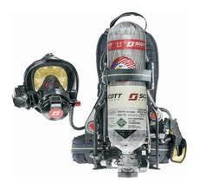

**Policy:**

Self-contained breathing apparatus (SCBA) will be provided for and will be used by all personnel working in areas where:

1. The atmosphere is hazardous
2. The atmosphere is suspected of being hazardous
3. The atmosphere may become hazardous

All personnel on scene working below ground level or inside any confined space will be provided and will use an SCBA. Unless the safety of the atmosphere can be established by testing and continuous monitoring.

Damage to the SCBA will be reported to the incident commander immediately. The incident commander will inspect the damage and determine if the unit is to be repaired or replaced. Full personal protective gear, as detailed in the Turnout Gear SOG is to be worn together with the SCBA.

The incident commander may use his/her discretion to determine the need for use of SCBA where no specific guideline has been established. The SCBA is to be worn whenever there is any doubt that a hazardous condition either exists or could exist in the near future.

Each SCBA used at a scene will be thoroughly cleaned and inspected following the guidelines established by the manufacturer. SCBA's will be inspected at least once each month following the manufacturer's guidelines. Only those members trained to do so may repair any of the working components of the SCBA. Logs of repairs made on each unit will be maintained and held on file for the life of the unit.

The intent of this procedure is that the SCBA will be worn by any member who may potentially encounter hazardous atmosphere conditions during any type of incident, fire, rescue, or hazardous materials.

**Purpose:**

To provide guidelines for the safe use of SCBA during emergency operations. Appropriate use of SCBA will include that the SCBA be in the positive pressure mode with the user having the face piece on and breathing SCBA air. The user will wear and utilize a PASS device.

**Procedure:**

* All personnel utilizing SCBA will operate in teams of two or more when in hazardous atmospheres.
* Personnel utilizing SCBA will not jeopardize the protective integrity of the SCBA for any reason in known or unknown hazardous atmospheres.
* A growth of beard or facial hair at any point where the SCBA face piece is designed to seal with the face, regardless of the specific fit test measurement that can be obtained or hair that could interfere with the face piece valve function will be PROHIBITED for personnel to wear SCBA.
* Eyeglasses with any strap or temple bar that passes through the face piece or the use of hard contact lenses will be PROHIBITED. The use of soft contact lenses may be permitted.
* Only personnel certified by the Granbury Volunteer Fire Department in the use of SCBA will wear SCBA in a hazardous atmosphere. To be certified, personnel must:
  + Become initially certified to wear SCBA by establishing competency to department standard.
  + Have received training and used SCBA at least twice a year.
* No fire fighter will lower his or her level of respiratory protection in any hazardous atmosphere until the incident commander declares the atmosphere safe using air monitoring.
* Whenever personnel enter a hazardous atmosphere, at least one person must remain outside the hazardous atmosphere with access to full protective clothing and SCBA in the event that entry personnel should require rescue. The apparatus operator or incident commander will be designated this position in the initial stages of an incident. A rapid intervention team will be assigned beyond this point.

| See the source image | | |
| --- | --- | --- |
| **G** | **SOG Title: SCBA Protection Program** | |
| **SOG Number:** | |
| **Original Date: 2011** | **Revision Date: 2/7/20** |
| **Granbury Volunteer Fire Department Standard Operating Guidelines** | | |

**Respiratory Protection Program**

**Purpose:** To identify the components of the Respiratory Protection units as it relates to Self-Contained Breathing Apparatus (SCBA), to ensure firefighter safety in IDLH environments. This document is intended to satisfy the requirements of OSHA 29CFR 1910.134, NFPA 1404 and NFPA 1500.

**Storage of SCBA:**

All units will be properly secured in the bracket provided on each vehicle. Spare cylinders will be stored in the brackets, holder provided and will not be stored loose, or where they may be at risk of damage. At scenes of substantial duration, driver / operators will make efforts to keep SCBA from freezing after use by storing them in the heated areas of the apparatus (where and when practical).

**Certification for Use:**

1. Medical
   1. All personnel who are expected to use SCBA will be evaluated and certified on an annual basis. A pulmonary function test will be used as the evaluation method and will be conducted by a third party authorized by the fire department. All new personnel will be medically evaluated prior to initial SCBA use. The member getting a physical from their doctor will meet this. Record of the medical evaluation will be kept in the individual’s file.
2. Fit Testing
   1. All personnel will annually be fit tested to ensure proper face piece size. This test will be conducted by SCBA maintenance personnel. All new personnel will be fit tested prior to initial SCBA use. Records of this testing will be maintained by the Respiratory Protection Program Coordinator.
3. Training
   1. All personnel will be trained in the proper use of SCBA. The training of personnel is under the auspices of the Training Division. The Training Division will keep a list of all personnel trained to wear SCBA. The department performance standard for complete donning of SCBA will be sixty seconds (NFPA 1001).
   2. All personnel are issued a face piece. The inspection and cleaning are the responsibility of the wearer. The face piece will be kept in the bag when not in use. The face piece inspection will consist of the following:
      1. Visual inspection of the face piece and head harness.
      2. Check for a tight seal.
      3. Exhalation valve is working properly.
      4. Nose cup is properly installed.

**SCBA Use:**

Facial hair that comes between the sealing surface of the face piece and the face will not be permitted. Personnel will don SCBA in the following scenarios:

1. The atmosphere is hazardous.
2. The atmosphere is suspected of being hazardous.
3. The atmosphere may rapidly become hazardous.
4. During confined space and/or below grade operations.
5. In any oxygen deficient atmosphere.
6. When instructed to do so by an officer

Personnel responding to a potential fire incident will have SCBA strapped on and ready for use when reporting to the Incident Commander for assignment. On apparatus that are equipped with a built-in SCBA bracket on the seat, the harness can be donned en-route.

All personnel will don and place in operation their SCBA before entering any IDLH atmosphere. Personnel operating in an SCBA will do so in teams of at least two (2), in accordance with Granbury Volunteer Fire Department policy.

***SCBA will continue to be utilized during all phase of suppression activities including overhaul.***

Smoke ejector use should be considered for continuous ventilation. Caution will be used with gasoline-powered fans to avoid introduction of exhaust gases into the atmosphere.

When SCBA are removed, they will not be left in the building where they may be damaged. SCBA will be returned to a central staging area for service and returned to a condition ready for use until they are returned to their respective apparatus.

**Air Management and Emergency Procedures:**

The Rule of Air Management (ROAM) will be utilized when operating in an IDLH atmosphere. The key components of ROAM are:

1. Know how much air you have before entering an IDLH.
2. Manage your air as you proceed
3. Exit the IDLH before the low air alarm activates.

If any member of the crew has a low air alarm or has a malfunction of any part of their SCBA, the entire crew will exit the building immediately.

**After Use Inspection**: After every use of a SCBA, the wearer will be responsible for the following:

1. Clean and wipe dry the harness, cylinder and face piece.
2. Fill all empty cylinders.
3. Perform a daily inspection.

**Refilling of Cylinders:** The routine refilling of cylinders will be done in accordance with the recommendations of the cylinder and cascade system manufacturers. Cylinders will be placed inside the fragmentation guards (tubes) during refilling.

The following is the procedure that will be used for refilling air cylinders:

1. Each unit is responsible for filling their cylinders after an incident.
2. Cylinders are to be refilled at the Fire Station or a mobile cascade if on scene.
3. Ensure that the proper numbers of cylinders are returned to the apparatus.
4. If a cylinder is damaged, replace it with a spare.
5. Follow the maintenance procedure after replacing a damaged cylinder.

**Filling Cylinders from an Outside Agency:**

When a request is made to fill air cylinders from an outside agency the hydrostatic test date of the cylinder(s) will be checked for compliance. All cylinders must be tested every five (5) years. If the cylinders are found to be out of date, they will not be filled. All filling of cylinders will be done by a Granbury Volunteer Fire Department member.

**Eyeglasses and Corrective Vision Eyewear:**

Personnel will not wear standard eyeglasses in conjunction with SCBA. Any style of eyewear, which compromises the seal, prohibited. Contact lenses are permitted, and spectacle kits, which attach to the inside of the face piece and lenses are available upon request to the Fire Chief.

**Records and Reports:**

It is the responsibility of all department Officers to insure that records are kept for each of the following areas:

1. Serial numbers of face pieces, harnesses, and cylinders.
2. Air quality testing results.
3. SCBA equipment out of service for repair.
4. SCBA equipment testing and repairs.
5. Compressor repairs and routine maintenance.

| See the source image | | |
| --- | --- | --- |
| **G** | **SOG Title: High Visibility Safety Vests** | |
| **SOG Number:** | |
| **Original Date: 2011** | **Revision Date: 2/7/20** |
| **Granbury Volunteer Fire Department Standard Operating Guidelines** | | |

**High Visibility Safety Vests**

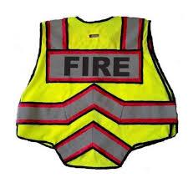

**Purpose:**

To establish Fire Department policy on the wearing of appropriate safety apparel on emergency incidents

**General Information:**

In order to provide greater safety and visibility for Granbury Volunteer Fire Department members, high visibility safety vests or other issued reflective materials will be worn during day and night emergency incidents that occur in or near traffic conditions. Traffic conditions will be defined as any street or road that is open to any type of vehicle traffic. Included in this is any sidewalk or path that is next to any traffic condition. Other considerations and not limited to:

1. Medical emergency in or near a street or large parking area

2. Re-packing hose lines.

3. Setting up a landing zone for a Medevac.

4. Other situations involving traffic or the need to identify emergency responders.

The prescribed safety vests may be of the following types:

1. Issued by Granbury Volunteer Fire Department, high visibility safety vests with reflective stripes and marked Fire Department or Emergency Services.

**Responsibilities**:

1. Company Officers as well as all Fire Department members are responsible to make sure that all members are attired properly to ensure high visibility and identity as a Fire Department member.

| **See the source image** | | |
| --- | --- | --- |
| **G** | **SOG Title: SCBA Inspection** | |
| **SOG Number:** | |
| **Original Date: 5/22/20** | **Revision Date: 1/25/20** |
| **Granbury Volunteer Fire Department Standard Operating Guidelines** | | |

**Self-Contained Breathing Apparatus Inspection Log**

**Purpose:**

To provide a standardized method of inspecting self-contained breathing apparatus and documenting the information for action, reference and analysis.

**Self-Contained Breathing Apparatus Inspection Log**

Department _______________________________________ Station

Apparatus #

**SCBA INFO SPARE CYLINDER INFO**

Face piece # _______________________________________ Cylinder #

Mfg. _____________________________________________ Current Hydro Test Date

Regulator Ser. # ____________________________________ Date Purchased

Model # __________________________________________

**WEEKLY INSPECTION**

| Date | Cylinder | | Clean | Audi Alarm OK | Remarks | Initial | Date | Cylinder | | Clean | Audi Alarm Off | Remarks | Initial |
| --- | --- | --- | --- | --- | --- | --- | --- | --- | --- | --- | --- | --- | --- |
| # | Pressure | # | Pressure |
|  |  |  |  |  |  |  |  |  |  |  |  |  |  |
|  |  |  |  |  |  |  |  |  |  |  |  |  |  |
|  |  |  |  |  |  |  |  |  |  |  |  |  |  |
|  |  |  |  |  |  |  |  |  |  |  |  |  |  |
|  |  |  |  |  |  |  |  |  |  |  |  |  |  |
|  |  |  |  |  |  |  |  |  |  |  |  |  |  |
|  |  |  |  |  |  |  |  |  |  |  |  |  |  |
|  |  |  |  |  |  |  |  |  |  |  |  |  |  |
|  |  |  |  |  |  |  |  |  |  |  |  |  |  |
|  |  |  |  |  |  |  |  |  |  |  |  |  |  |
|  |  |  |  |  |  |  |  |  |  |  |  |  |  |
|  |  |  |  |  |  |  |  |  |  |  |  |  |  |
|  |  |  |  |  |  |  |  |  |  |  |  |  |  |
|  |  |  |  |  |  |  |  |  |  |  |  |  |  |
|  |  |  |  |  |  |  |  |  |  |  |  |  |  |
|  |  |  |  |  |  |  |  |  |  |  |  |  |  |
|  |  |  |  |  |  |  |  |  |  |  |  |  |  |
|  |  |  |  |  |  |  |  |  |  |  |  |  |  |
|  |  |  |  |  |  |  |  |  |  |  |  |  |  |
|  |  |  |  |  |  |  |  |  |  |  |  |  |  |
|  |  |  |  |  |  |  |  |  |  |  |  |  |  |
|  |  |  |  |  |  |  |  |  |  |  |  |  |  |
|  |  |  |  |  |  |  |  |  |  |  |  |  |  |
|  |  |  |  |  |  |  |  |  |  |  |  |  |  |
|  |  |  |  |  |  |  |  |  |  |  |  |  |  |
|  |  |  |  |  |  |  |  |  |  |  |  |  |  |
|  |  |  |  |  |  |  |  |  |  |  |  |  |  |
|  |  |  |  |  |  |  |  |  |  |  |  |  |  |
|  |  |  |  |  |  |  |  |  |  |  |  |  |  |
|  |  |  |  |  |  |  |  |  |  |  |  |  |  |
|  |  |  |  |  |  |  |  |  |  |  |  |  |  |
|  |  |  |  |  |  |  |  |  |  |  |  |  |  |
|  |  |  |  |  |  |  |  |  |  |  |  |  |  |
|  |  |  |  |  |  |  |  |  |  |  |  |  |  |
|  |  |  |  |  |  |  |  |  |  |  |  |  |  |
|  |  |  |  |  |  |  |  |  |  |  |  |  |  |
|  |  |  |  |  |  |  |  |  |  |  |  |  |  |
|  |  |  |  |  |  |  |  |  |  |  |  |  |  |
|  |  |  |  |  |  |  |  |  |  |  |  |  |  |
|  |  |  |  |  |  |  |  |  |  |  |  |  |  |

**Inspection after Each Use**

Face piece # ______________________________

| Date | Cylinder1 | | Face piece & Breathing Tube OK | Belt & Harness OK | Conditions OK | Cleaned & Sanitized | Remarks | Inspected By | Date Inspected |
| --- | --- | --- | --- | --- | --- | --- | --- | --- | --- |
| OK2 | Changed |
|  |  |  |  |  |  |  |  |  |  |
|  |  |  |  |  |  |  |  |  |  |
|  |  |  |  |  |  |  |  |  |  |
|  |  |  |  |  |  |  |  |  |  |
|  |  |  |  |  |  |  |  |  |  |
|  |  |  |  |  |  |  |  |  |  |
|  |  |  |  |  |  |  |  |  |  |
|  |  |  |  |  |  |  |  |  |  |
|  |  |  |  |  |  |  |  |  |  |
|  |  |  |  |  |  |  |  |  |  |
|  |  |  |  |  |  |  |  |  |  |
|  |  |  |  |  |  |  |  |  |  |
|  |  |  |  |  |  |  |  |  |  |
|  |  |  |  |  |  |  |  |  |  |
|  |  |  |  |  |  |  |  |  |  |
|  |  |  |  |  |  |  |  |  |  |
|  |  |  |  |  |  |  |  |  |  |
|  |  |  |  |  |  |  |  |  |  |
|  |  |  |  |  |  |  |  |  |  |
|  |  |  |  |  |  |  |  |  |  |
|  |  |  |  |  |  |  |  |  |  |
|  |  |  |  |  |  |  |  |  |  |
|  |  |  |  |  |  |  |  |  |  |
|  |  |  |  |  |  |  |  |  |  |
|  |  |  |  |  |  |  |  |  |  |
|  |  |  |  |  |  |  |  |  |  |
|  |  |  |  |  |  |  |  |  |  |
|  |  |  |  |  |  |  |  |  |  |
|  |  |  |  |  |  |  |  |  |  |
|  |  |  |  |  |  |  |  |  |  |
|  |  |  |  |  |  |  |  |  |  |
|  |  |  |  |  |  |  |  |  |  |
|  |  |  |  |  |  |  |  |  |  |
|  |  |  |  |  |  |  |  |  |  |
|  |  |  |  |  |  |  |  |  |  |
|  |  |  |  |  |  |  |  |  |  |
|  |  |  |  |  |  |  |  |  |  |
|  |  |  |  |  |  |  |  |  |  |
|  |  |  |  |  |  |  |  |  |  |
|  |  |  |  |  |  |  |  |  |  |
|  |  |  |  |  |  |  |  |  |  |
|  |  |  |  |  |  |  |  |  |  |
|  |  |  |  |  |  |  |  |  |  |
|  |  |  |  |  |  |  |  |  |  |
|  |  |  |  |  |  |  |  |  |  |
|  |  |  |  |  |  |  |  |  |  |
|  |  |  |  |  |  |  |  |  |  |
|  |  |  |  |  |  |  |  |  |  |
|  |  |  |  |  |  |  |  |  |  |
|  |  |  |  |  |  |  |  |  |  |
|  |  |  |  |  |  |  |  |  |  |

| See the source image | | |
| --- | --- | --- |
| **G** | **SOG Title: Scene Preservation** | |
| **SOG Number:** | |
| **Original Date: 02/2/20** | **Revision Date:** |
| **Granbury Volunteer Fire Department Standard Operating Guidelines** | | |

**Scene Preservation**

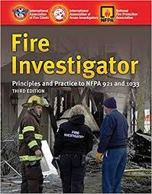

**Purpose:**

The determination of fire origin and cause is necessary for all fire incidents. The Officer in Charge is responsible for determining when a Fire Investigator is needed. This determination is dependent on the information gathered at the scene and/or circumstances of the fire. The on duty Fire Investigators are available through Dispatch and Deployment or by phone to consult with Command prior to or during response to assist Command. A fire investigation is conducted after fire control and salvage activities are completed, but before overhaul actions, which could hinder the investigation.

**Dispatch:**

A Fire Investigator dispatched by Dispatch and deployment or called by the Officer in Charge, will respond to the scene reference the following circumstances:

• Fire deaths or serious fire injuries

• All working first alarm or greater structure fires

• The City Fire Investigator will be notified on all structure fires that cause more than light smoke damage.

• Explosions and bombings

• Requested by Granbury Police Department to respond to known arson fires

• Car, field, or dumpster fires that have an identified lead or suspect in custody

• Attempted arsons

• If determined by members on scene; scalding burns, electrical accidents, and minor accidental burn injuries

• When requested to make contact with homeowner for the purpose of insurance matters

• Minor fires caused by juveniles playing with fire, matches, etc.

**NON-DISPATCH:**

A Fire Investigator is not needed for the following situations. The company officer is responsible for completing an accurate Field Incident Report to document the fire cause:

• Minor fires where cause is determined to be accidental if occupants want to file an insurance claim

• Car fires originating in the engine area during vehicle operation, abandoned autos, or vehicle arsons with no identified suspects

• Minor grass, fence, or trash fires with no witnesses or suspects

• To hold the scene until another agency or service responds

If an incident is determined to be of a minor nature (e.g. accidental, no injuries, slight fire damage) and the cause can be determined by the Company Officer on scene through the information gathered at the scene and/or circumstances of the fire, units on the scene will gather the information needed and to accurately complete the required report. If a victim requests information regarding their fire loss, the Senior Member or Officer will contact Dispatch and The City Fire Inspector to assist the victim to accessing Fire Department information.

**FIRE SCENE COORDINATION:**

When a Fire Investigator is on the scene or responding, crews will delay non-essential overhaul and secure the fire scene until the Fire Investigator arrives. Salvage and all unnecessary interim activities, which may alter, contaminate the fire scene, or interfere with a subsequent origin and because investigation must be discontinued until authorized to continue by the responding Fire Investigator.

Command will assign personnel to protect and maintain custody of the fire scene until the arrival of a Fire Investigator, especially when the responding Fire Investigator has indicated a delay in response.

After achieving fire control, Command may release crews not required for the completion of the investigation and/or overhaul. In some cases, involving lengthy investigations, crews may return to quarters and later respond back to the scene to complete overhaul activities when requested by the Fire Investigations Sector.

Command will turn over jurisdiction of the fire area to the Fire Investigator as soon as possible after the fire is stabilized. The Investigator retains jurisdiction of the scene until it is released back to Command. The Fire Investigator may inform Command they need to maintain custody of the scene for further investigation.

The Investigator will request from Command any personnel or equipment necessary for the investigation. Command will make every attempt to meet such requests, to the extent possible under the prevailing circumstances.

All personnel will cooperate with the Fire Investigator and the Fire Investigations Sector. Protection of the fire scene and preservation of physical evidence is a primary concern once life safety and fire control are achieved. An attempt to identify the victims and witnesses at the fire scene will be made as soon as possible, and will not be delayed until the Fire Investigator is on the scene. Obtaining the identification of victims and witnesses is critical to the investigative process.

**PRESERVATION OF EVIDENCE:**

Every fire scene contains evidence. Firefighting operations present the greatest potential for damage to evidence, which may be used by the Fire Investigators and the Police Department in subsequent court cases and prosecution.

Evidence of fire cause is rarely destroyed by fire. The form, shape, color, size, and weight of items may be altered, but evidence can still be identified upon trained examination. It is imperative to preserve evidence as found, in place and not moving fire debris unnecessarily.

It is the responsibility of the Fire Department to protect the fire scene from unnecessary damage during firefighting operations. Special care exercised during extinguishment will avoid the destruction of evidence through the misuse of fire streams. Salvage operations should be minimal until the initial fire investigation is completed, and should be confined to diminishing loss. Crews assigned to Loss Control Sector should incorporate scene security and evidence preservation into their plan to stop the loss.

The fire scene is the Fire Investigator's laboratory. It is searched carefully and thoroughly, photographed, diagrammed for placement of contents and evidence, and evidence is then collected and preserved. The fire scene must be secured. Evidence cannot be used in court unless the Fire Investigator can establish a chain of custody by proving who found the evidence, where it was found and the evidence was not tampered with while in official custody. To ensure that the chain of custody remains unbroken, the scene must remain in the sole custody of the Fire Department. When at a fire scene where custody must be maintained, a guard must be posted, and custody must be maintained until the scene is released. No unauthorized person may enter the scene. The Fire Department has the legal authority to close the scene entirely, even to the property owner or to other interested person/s. It is vital that the Fire Department prevent personnel from unnecessarily walking through a fire area, walking on, obscuring evidence, or picking up and moving evidence. This includes both Fire Department personnel and the media. If it is essential that evidence be moved or if necessary firefighting operations may damage evidence, the evidence must be covered or its location marked before moving it carefully to a secure location.

**FIRES**:

• Officers will assist the Fire Department in determining the location, size, type of fire, and any special information, which may help in determining the number of fire units necessary.

• Officers will take appropriate action to rescue victims of fires but, if possible, will notify the Fire Department prior to any rescue attempt.

• Officers’ primary responsibility at the fire scene will be to control pedestrian and vehicular traffic as well as to prevent the interference with firefighters or officers at the scene.

NOTE: When persons disobey or interfere with a firefighter at a fire scene, a senior member or officer can ask for assistance from law enforcement.

**ARSON INVESTIGATION:**

When arson is suspected, officers will secure the scene and request a Fire Department investigator. Upon the fire investigator’s arrival at the scene, officers will advise them on:

• Observations of smoke color

• Flame intensity

• Security of the property upon first officer’s arrival

• Any personal knowledge of past activity at the premises

• All fire apparatus carry the yellow or red “FIRE LINE - DO NOT CROSS” tape, available to officers to aid in securing the scene.

• Arson of vehicles will only be investigated by the Fire Investigations Section when a suspect is in custody or immediate investigation is possible.

• The responding fire department is responsible for relaying all suspect information to the Fire Investigations Section and supplying the victim with necessary information.

• The Fire Investigations Section will conduct follow-up investigations.

• Victims’ questions will be referred to the Fire Department.

• An engine company should be called to the scene of vehicle arson after the fire has been extinguished so that a report can be prepared for the Fire Investigator.

**Arson Evidence:**

• Fire investigators are responsible for the collection, preservation, and impounding of all arson evidence found at the scene.

• The fire investigator will take all necessary photographs, which may include those related to another crime at the arson scene.

| See the source image | | |
| --- | --- | --- |
| **G** | **SOG Title: Seat Belt Use** | |
| **SOG Number:** | |
| **Original Date:** | **Revision Date:** |
| **Granbury Volunteer Fire Department Standard Operating Guidelines** | | |

**Seat Belt Use**

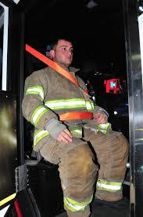

**Purpose:**

To establish appropriate and safe behavior regarding the use of safety belts when operating or riding in an emergency vehicle.

**Procedure:**

All persons driving or riding in fire department vehicles will be seated in approved riding positions with seatbelts or safety restraints fastened at all, times when the vehicle is in motion. The driver will not begin to move the vehicle until all passengers are seated and properly secured. All passengers will remain seated and secured as long as the vehicle is in motion. Seatbelts will not be loosened or released while enroute to dress or don equipment. Members will not attempt to mount or dismount from a moving vehicle under any circumstances.

**Exception:**

A fire department member who is providing direct patient care inside an ambulance will be permitted to release shortly the seat belt while the vehicle is in motion – IF IT IS ESSENTIAL TO PROVIDE PATIENT CARE. When the procedure has been completed, the fire department member will refasten the seatbelt. Time without the protection of a seat belt will be minimized.

| See the source image | | |
| --- | --- | --- |
| **G** | **SOG Title: Non-Smoking and Tobacco Free Areas** | |
| **SOG Number:** | |
| **Original Date: 2/8/20** | **Revision Date:** |
| **Granbury Volunteer Fire Department Standard Operating Guidelines** | | |

**Non-Smoking and Tobacco Free Areas**

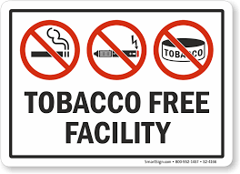

**PURPOSE:**

The Granbury Volunteer Fire Department is committed to maintaining tobacco free facilities as subscribed to by the laws of the State of Texas, City of Granbury and recommended by the Surgeon General of the United States.

**POLICY:**

City of Granbury requires that public places and places of employment must be completely smoke-free inside and within 15 feet from entrances, exits, windows that open and ventilation intakes.

This tobacco prohibition applies to all indoor spaces including living quarters, engine bays, and administrative offices. In addition, the use of tobacco products is not permitted in any vehicle owned, operated or rented by the City of Granbury.

Tobacco use is discouraged at any time during public events, i.e. demonstrations; block party, fire ground, and expo. Tobacco use will not be in the view of the public. Includes: cigarettes, EVAP, cigars, pipes, and smokeless tobacco products such as chew, snuff and dip

**Smoking areas:**

* Approved smoking areas are behind each station
* Members are responsible for policing these areas and making sure there is no trash and to dispose of cigarette butts appropriately.

| **See the source image** | | |
| --- | --- | --- |
| **G** | **SOG Title: Social Media** | |
| **SOG Number:** | |
| **Original Date: 2011** | **Revision Date: 1/25/20** |
| **Granbury Volunteer Fire Department Standard Operating Guidelines** | | |

**Social Media**



**Purpose:** To establish Standard Operating Guidelines for using social media hardware and software in a manner consistent with the best interest of the Granbury Volunteer Fire Department.

Statistics indicate approximately two of every three Americans visit social media networks online. Facebook alone boasts more than 900 Million account holders worldwide. Average Facebook users add 90 pieces of content per month to their personal profile; are tied to more than 130 “friends” on their account; and 50 percent log in on a daily basis. Coupled with Twitter, LinkedIn, and other social media it is necessary to manage the posting and transmission of information on these sites.

**Procedure:** The Granbury Volunteer Fire Department maintains a website and Facebook page for communicating key Granbury Volunteer Fire Departmental information about our Granbury Volunteer Fire Department to the public.

In addition, volunteers (members) are joining social media networks and Web sites at a rapid pace. Facebook, YouTube, Twitter, LinkedIn, personal Web pages and blogs are only a few of the current social media resources that are tapped frequently. Granbury Volunteer Fire Department members’ usage, written content, as well as photographic and video-based images on their personal social media sites, as well as on fire department sites can create a multitude of problems as individuals and as a Granbury Volunteer Fire Department.

As such, Granbury Volunteer Fire Department may have an interest with their members’ social media communications that are considered a breach of confidential information, inappropriate, offensive, unprofessional, disparaging, defamatory, discriminatory or harassing. Among other risks, Granbury Volunteer Fire Department could be held liable for its members’ postings on their personal social media networking sites.

An inherent conflict regarding social media is an individual’s reasonable expectation of privacy or confidentiality when the content (written text, pictures or videos) is being disseminated on the World Wide Web. Any person posting a video on YouTube, for example, is essentially the owner of his or her own international Internet distribution center or “television” station. A Granbury Volunteer Fire Department member’s social media content could be distributed for “the world to see” even when it is not the intention. An email, Facebook post, photograph, blog or video, could be passed along to an endless number of recipients.

While individuals may attempt to limit who has access to their social media sites or communications, these communications frequently land in the hands of unintended recipients. Inappropriate, offensive or personal communications have been called to the attention of Granbury Volunteer Fire Department senior members, officers of Chiefs who are left to determine what actions, if any, could or should be taken against the members who authored the written content or posted the pictures or videos.

When such incidents occur, a variety of different factors will be taken into consideration when assessing the Granbury Volunteer Fire Department interest in objecting to members’ social media usage:

On Granbury Volunteer Fire Department time or within Granbury Volunteer Fire Department facilities – Granbury Volunteer Fire Department has a vested interest in what behavior or activities its members are engaged in while “on the clock” within Granbury Volunteer Fire Department facilities or otherwise engaged in Granbury Volunteer Fire Department related activities. Members should be cognizant of their inappropriate usage of Granbury Volunteer Fire Department owned telephones, computers or other devices to communicate offensive, intimidating, discriminatory, harassing or other unprofessional social media content. Members may be disciplined even when using their own personal laptop computer or Smartphone while on duty, Granbury Volunteer Fire Department property or otherwise engaged in Granbury Volunteer Fire Department related business. Members may post pictures, videos or written text on their personal social media site while off-duty. However, it is crucial members understand that postings made on their own time, from their own computer or Smartphone, and while off Granbury Volunteer Fire Department property can still harm the Granbury Volunteer Fire Department, its members and the community served. Under a variety of circumstances, these off-duty communications can be tied directly to business-related activities, personal or professional reputation within the community or member relationships.

Members of Granbury Volunteer Fire Department may use their personal social media networks to discuss Granbury Volunteer Fire Department related business information and could violate confidentiality laws and/or Granbury Volunteer Fire Department policies. Members may communicate sensitive or confidential information about the Granbury Volunteer Fire Department financial, operational and personnel functions. Similarly, social media sites may contain medical or personal information about citizens served by the Granbury Volunteer Fire Department.

Problems result when a Granbury Volunteer Fire Department member posts information, allegations, pictures or videos about members that could be considered harmful to that individual. For instance, a member can post disparaging allegations that are harassing or discriminatory in nature against members. Again, it may be irrelevant if the offending party posts such information while on or off-duty.

Based upon the aforementioned issues, which pose challenges to effective management of and protection of the Granbury Volunteer Fire Department, this guideline will apply to determine what constitutes a conflict and related social media offense for review by the Granbury Volunteer Fire Department membership.

1. Inappropriate usage of Granbury Volunteer Fire Department time or equipment (i.e. computers) or is otherwise detrimental to productivity, morale, work culture or the mission and purpose of the Granbury Volunteer Fire Department.

2. Conduct unbecoming of a member/Code of Conduct – The emergency services industry relies heavily on the public trusting in the integrity and professionalism of its members. Granbury Volunteer Fire Department has instituted policies that allow members to be disciplined for behavior on or off duty that reflects poorly on the integrity and professionalism of the Granbury Volunteer Fire Department and its membership.

3. Breach of confidentiality or unauthorized communications regarding private business-related information. This may include financial information, operational data, sensitive personnel matters or even photos or videos taken at emergency scenes.

4. Misuse or misrepresentation of the Granbury Volunteer Fire Department’s name or business. For their personal social media site, members may “copy and paste” the Granbury Volunteer Fire Department’s logo and consequently violate copyright or trademark laws or protections, with permission of the President and Chief.

5. “Representing” the Granbury Volunteer Fire Department – An individual’s social media site may indicate he or she is a member of Granbury Volunteer Fire Department. The member must understand that representations made by that person on the social Web site could be misperceived as representing the views of the Granbury Volunteer Fire Department and act accordingly.

6. Members review and sign the acknowledgement and sign-off page of this policy, indicating an understanding of the parameters of the electronic communications systems (including social media) policy. This includes the Granbury Volunteer Fire Department’s ability to monitor their usage while on duty, within Granbury Volunteer Fire Department facilities or while engaging in Granbury Volunteer Fire Department related activities.

Granbury Volunteer Fire Department is implementing a policy that bans members’ usage of social media networks is most likely unrealistic and will be perceived as overreaching by membership, and instead, focus on a policy that is grounded in common sense and places reasonable restrictions on content and usage.

**GRANBURY VOLUNTEER FIRE DEPARTMENT** **SOCIAL MEDIA GUIDELINE STATEMENT**

I __________________________________- have reviewed the Granbury Volunteer Fire Department Social Media Standard Operating Guideline, I _________________________ understand the documents content and agree to comply with the requirements of the SOG. I understand that failure to comply may result in actions, consistent with the progressive discipline guidelines of the Granbury Volunteer Fire Department.

_____________________________________________

Signature

_____________________________________________

Chief or Assistant Chief Signature

___________________________

Date

| See the source image | | |
| --- | --- | --- |
| **G** | **SOG Title: Sprinklered Buildings** | |
| **SOG Number:** | |
| **Original Date: 1/30/20** | **Revision Date:** |
| **Granbury Volunteer Fire Department Standard Operating Guidelines** | | |

**Sprinklered Building Operations**

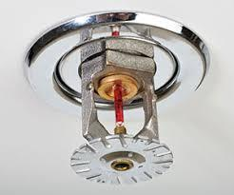

**Purpose:**

To provide guidelines for operations at buildings that have sprinkler systems.

**Procedure:**

* It will be the responsibility of the Incident Commander to ensure that the sprinkler system is supplemented by pumping a fire department connection in the initial stages of an incident.
* The initial arriving engine will position near the fire department connection and perform one of the following operations:
  + Fire department connection on the building:
    - Connect two 2 ½” hose lines to the Siamese.
  + Remote fire department connection:
    - Connect a 5” hose with a 30 degree fitting or connect two 2 1/2“ hose lines.
* If the building has a standpipe system, the standpipe will take precedence.
* The sprinkler, system will be pumped at 150 psi at the discharge of the engine. If the engine cannot maintain 150 psi, this means too many sprinkler heads have fused and an additional engine will be required to help supply the system.
* Pump operators should be aware of the possibility of pumping against a closed or defective check valve. This can be accomplished by closing the discharge of the hose supplying the sprinkler. If the check valve was open, an increase in pump pressure should occur. If the valve was closed, there will be no increase in- the pump pressure because water was not entering the system. The pump operator will immediately notify the IC if’ water is not entering the system.
* The second arriving engine will provide water supply to the initial engine. The use of private fire hydrants should be avoided because of the possibility of decreasing the flow of water to the sprinkler system.

| See the source image | | |
| --- | --- | --- |
| **G** | **SOG Title: Response Time Standard** | |
| **SOG Number:** | |
| **Original Date: 1/27/20** | **Revision Date:** |
| **Granbury Volunteer Fire Department Standard Operating Guidelines** | | |

**Standard of Response Cover**

**NFPA 1720  
Standard for the Organization and Deployment of Fire Suppression Operations, Emergency Medical Operations, and Special Operations to the Public by Volunteer Fire Departments, 2010 Edition**

**Organization, Operation, and Deployment**

**Staffing and Deployment.**  
The fire department will identify minimum staffing requirements to ensure that a sufficient number of members are available to operate safely and effectively. The table below will be used by the AHJ to determine staffing and response time objectives for structural firefighting, based on a low-hazard occupancy such as a 2000 ft2 (186 m2), two-story, single-family home without basement and exposures and the percentage accomplishment of those objectives for reporting purposes as required.

| **Demand Zonea** | **Demographics** | **Minimum** **Staff to Respondb** | **Response** **Time (minutes)c** | **Meets** **Objective (%)** |
| --- | --- | --- | --- | --- |
| Urban area | >1000 people/mi2 | 15 | 9 | 90 |
| Suburban area | 500–1000 people/mi2 | 10 | 10 | 80 |
| Rural area | <500 people/mi2 | 6 | 14 | 80 |
| Remote area | Travel distance ≥ 8 mi | 4 | Directly dependent on travel distance | 90 |
| Special risks | Determined by AHJ | Determined by AHJ based on risk | Determined by AHJ | 90 |

The City of Granbury is Suburban Area with a national response time of 10 minutes. The Granbury Volunteer Fire Department will respond to incidents involving serious threat to life and property, arriving on scene within seven (7) minutes of dispatch for calls in The City of Granbury, with a minimum of three (3) qualified firefighters, and a Class A Pumper, 95% of the time.

| **See the source image** | | |
| --- | --- | --- |
| **G** | **SOG Title: Fire Standby** | |
| **SOG Number:** | |
| **Original Date:2011** | **Revision Date:1/25/20** |
| **Granbury Volunteer Fire Department Standard Operating Guidelines** | | |

**Fire Standby Agreement**

**Purpose:**

Establish a guideline for the requirements and expectations of personnel when they are on standby at a station during an incident

**Procedure:**

Personnel who standby at a station during an incident may receive credit for the incident will be responsible for the following:

1. Prepared to man an apparatus should the need arise.
2. Remain at the station until authorized to “stand down” by a senior member or officer of the current incident.
3. Assist in the returning apparatus and equipment to service as they return of the incident.
4. If a person on standby leaves the station before the incident is concluded without notifying a senior member or officer at the incident, the senior member or officer may “strike” that person’s name from the ticket following a discussion with the person and Chief or Assistant Chief.

| See the source image | | |
| --- | --- | --- |
| **G** | **SOG Title: Testing and Inspections** | |
| **SOG Number:** | |
| **Original Date:** | **Revision Date:** |
| **Granbury Volunteer Fire Department Standard Operating Guidelines** | | |

**Testing and Inspections**

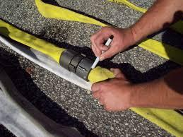 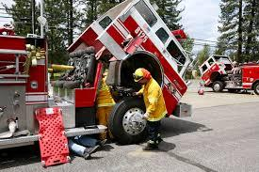 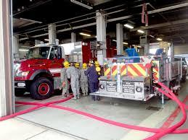

**Purpose:**

Equipment to be tested and documented for safety of Granbury Volunteer Fire Department members and to help ensure the readiness of the equipment for use on any emergent scene.

**Recommended Testing:**

1. Annual Hose Pressure testing of the following sizes:
   1. 1 ¾”
   2. 2”
   3. 2 ½”
   4. 5”
2. Annual Pump and flow testing on all apparatus water pumps:
3. Annual Aerial Ladder Testing:
   1. Non-destructive Test
   2. Flow test on water way
4. Annual Hydraulic Extrication Tool Test and inspection
5. Annual stationary SCBA refill compressor testing
   1. Station 1
   2. Station 2
6. Annual mobile SCBA refill compressor testing
   1. Support 1
7. Annual Ground Ladder Testing
   1. Little Giant
   2. 8’ attic ladder
   3. 12’ roof ladder
   4. 14’ roof ladder
   5. 24’ extension ladder
   6. 35 extension ladder
8. Annual PPE inspection done by PPE coordinator

**Procedure**: Granbury Volunteer Fire Department Chief can appoint approved members to do the testing listed above, but must follow all NFPA standards and documentation requirements per NFPA. The Granbury Volunteer Fire Department can also use independent contractors or companies that follow NFPA standards and documentation for the testing listed above. It is also recommended currently to have independent contractors or companies that are insured, trained and equipped for the testing listed above to provide the best safety measure for the membership.

| See the source image | | |
| --- | --- | --- |
| **G** | **SOG Title: Uniforms** | |
| **SOG Number:** | |
| **Original Date: 2011** | **Revision Date: 2/1/20** |
| **Granbury Volunteer Fire Department Standard Operating Guidelines** | | |

**Uniforms, Badges and Issued Equipment**

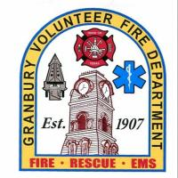

**Purpose**. The purpose of the Granbury Volunteer Fire Department (GVFD) Uniform and Equipment Regulations is to. Provide descriptions of all authorized equipment provide guidance on prescribing uniform wear and establish a board of individuals who will recommend appropriate changes to uniforms and equipment.

**Applicability**. This policy applies to all firefighters who are in an active, support or lifetime member roles. It is issued for information and guidance, and requires compliance when wearing the uniform and equipment as a representative of the Granbury Volunteer Fire Department.

**Responsibilities.**

a. The Fire Chief will:

1. Establish a uniform board to review uniform and equipment proposals.
2. Approve or disapprove proposed changes in uniforms and equipment recommended by the uniform board.
3. Hold firefighters monetarily accountable for uniforms damaged or lost due to willful negligence.
4. Hold departing firefighters monetarily accountable for uniforms not returned or when lifetime members do not return structure equipment.
5. Assign an Equipment Manager(s) to issue uniforms and equipment.
6. Create an Equipment Sign Out Sheet for inventory management.

b. Uniform Board will:

1. Be made up of Assistant Fire Chief (as chairperson), Station Captains, Training Captain and Equipment Manager.
2. Review all proposed changes to uniforms and equipment, recommend action to the Fire Chief, ensuring changes are necessary, cost effective, and kept to a minimum.
3. Meet at least semi-annually and convene special working groups as necessary.

c. Equipment Manager will:

1. Be responsible to issue equipment as noted in paragraph 4 below.
2. Maintain all routine and advanced inspection checklists for 5 years.
3. Maintain all uniform and equipment issue receipts for as long as the firefighter is active at GVFD.

d. Firefighters will:

1. Properly maintain their uniforms and equipment in manner prescribed by the recommended care instructions.
2. Perform routine and advanced inspections of uniforms and equipment as prescribed in paragraph 5 below.
3. Immediately notify their Station Captain of any damage to their uniforms and/or equipment.
4. Firefighters certified for interior firefighting and responding to a minimum

number of calls will be ordered a second set structure equipment to be used as reserve. The reserve equipment will be packaged separately in a storage bag. The equipment may be used when needed while primary equipment is awaiting full decontamination.

1. Firefighters must perform a perfunctory decontamination at the scene, if possible, or immediately upon arriving back at the station. Perfunctory decontamination will include, but is not limited to, bunker coat, bunker pants, gloves, boots, SCBA and SCBA mask. Upon arrival back at the station, firefighters will perform a full decontamination by running equipment through the washer/extractor and dryer. Firefighters with reserve structure equipment will pull the reserve equipment out of storage to replace the primary equipment. Once full decontamination of the primary equipment is complete, it will be placed in a storage bag as the reserve equipment.

4. Equipment and Uniforms. Each firefighter will receive a standard issue uniform and equipment split between two phases: Probationary phase and Active phase.

1. Probationary phase. After an applicant is accepted per the by-laws, they will receive used equipment to facilitate learning and integration into the firefighting environment. All equipment must be within expiration.
2. Active phase. After the probationary phase of 6 months and an additional waiting period of 1-year, active phase members will be ordered new equipment and equipment, depending on call status. If an active phase member does not meet minimum call status, the Fire Chief, Assistant Fire Chief and Station Captain will make a determination if new uniforms and equipment will be procured for the member.
3. Standard Issue. Uniforms and equipment will be issued per the annotated list below (uniforms and equipment components are listed in paragraph 6):
   1. Officers will receive Class B uniforms and Structure Equipment.
   2. Active Firefighters will receive Class B uniforms and Structure Equipment. Firefighters must wear Class B uniforms for official functions.
   3. Lifetime Members. Lifetime members will receive Class B uniforms only. Upon achieving Lifetime status, firefighters must return all Structure Equipment to the Equipment Manager.

5. Accountability and Maintenance.

a. Once a firefighter receives their uniforms and equipment, it will be assigned in firehouse manager reporting system. Upon the issuing and assigning in firehouse manager reporting system, the firefighter acknowledges that if it is damaged through willful negligence or abuse, lost or upon departure from the department, they will be held monetarily accountable for it.

b. During the third month of each quarter during station clean up, all firefighters must conduct a routine inspection of their uniforms and equipment. The Equipment Manager will ensure that the Station Captains have proper inspection checklists. Station Captains will distribute inspection checklists to the firefighters and return completed checklists to the Equipment Manager after the inventory has been completed. All routine inspections must be completed no later than the last day of each quarter.

c. At the end of the year on the station clean-up day, all firefighters must conduct an advanced inspection of their uniforms and equipment. The Equipment Manager will ensure that the Station Captains have proper inspection checklists. Station Captains will distribute inspection checklists to the firefighters and return completed checklists to the Equipment Manager after the inventory has been completed. All advanced inspections must be completed no later than the last day of the year.

6. Uniform and Equipment Component List.

a. Class B Uniforms

* 1 each 5.11 Taclight PDU long sleeve shirt or equivalent midnight navy in color
* 1 each 5.11 Taclight PDU pants midnight navy in color or equivalent
* 1 each 5.11 Tachlight pants midnight navy in color or equivalent (for daily response)
* 1 each silver Granbury Volunteer Fire Department Badge (a gold one will be issued to officers when promoted)
* 1 each 5.11 job shirt
* 1 each Belt
* 1 pair black work boots or black shoes
* 1 each name badge for job shirt
* 1 each EMS appropriate badge for medical identification

c. Structure Equipment

* 3 each Granbury Volunteer t-shirt’s
* 1 each Granbury Volunteer Fire long sleeve shirt
* 1 each Granbury Volunteer Hoodie
* 1 each Belt
* 1 each Structure Bunker Pants
* 1 each Structure Bunker Coat
* 2 each Nomex Hoods
* 1 each Structure Helmet
* 1 each SCBA Mask
* 1 each Mask Amplifier
* 1 pair Structure Gloves
* 1 pair Extraction Gloves
* 1 each Granbury Volunteer Fire Department ID Badge
* 1 each Safety Glasses

| See the source image | | |
| --- | --- | --- |
| **G** | **SOG Title: Use of Department Owned Property** | |
| **SOG Number:** | |
| **Original Date: 2/2/20** | **Revision Date:** |
| **Granbury Volunteer Fire Department Standard Operating Guidelines** | | |

**Use of Department Owned Property**

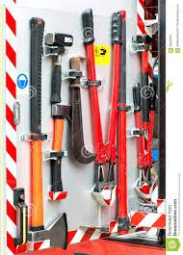

**Purpose:** Members may request the use of Granbury Volunteer Fire Department property for their own personal use.

**Special Procedures:**

The member making the request must:

1. Notify a Captain
2. State what their intended use of the equipment is
3. Know that if they break or loose the equipment, then that person is responsible for its replacement at their own cost
4. Return the equipment in a proper time
5. Return the equipment cleaned and ready for service

*Under no circumstances is the member allowed to keep the equipment for longer than the agreed return time stated upon making the initial request.*

*The officer approving the request assumes all responsibility for the return of the equipment loaned.*

| See the source image | | |
| --- | --- | --- |
| **G** | **SOG Title: Vehicle Safe Operations** | |
| **SOG Number:** | |
| **Original Date:1/25/20** | **Revision Date:** |
| **Granbury Volunteer Fire Department Standard Operating Guidelines** | | |

**Vehicle Safe Operations**

**Purpose:** To provide a guideline to emergency vehicle driver/operators, officers and all personnel involved in movement and direction of emergency vehicles.

**Procedure:**

* Granbury Volunteer Fire Department vehicles will be operated in a fashion that contributes to the safety of all persons and property.
* All vehicles, including personal vehicles will be operated in compliance with The City of Granbury and State of Texas General Statutes.
* Operators of Granbury Volunteer Fire Department vehicles will be directly responsible for the safe and sensible operation of the vehicles wider all circumstances. When the driver is under the supervision of an officer, that officer will also assume responsibility for the actions of the driver.
* Drivers will not move fire department vehicles until all personnel are seated and secured with seat belts or in approved riding positions. EMS personnel actively performing medical care in the ambulance while the vehicle is in motion will be secured by a seat belt to the extent to allow effective application of such emergency medical care.
* Under no circumstances will any personnel ride on a moving vehicle in any position other than approved riding positions.
* Code 1 responses are defined as the use of emergency lights and audible warning devices with the optional use of air horns while en-route to an emergency incident.
* Code 2 responses are defined as responding with the flow of traffic without the use of emergency lights and audible warning devices.

**Emergency Response**

* Departing the Station
  + Driver will look down both sides of the vehicle to assure that no compartment doors are open and the area is free of obstructions prior to mounting the apparatus. No compartment door will be left open and no unsecured objects will be left on the apparatus while unattended under any circumstances.
  + The driver will safely and efficiently mount the apparatus
  + All personnel on board will be secured with seat belts
  + Hearing protections will be worn if required
  + The apparatus bay door will be assured to be completely open
  + The driver will be sure of destination and know a convenient route prior to departing station.
  + Code 1 response is approved only in conjunction with emergency incidents. The use of a Code 1 response does not automatically give the right of way to emergency vehicles but is to request the right of way from other vehicle operators based on their awareness of the emergency vehicle presence. Emergency vehicle operators must make their presence and intentions known to other vehicles, and must drive defensively and be aware of the unexpected actions of others.
  + When approaching and crossing an intersection with the right of way, drivers will not exceed the posted speed limit. When it is necessary louse the center of the opposing lane to approach an intersection controlled by traffic lights or stop signs, the vehicle will come to a complete stop prior to proceeding through the intersection, including situations where your direction of travel has the green traffic light.
  + When approaching an intersection where your direction of travel has a red traffic light or stop sign, the vehicle will come to a complete stop and proceed only when the driver is assured that oncoming traffic in all lanes has yielded the right of way.
  + During emergency response, emergency vehicles will avoid passing other emergency vehicles. If passing becomes necessary, permission and confirmation must be obtained through radio communication.
  + Emergency vehicles departing the station simultaneously should travel the same route to the incident while maintaining a minimum distance of 300 feet between vehicles.
  + When it is necessary to pass other vehicles in the same direction of travel, it will be performed only to the left side of such traffic.
  + Granbury Volunteer Fire Department vehicles are authorized to exceed the posted speed limit only when responding Code 1 under favorable conditions, such as light traffic, good visibility and good road and weather conditions. The posted speed limit will not be exceeded by more than 10 mph and if unfavorable conditions are encountered, the vehicle will not exceed the posted speed limit.
  + When emergency vehicles approach a railroad crossing without gates or with the gates in the up position, the vehicle will stop and proceed when the driver is assured that no railroad traffic is approaching. When a railroad crossing is in the warning position (gates down and lights flashing), the vehicle will come to a complete stop. The vehicle may only proceed when the warning devices have returned to a non-warning position and the driver is assured that no railroad traffic is approaching.
  + When an emergency vehicle approaches a school bus with the buses warning lights in operation, the vehicle will come to a complete stop and only proceed with caution at a maximum of 5 mph when the buses warning devices are turned off.

**Non - Emergency Operation**

* All vehicles will be operated in conjunction with The City of Granbury and State of Texas General Statutes with regard to driving and Code 2 response will be utilized.

**Vehicle Backing and Motions**

* The backing up of emergency vehicles should be avoided whenever possible. When backing up is necessary, spotters will be utilized. In addition, spotters will be used when negotiating forward turns with limited side clearances and when height clearances are uncertain.
* When the driver is the only personnel on the vehicle, the driver should attempt to locate personnel for spotting the vehicle. If personnel are not available, the driver will dismount apparatus and perform a 360-degree survey of the area around the vehicle to determine if any obstructions are present. The only exception to this survey will be the ambulance at the hospital.
* When a vehicle is backing up, a minimum of two spotters will be used, including the front seat passenger if necessary. The left rear corner of the vehicle is the primary spotter position with the other spotter positioned at the right rear corner. When a single spotter is utilized, the spotter will be positioned at the left rear corner.
* Spotters will discuss the intention of the driver before proceeding. The communication or warning method will be agreed upon prior to backing. Both door windows (driver and passenger) will be open to allow for clear communication between spotters and the driver.
* The vehicle will not proceed with backing until all spotters are in position and then communicate confirmation to start backing. Spotters will remain visible to the driver at all times. If the driver loses sight of the primary spotter, the vehicle will be immediately stopped until the spotter becomes visible and confirmation to resume backing is given. Spotters will utilize the motions described in this standard for backing up vehicles.
* The driver of the vehicle is responsible for compliance with this standard and safe backing of the apparatus.
* Squads will be excluded from this section but should practice caution when backing.
* Vehicle Backing Motions:

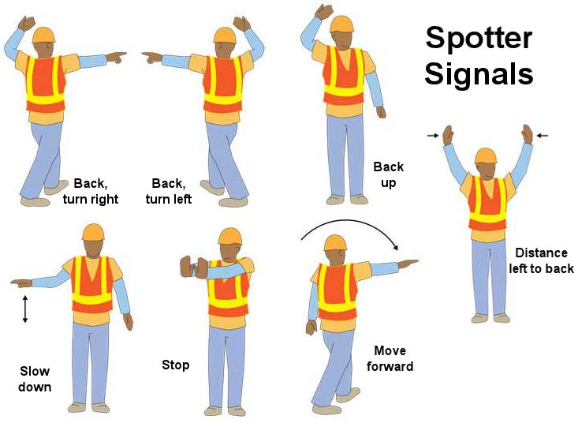

| See the source image | | |
| --- | --- | --- |
| **G** | **SOG Title: Probationary / New Members Riding on Apparatus** | |
| **SOG Number:** | |
| **Original Date: 02/23/20** | **Revision Date:** |
| **Granbury Volunteer Fire Department Standard Operating Guidelines** | | |

**Probationary / New Members Riding Apparatus**

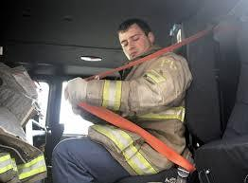

**Purpose:** All new members, probationary or guests must have approval from the Chiefs, Officers or senior member to ride apparatus in any capacity. Whether that apparatus is responding to an emergency or providing public service events. At any time, the Chiefs, Officers or senior member may refuse to allow a new member, probationary or guests onto the apparatus. It is fully up to the discretion of Chiefs, Officers or senior member.

| See the source image | | |
| --- | --- | --- |
| **G** | **SOG Title: Granbury Volunteer Fire Department Structure** | |
| **SOG Number:** | |
| **Original Date: 2/27/20** | **Revision Date:** |
| **Granbury Volunteer Fire Department Standard Operating Guidelines** | | |

**Granbury Volunteer Fire Department Structure**

**Purpose:**



| See the source image | | |
| --- | --- | --- |
| **G** | **SOG Title: Unlocking vehicles** | |
| **SOG Number:** | |
| **Original Date: 3/4/20** | **Revision Date:** |
| **Granbury Volunteer Fire Department Standard Operating Guidelines** | | |

**Unlocking Vehicles With and Without Life Safety Concerns**

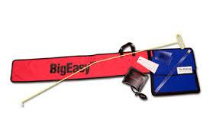

**Purpose:**

The Granbury Volunteer Fire Department can be dispatched to emergent and non emergent calls where someone has been locked out of their own personally owned vehicles. There are two conditions that will be considered for action taken:

* With Life Safety - If there is a life safety risk to a person or animal locked inside the vehicle, fire fighters may use any or all tools availible to them to make immediate access to the victim. Consideration should be given to if the vehicle is running, if it is obvious the A/C or Heat is left on and where the vehicle is parked.
* Without Life Safety – If an individual is locked, out of the vehicle and are requesting the fire fighters to open the vehicle to access their keys. Firefighters will consider:
  1. The appropriate training with the Big Easy
  2. The limitations and costs of specific vehicle makes and models (If the vehicle is an “exotic” do not make any attempt to open the vehicle)
  3. Does the glass window of the vehicle roll into the top frame of the vehicle
  4. Advise the owner of possible damage to the vehicle
  5. If possible, proof of ownership of the vehicle (insurance with their name)

| See the source image | | |
| --- | --- | --- |
| **G** | **SOG Title: Response Schedule** | |
| **SOG Number:** | |
| **Original Date: 03/12/2020** | **Revision Date:** |
| **Granbury Volunteer Fire Department General Operating Guideline** | | |

**Response Schedule**

**Purpose:** This schedule helps Granbury Volunteer Fire Department fire crews take the appropriate apparatus to emergent and non-emergent dispatched calls. Part of taking the appropriate apparatus is taking the proper amount of people on apparatus to meet the safety standards established by other SOP/SOGs adopted by Granbury Volunteer Fire Department:

Minimum of 3 persons per apparatus: E1, E3, E6, R1, R2, TW1, L1

Minimum of 2 persons per apparatus: S1, S3, C1, B1, B2, B3, B4

*(During designated wildland seasons, brush trucks will be required to have a crew of three)*

Single person apparatus use: T1, SP1

This guideline is a recommendation; there are times when senior members or officers can choose the appropriate crew size for the response to the dispatched calls.

**Response Schedule:**

City Residential Structure Fire –

1st Alarm - E1 or TW1, L1 or R2, A5

2nd Alarm - R1, R2, SP1, E3, R5

City Commercial Structure Fire –

1st Alarm - TW1, L1, SP1, A5

2nd Alarm - E1, R1, R2, E3, R5

ETJ Structure Fire

1st Alarm - T1, E6, SP1, T5

2nd Alarm - E1, R1, R2, E3, A5, R5

County Structure Fire –

1st Alarm - T1, E6, SP1, S1, S3, C1, T5

2nd Alarm - B1, B2, B3, B4, E3, A5, R5

Major Accident/Rescue

1st Alarm - R1, R2, R5

2nd Alarm - E1, TW1, L1, SP1, S1, S3, C1, E3

EMS

1st Alarm - S1, S3, C1, S5

2nd Alarm - SP1, R2, E3, R5

Wildland

1st Alarm - B1 or B3, T1 or E6, B5

2nd Alarm - B1, B2, B3, B4, T1, E6, T5

HazMat

1st Alarm - R1, R2, R5

2nd Alarm - TW1, L1, E1, E3, A5

Unknown

1st Alarm - R1, R2, SP1, A5

2nd Alarm - SP1, E1, E6, E3, R5

| See the source image | | |
| --- | --- | --- |
| **G** | **SOG Title: Water Rescue / FAST Team** | |
| **SOG Number:** | |
| **Original Date:2011** | **Revision Date:1/25/20** |
| **Granbury Volunteer Fire Department General Operating Guideline** | | |

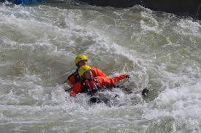

# PURPOSE: This Operational Guideline will establish standard procedures and considerations for the mitigation of all water rescue/recovery operations.

# RESPONSIBILITY

1. All Incident Commanders are responsible to comply with and ensure that personnel under their command are adequately trained, fully understand, and comply with this guideline.
2. All Rescue Personnel have the responsibility to learn and follow this guideline.

# OPERATIONAL GUIDELINE

**GENERAL SAFETY PRECAUTIONS**

1. Water Rescue Team members will exercise every safety precaution to achieve the highest degree of safety to themselves and victims that is proportionate with the hazardous situation in which they are operating.
2. Rescue priorities are:

# Self-rescue

* + - 1. **Security / Safety of fellow teammates**
      2. **Victims**
    1. The Safety Officer at all incidents involving water should be trained to recognize the additional hazards associated with water-related activities. The Incident Commander should insure the appointed Safety Officer has been trained to the Technician Level in water rescue, and is trained to the level within this Water Rescue Guideline.
  1. Personal protective equipment
     1. Personnel working 10’ or less from the water’s edge shall have donned the appropriate personal protective equipment (PPE), including personal flotation device (Type V PFD), water rescue helmet, throw bag (75’ bag), and whistle.
     2. Any boat operator entering a boat in the water shall wear at least a Type V PFD and water rescue helmet.
     3. Primary and secondary rescuers, and Water Safety Team rescuers **SHALL** wear Type V PFDs, water rescue helmets, rescuer throw bag (55’), whistle and webbing.
     4. All Fire Department members and other rescue personnel operating at the scene of the water rescue incident should wear a helmet. **Fire helmets** should not be worn close to the water.
     5. Structural firefighting turnouts and bunker style boots SHALL never be worn on the water’s edge, in the boat, or in the water. For law enforcement personnel gear belts and protective vests should be kept away from water area also.
     6. Gloves will be worn if the member is actively involved in rescue operations.
     7. Flood situations or other contaminated water environments suggest the use of wet-suits by the primary boat operator and the two primary rescuers. Dry suits should be work in extreme conditions
     8. All other protective clothing and equipment will be utilized as deemed necessary by the Incident Commander, the Rescue Officer, Rescuers, or the Safety Officer.
  2. Never tie a rope around or directly to a rescuer. All ropes tied to a rescuer will be done using a cow tail or directly to the breakaway and ONLY during a “live bait” scenario. Type V rescue PFD will be used for a “go” rescue evolution. Use only the approved steel ring attachment or Cow tail for rope attachment.
  3. No swift water rescue personnel will perform tasks that are beyond his/her level of expertise.
  4. It is expressly forbidden that any swift water rescue personnel enter the water during a swift water rescue operation, without at least a boat, a boat operator, and one other backup swift water rescuer present.

3.6.1 Any personnel that does not feel completely confident in the tasks he/she is asked to perform should notify the team lead or Officer in charge, and refrain from doing the tasks assigned. The rescuer has the final “Go or NoGo” decision.

# TACTICAL CONSIDERATIONS

* 1. Arrive on scene. Take command. Size-up the situation.
  2. Secure responsible party or witness**.**
     1. Command should secure a witness as soon as possible after arriving on scene. This will help in identifying and locating the problem.

# Initiate victim location

* + 1. The first arriving unit will become the Primary Search Team and its officer designated as Search Sector. They will begin to locate and account for all victims. This search team is also known as a *Hasty Team* and will conduct a search of each bank, checking in and around trees and debris piles for victims.
    2. Upon locating victim(s), Command will be notified, and the information used to determine whether rescue or recovery operations should be initiated.
    3. Upon arrival of the boat and other units, the Primary Search Team will continue their search. If conditions are such that a victim may be washed downstream faster than the Search Team can travel, additional Search Teams will be assigned well downstream, to a location where resources can be staged before the arrival of the victim.
       1. Water flow rate, velocity, obstacles, and access will be considered when assigning a downstream Search Team.
    4. A Secondary Search Team may be assigned as quickly as conditions allow, moving on both sides of the stream from the last known location toward the downstream Search Team(s).
    5. The Search Sector will be terminated when all victims are accounted for, or on the orders of the Incident Commander.

# Assess the need for additional resources.

4.5.1 **Command** should immediately begin assessing the need for additional resources. If additional resources are necessary, Command should put in an early call for them. If later, it is determined that they are not necessary, Command can put those units back in service.

# Assess the hazards.

**Command** should do an immediate assessment of the present hazards. Command shall assign the safety officer.

* + 1. The **Safety Officer** will be responsible for identifying the hazards present and to have them secured if possible. If it is not possible to secure hazards, the **Safety Officer** will notify all personnel of the hazards and notify Command so that an action plan can be established.
       1. Some hazards associated with water rescue operations would be: volume, velocity, and temperature of water, floating debris, unusual drop-offs, hydraulic effects, and depth of water.

# Select a strategy of "rescue" or “recovery".

Based on the conditions present and the hazards to rescuers, Command will have to make the decision to operate in the rescue or recovery mode.

* + 1. If Command determines that the operation will be run in the rescue mode, rescue should begin as soon as possible, and Command should assign an individual as **Rescue Sector.**

# Develop and implement an action plan.

Command should establish an action plan as soon as possible. The step-by-step plan should be communicated to all personnel involved in the rescue.

# PRE-RESCUE OPERATIONS

* 1. Make the general area safe.
     1. Command or his/her designee should begin to make the general area safe including securing the area and not allowing civilian personnel into the water.
     2. In swift-water rescue incidents, Command should assign an **upstream spotter** to spot floating debris or objects that may affect the rescue, and notify **Command** or the **Rescue Sector** as these objects approach the incident.

Command may also want to assign a helicopter the task of aerial recon for spotting hazards.

# Make the rescue area safe.

* + 1. Command should secure the immediate rescue area. He/she shall utilize an accountability system to account for all personnel working within the rescue area.
    2. The hazards in the rescue area should be secured within means. **Command**

or the **Safety Sector** shall notify all rescuers with the possible hazards they may encounter.

# Pre-Rescue/Recovery.

* + 1. Depending on the action plan established, Command **SHALL** establish a **Rescue Sector**. The Rescue Sector will be responsible for gathering all equipment and personnel necessary to operate according to the action plan.
    2. The Rescue Sector will assign personnel to conduct and support the rescue operation as the incident enters the rescue phase.
    3. Rescue operations will not begin without a Water Safety Team in place. The Water Safety Team, at a minimum, shall be equipped with PFDs, helmets, throw bags, gloves, boots, wetsuits, and personnel safety devices.
       1. The Water Safety Team will be provided (if applicable) with a boat and operator that is dedicated to the Water Safety Team.
       2. Before rescue operations begin, the Water Safety Team and boat will be launched downstream of the rescue operation. The boat will have the motor idling and be in a ready position to effect rescue.
       3. The Water Safety Team will consist of a minimum of three personnel, including the Water Safety Team boat operator, with a minimum of (1) rescue technician.
       4. A rescue technician or designee will be designated as the Water Safety Team Officer.
    4. Rescues involving boat operations should be done with two boats and crews assigned to the rescue, one as primary boat and one as secondary boat.
    5. A Boat crew will consist of three personnel: an operator and two (2) rescuers. Whenever possible, the three personnel should be technician level rescuers.
    6. Command should assign **downstream personnel**, with throw bags, and additional intervention devices as needed prior to commencing any rescue operation.
    7. Personnel should be assigned to both sides of the riverbank for incidents involving swift-water rescue if possible.
    8. The **Rescue Sector** should develop an alternative action plan that can be communicated to all personnel operating in the rescue area should the initial action plan become compromised.

# 6.0 RESCUE OPERATIONS

6.1 After pre-rescue operations are complete, the **Rescue Sector** shall put forth the action plan for the removal of the victim(s). Rescues should be conducted with the least amount of risk to the rescuer necessary to rescue the victim(s). Low risk operations are not always possible. If the rescue must occur by means of a high-risk operation, the **Rescue Sector** shall communicate with **Command** the risk/benefit of the operation.

# The order of water rescue from low risk to high risk will be:

* + 1. **TALK:** the victim into self-rescue. If possible, the victim can be talked into swimming to shore or assisting the rescuers with his/her own rescue. If a victim is stranded in the middle of a flash flood, this will not be prudent.
    2. **REACH:** If possible, the rescuer should extend his/her hand or some other object such as a pike pole, inflated hose, or ladder to remove the victim from the water.
    3. **THROW:** If the victim is too far out in the water to reach, rescuer(s) should attempt to throw the victim a throw bag or some piece of positive flotation (i.e., PFD, rescue ring). If the victim can grab the throw bag, the rescuer can pendulum belay or haul the victim to the nearest bank. Care should be taken to assure the victim will be belayed to a safe downstream position.
       1. Downstream personnel should be in position during the actual rescue operation.
       2. First responders that have had operational level, water rescue training should be able to conduct the above rescues without the help of the Technician level rescuers. If the victim cannot be reached by either of these methods, Command should consider stopping the operation until Technician level units arrive. After the boat and technician level rescuers arrive, Command should discuss with them the action plan. Command should consider assigning the **Rescue Sector** to a company officer or Technician level rescuer.
    4. **ROW:** If it is determined that a boat based operation shall be run, Command should assign a company on the opposite bank to assist **Rescue Sector** in establishing an anchor for a rope system. The company on the opposite bank will be made aware of the action plan.
       1. **Rescue Sector** will be responsible for seeing that the rope system used for the boat based operation is built safe and proper. A minimum of 2- point tether should be built for swift-water operations.
       2. **Rescue Sector** should consider personal protective equipment (PPE) for victim(s).
    5. **GO:** If it is not possible to ROW (boat base operation) to the victim, **Rescue Sector** should consider putting a rescuer in the water to reach the victim. This is a very high-risk operation. Only rescuers with the proper training and equipment should be allowed to enter the water. Prior to the rescuer actually proceeding into the water, he/she shall discuss the action plan, including specific tasks and objectives, hazards and alternate plans.
       1. The rescuer shall never be attached to a lifeline without the benefit of a quick-release mechanism.
       2. The rescuer should take PPE of at least a PFD to the victim. Members **SHALL** not do a breath-hold surface dive to locate a victim beneath the surface of the water.
    6. **HELO:** At times the use of a helicopter is the most reasonable method of reaching the victim. Helicopter operations over water are high-risk operations. Command should consult with **Rescue Sector** and the pilot to determine the risk/benefit of the use of a helicopter. If the pilot says he/she can do the operation, Command should consider it.
       1. **Rescue Sector** should assign rescuers to the helicopter and discuss with the pilot and the rescuers the specific action plan.
       2. **Rescue Sector**, or his/her designee should address the weight and balance considerations. Command will have the final say on the use of a helicopter for water rescue operations. The pilot will have the final say on how the helicopter will be used.

# Property Recovery Operations

Members should not become part of a towing operation to remove vehicles from the water. One agency should stand by for *rescue* if a tow truck driver insists on retrieving the vehicle.

# Additional Considerations:

* + - 1. HEAT. Consider hydration issues and rotation of crews.
      2. COLD. Consider the effects of hypothermia on victim and rescuers.
      3. RAIN/SNOW. Consider the effects of rain or snow on the hazard profile.
      4. TIME OF DAY. Is there sufficient lighting for operations extending into the night?
      5. Consider the effect on family and friends; keep family informed.
      6. Consider news media; assign a P.I.O., Public Information Officer

# ASSESSING THE VICTIM

* + 1. Once the rescuer(s) have reached the victim, they should do an immediate assessment of the victim, a quick assessment of the ABC's, and the exact method of entrapment.
    2. If the victim is conscious, the rescuer should determine if the victim can assist in his/her own rescue.
    3. If the victim is unconscious, the rescue must be quick. If it has been determined to be an underwater or recovery operation, **Rescue Sector** should proceed with a dive operation by contacting dive team at DCBE Fire Department or Sheriff DEPT.
    4. If the victim can assist in his/her own rescue, the rescuers should proceed with the rescue action plan. The victim should be brought to shore as soon as possible.

# TREATMENT

* 1. As soon as the victim is brought to safety, an assessment should be done by ALS personnel. Treatment shall be administered as per local protocol.
  2. If necessary, the victim shall be transported to the appropriate facility.

# TERMINATION OF THE INCIDENT

Command should begin termination as soon as possible after the victim has been removed from the water. This shall include securing all the equipment used for the rescue and personnel accountability. This may also include witnesses, photo's, victim's personal effects, or equipment used in the rescue.

* + 1. Command should consider activating the Critical Incident Stress Debriefing for extraordinary or extended operations.

# Prepare for Termination

* + 1. Personnel accountability.
    2. Equipment accountability.

9.1.5 If there has been a fatality, **Rescue Sector** may consider leaving equipment in place for investigative purposes.

* + 1. On-scene cleaning and decontamination operation.
    2. Re-stock vehicles.
    3. On-scene debriefing (hot wash).
    4. Secure the scene.
    5. Return to service.

# EMERGENCY and MAYDAY SITUATIONS

* + 1. Upon a member falling into the water by accident, or if a member is in need of assistance, they will signal audibly, and then activate their strobe light.
    2. If the member is equipped with a radio, they will transmit a mayday.
    3. After the radio transmission, the member needing assistance will deliver repeatedly a series of three short blasts on his / her whistle signifying that they are in need of assistance or having an emergency.
    4. The member needing assistance will activate the strobe light attached to his / her PFD for a visual indicator of who is in need of assistance.
    5. Upon receipt of a Mayday radio transmission, or upon hearing the whistle signal, the IC will activate the Water Safety Team.
    6. The Water Safety Team Officer will communicate with the IC and take appropriate actions
    7. All personnel on the scene will switch operations to a different channel, leaving the member needing assistance, the Water Safety Team, and the IC on the original operations channel.
    8. If the Water Safety Team is activated, the IC must replace them with another standby Water Safety Team, or cease all other operations until the Mayday is mitigated, and the Water Safety Team is restaged.
    9. The evacuation signal for the rescue site will follow existing FD procedures for evacuating structures at structure fires. Signaling should be done over radios, with whistles, and with vehicle sirens.

# Communication

* + 1. Radio communication is the preferred method of communication.
    2. Whistle signals are as followed:

1 whistle blast = stop and/or look 2 whistle blasts = look upstream

3 whistle blasts = look downstream

3, 3, 3 whistle blasts = Emergency/Mayday

* + 1. Hand Signals will be utilized for situations where audible radio or voice operations cannot be used.
    2. All hand signals that will be used are located in appendix A.

# TRAINING

* + 1. All Training levels should be compliant with NFPA 1670 and NFPA 1006 standards
    2. All personal **SHALL** have a current FAST certificate of training.
    3. Awareness
    4. First Responder
    5. Operations
    6. Technician

# Appendix A

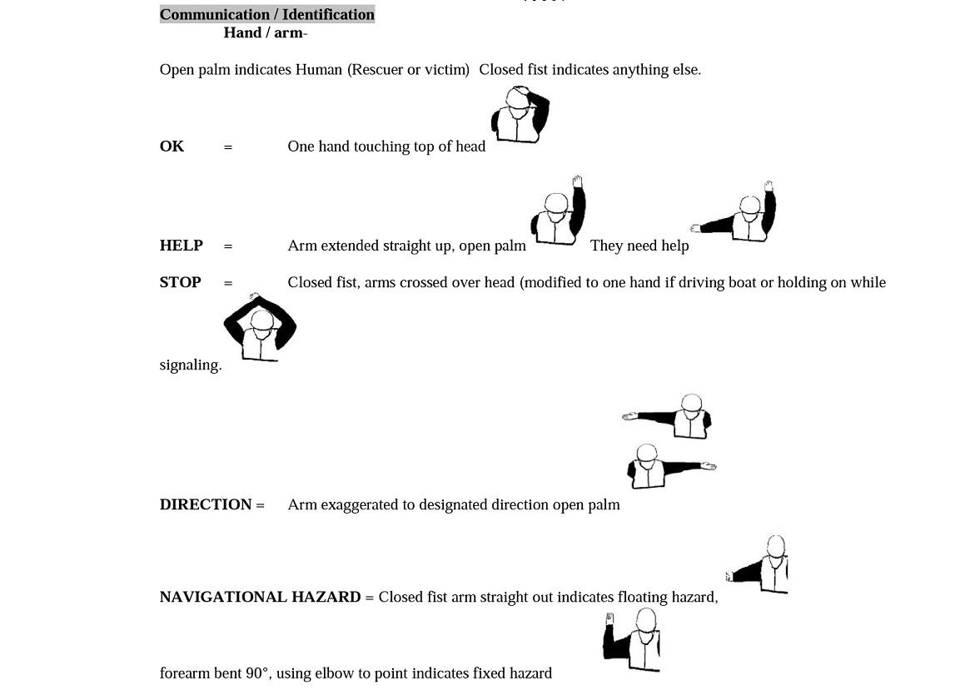

**Appendix B**

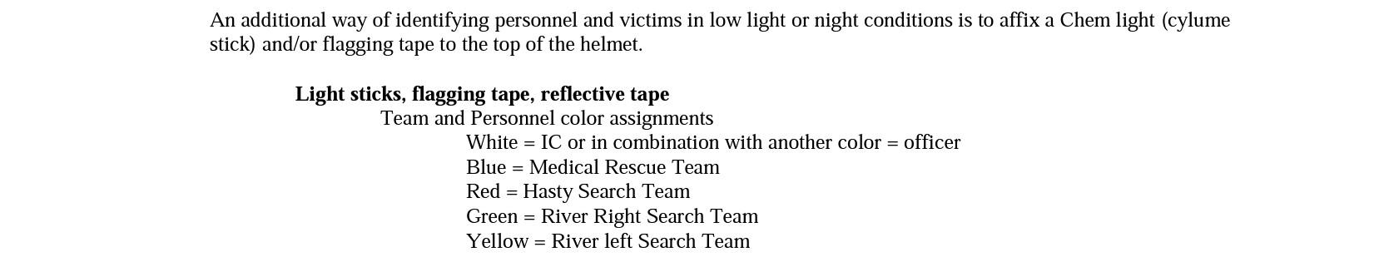

| See the source image | | |
| --- | --- | --- |
| **G** | **SOG Title: Driver Qualifications** | |
| **SOG Number:** | |
| **Original Date:03/18/2020** | **Revision Date:** |
| **Granbury Volunteer Fire Department General Operating Guideline** | | |

**Driving - Emergency Apparatus Driver Selection**

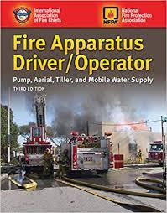

**Purpose:**

To provide for the effective and efficient selection of drivers for Granbury Volunteer Fire Department emergency vehicles.

**Procedure:**

Emergency vehicles are one of the most important assets that Granbury Volunteer Fire Department has. The safe operation of these vehicles, particularly during emergency response, depends greatly on the ability and skills of the driver.

With so much depending on the driver’s abilities, Granbury Volunteer Fire Department will select and utilize only the best drivers. Selecting, training and maintaining good, safe drivers should not be left to chance. Granbury Volunteer Fire Department can minimize negative attributes and maximize all of the good attributes of a driver by utilizing the following operations and methods.

**Motor Vehicle Reports (MVRs)**

Knowing your drivers on and off duty driving habits and record, is an important tool in both selecting and maintaining the safest drivers for your emergency vehicles. Routine administrative reviews of all drivers MVRs is the most effective way to know the specific driving habits of individual drivers. It is recommended that all MVRs should be reviewed annually and that a copy be retained in each members personnel file.

If the department chooses to conduct the MVRs on less than an annual basis, then interim activities should be completed. Some of these activities would require each driver to produce a valid driver’s license and financial responsibility card (proof of insurance) and retain a photocopy in the members file. Equally as important is how these MVRs are evaluated. An evaluation criteria should be included as part of the evaluation process and should be used so that everyone’s records are evaluated equally.

Department of Motor Vehicles Transcript Evaluation Requirements

**Class A Violation**

An individual who has a Class A violation within the past three (3) years normally receives a license suspension from the Department of Motor Vehicles, which issued the license. This guideline calls for suspension of driving privileges for anyone convicted of a Class A violation for a period of eighteen (18) months. Additionally, any of these individuals would be required to attend an approved driver-improvement program, or equivalent training, and be re-qualified to operate emergency vehicles.

**Class B Violation**

Any individual who has a combination of two (2) Class B moving violation convictions and/or chargeable accidents in a three (3) year period will be issued a warning letter from the chief officer or administrative officer of the Granbury Volunteer Fire Department.

The Chiefs or Captains of Granbury Volunteer Fire Department will issue any individual who has a combination of three (3) moving violation convictions and/or chargeable accidents in a three (3) year period a suspension of driving department vehicles for a period of ninety (90) days.

Any individual who has more than three (3) moving violation convictions or three (3) chargeable accidents or any combination of more than three (3) of the formerly stated violations in a three (3) year period will be issued a suspension of driving department vehicles for a period of at least one (1) year. In addition, the same individual would be required to complete an approved driver improvement program and be re-qualified to operate emergency vehicles.

**Note**: Unusual circumstances with individual cases would be evaluated on a case-by-case basis.

Violation Types

**Violations**

Designation of Type A and Type B violations are based on a survey of state point systems. Violations receiving higher numbers of points are classed as Type A.

**Type A Violations**

* Driving while intoxicated.
* Driving under the influence of drugs.
* Negligent homicide arising out of the use of a motor vehicle (gross negligence).
* Operating during a period of suspension or revocation.
* Using a motor vehicle for the commission of a felony.
* Aggravated assault with a motor vehicle.
* Operating a motor vehicle without owner’s authority.
* Permitting an unlicensed person to drive.
* Reckless driving.
* Hit and run driving.

**Type B Violations**

All moving violations not listed as Type A violations. (Exceeding posted speed limit is a Type B violation).

**Note**: Unusual circumstances with individual cases would be evaluated on a one-to-one basis.

**Requirements for Drivers to Be Considered as an Operator:**

1. Active Member
   1. By Chief, Officer or Senior Member request, a probationary member may be asked to respond, non-emergent, to any scene for support of that member or apparatus.
2. EVOC Completed and passed. (Emergency Vehicle Operator Course)
3. Has demonstrated in training and/or one on one sessions that the training member verifies the applicant is comfortable with the operation of the apparatus and know where tools and equipment are located.
4. Pump Ops Class completed and passed. For apparatus that also carry water and have a fire pump. A Pump Ops class must have been taken before consideration of being signed off to operate the apparatus.
5. For any apparatus, over 26,001 pounds, a Class B driving license, issued by the State of Texas, must have been taken and passed, proof of the license given to a Chief or Officer. A copy will be made and put into the individual’s personal file.
6. If an active member at any times they feel they are prepared and trained enough to operate an apparatus they can make the request to any of the Chiefs or Officers.

| See the source image | | |
| --- | --- | --- |
| **G** | **SOG Title: Vehicle Extrication** | |
| **SOG Number:** | |
| **Original Date:03/20/2020** | **Revision Date:** |
| **Granbury Volunteer Fire Department General Operating Guideline** | | |

**PURPOSE:** Vehicle extrications require good judgment, proper training, and creativity. A plan should be used to accomplish tasks safely, rapidly, and efficiently while making the actions of the members predictable and coordinated.

**PROCEDURE:** It shall be the responsibility of the Incident Commander with input from operational and medical personnel, and other resources to determine what extrication tactics are to be performed at an incident. Training, expertise, scene hazards, patient condition, resources, and extenuating circumstances shall influence the methods and pace of each incident.

1. En route, consider location, mechanism and traffic hazards

A. Request additional units for “blocking,” and/or specialty equipment as indicated (e.g. ladder companies)

2. At scene, position apparatus to block traffic beginning with highest risk to lowest risk. At least one lane wider than the incident.

**TERMINOLOGY:**

Standardized terminology shall be used at all extrication scenes. A complete list can be found in the Vehicle Extrication Book. The following terms shall be used during incident operations, and are a subset of the larger set:

A. Action Circle/Hot Zone: The area at an extrication scene where the maximum danger exists. This is the area where the extrication is taking place and quite often contains many other hazards. Personal Protective Equipment (PPE) and extreme caution must be used in this area.

B. AFV: Alternative Fuel Vehicle. A vehicle using other means of stored energy instead of, or in addition to gasoline, E-95 ethanol, or diesel fuel.

C. BEV: Battery Electric Vehicle. A vehicle using stored electricity as its only fuel.

D. CNG: Compressed Natural Gas-powered vehicle. A vehicle using compressed natural gas as a fuel for combustion in an internal combustion engine.

E. Cold Zone: The safe area outside the warm zone. Command, support functions, and staging would be in this area.

F. Extrication: A term used to describe the procedures used by rescue personnel to remove patients trapped by wreckage or by their injuries from vehicles involved in collisions or crashes.

G. FCEV: Fuel Cell Electric Vehicle. A vehicle using stored, compressed hydrogen gas to generate electricity for vehicle propulsion.

H. Freeze: A recognized term used to signal an unsafe situation that immediately stops all extrication activities until the dangerous situation has been mitigated.

I. HEV: Hybrid Electric Vehicle. A vehicle containing both a stored-electricity electrical drive system, as well as an internal combustion engine, both of which can be used for propulsion, either independently or together.

J. NGV: Natural Gas Vehicle. Same as a Compressed Natural Gas (CNG) vehicle.

K. PEPS Key: Short for Passive Entry Passive Start. A key fob used in vehicles with push-button start. To disable the ignition system in vehicles with PEPS keys, the fob must be removed at least 16 feet from the vehicle.

L. PHEV: Plug-in Hybrid Electric Vehicle. A type of HEV that can be plugged into 120/240 volt AC shorelines to charge the onboard propulsion battery. PHEVs usually have extended all-electric-drive range compared to HEVs.

M. Warm Zone: The transition area between the Hot Zone and the Cold Zone that acts as a buffer area. Caution must be exercised in this area as well. This zone is used for the tool staging, parts dump area, and is the zone in which one would find the safety officer.

**PROCEDURE**: Vehicle extrications shall follow basic procedures outlined in this section. Due to the uniqueness of these types of incidents involving vehicle extrication, detailed step-by-step procedures will not be implemented. Listed below are procedures to be followed by companies upon arrival at a vehicle extrication incident:

**Establish command when three or more units are en-route or incident is complex**

A. Direct incoming units approach and parking positions

B. Assign an Extrication Group Leader per vehicle with active “Mechanical” Extrication

C. Level 1 stage transport units until needed

D. Consider additional outside resources (eg. Heavy Wrecker)

**Complete size up and initiate scene control measures**

A. Outer circle – survey entire scene for hazards (traffic, electrical utilities, etc.), patients, witnesses

i. Consider thermal imaging

ii. Consider early, scene lighting and traffic alerting

B. Inner circle – DO NOT TOUCH VEHICLES PRIOR TO 360, assess immediate scene safety, consider:

i. Immediate control measures e.g.: wheel chocks, step chocks, extinguishers, etc. ii. Vehicles running and/or in gear, fire, smoke, gas, diesel, leaking fluids

iii. Number/condition of patients (patient condition determines urgency)

iv. Supplemental restraint systems (SRS), Hybrid/Electrical vehicle

C. Determine if Mechanical Extrication is needed – see appropriate questions

D. When “mechanical extrication” is called for – consider suppression needs (hose line, etc.) Start a 10-minute timer through dispatch

E. Declare extrication plans - Coordinate stabilization with extrication plan

i. Plan A, Plan B and Rapid plans shall be announced

ii. Capture the passenger compartment with 4-6 points of stabilization, consider:

1. Basic - step chocks, cribbing, First Responder Jacks, straps, chains 2. Advanced – struts, straps and air bags

F. Get Medic/EMT inside to perform functions of & become “Interior Stabilizer” and Pt. care (windowsdown, seat back, etc.)

G. R/D is assigned to Interior Stabilizer performing exterior functions (eg. communications, assist manually from outside) if manpower permits

H. Perform at least 2 plans simultaneously

1. Scan for airbags, strip trim and other coverings to determine location of pneumatic lifting pistons, pre-tensioners, airbags, and inflators.

I. Hazard Control

i. Traffic

ii. Fuel/fluid leaks

iii. Crowd control

iv. Hazardous materials

v. Electrical infrastructure

vi. Check contents of trunk vii. Battery/electrical system shutdown

J. Access Patient

i. Try opening doors before cutting

ii. Roll down windows

iii. Move seat(s) back

iv. Tilt/telescope steering column out of the way

v. Perform glass management

K. Assess Patient

i. Protect patient from breaking/flying glass

ii. Remove all non-laminated tempered glass before cutting

iii. Remove windshield independently, or with roof (use discretion) if performing a roof removal

iv. All breaking of glass shall be done in a controlled manner, with a spring loaded center punch, if possible, with glass pieces removed away from the patient.

L. Disentangle

M. Extricate

N. FIREFIGHTER AND PATIENT PROTECTION PPE shall be worn while working in the Hot Zone or in close proximity to extrication activities. At minimum, PPE at an extrication incident shall consist of:

A. Turnout gear (coat and pants)

B. Safety glasses

C. Helmet

D. Extrication or structural firefighting gloves

E. Protective boots

F. Reflective vest (if operating in/near a roadway or parking lot)

Precautions shall also be taken to protect the trapped or injured persons from further harm during the extrication. The use of blankets, short boards, and other devices should be utilized whenever possible.

| See the source image | | |
| --- | --- | --- |
| **G** | **SOG Title: Awards, Commendations and Nominations** | |
| **SOG Number:** | |
| **Original Date: 11/4/20** | **Revision Date:** |
| **Granbury Volunteer Fire Department General Operating Guideline** | | |

**Practice for Awards, Commendations and Nominations of Awards**

Purpose: To provide a means whereby deserving fire department members, employees, and members of the public will receive official departmental and public recognition for outstanding acts of valor or meritorious service to the community and the department.

Commendation Committee

A. The Fire Chief, Assistant Chief, and 1 appointed Station 1, 2 and 3 captain shall comprise the committee. The captains shall be appointed by the fire chief to the committee.

B. The Committee will serve a one (1) year term beginning 1 January, and ending the last day of December the same year.

C. The chairman of the committee shall be the elected fire chief.

Nomination Procedure

A. Any Fire Department member may submit a nomination for an award to the Chairman of the Commendation Committee.

B. The nomination and all related material shall be submitted promptly after accomplishment. It is recommended that nominations be submitted within 30 days following the act on which it is based, but no later than January 1 following the year in which it occurred.

C. All nominations must be appropriately justified and sufficiently detailed to allow proper evaluation and decision.

D. Each nomination must be submitted on a GVFD Awards Nomination Form.

E. All nominations shall include the following, if applicable:

1.Statement of at least one (1)eyewitness 2.Date/Time of the Incident 3.Names of all persons present 4.Any injury to person being nominated, if applicable 5.Narrative account of the incident

Awards and Selection Procedure

A. The Commendation Committee shall review recommendations for specific commendations and awards, as noted herein. Those commendations and awards that are otherwise selected are noted.

B. Each accomplishment shall be considered and voted on separately, even those involving a joint endeavor. The committee may call witnesses and request records regarding the matter considered.

C. If award is approved by committee, a document recording the award shall be placed in the member’s personnel file, and the corresponding medal(s), commendation ribbon(s) and/or certificate shall be presented in a timely manner at either a formal or informal gathering of the Department.

D. The Committee, at its discretion, can recommend and approve the presentation of a different award it feels is more appropriate for the act.

E. Awards not needing committee action or vote and awarded by completion of training/certification will be Special Operations/Tech Rescue, Years of Service Awards, EMS certification awards, FF1, FF2 and FF3 certification awards, Fire Officer 1,2,3,4, Fire Instructor.

Approved certification for EMS ribbon will be passage of National Registry and issuance of a Texas DHS state license. 4 levels of ribbons exist for EMS: EMR, EMT-B,AEMT, EMT-P. Approved either certification for Fire Officer 1,2,3,4 and Fire Instructor ribbon issuance will be through SFFMA or TCFP certification. FF1 and FF2 ribbon will be issued upon completion of and passage of testing and skills for SFFMA FF1 and FF2. FF3 ribbon will be issued upon completion of and passage of testing and skills for a TCFP Basic Suppression certificate.

Appeal Procedure

A. The Commendation Committee will, upon receiving correspondence from personnel recommending a commendation, grant one (1) appeal hearing of the decision of the Committee.

B. All appeals must be filed within five calendar days of the notification of the Commendation Committee’s final decision.

C. The Chief will appoint an Appellate Committee comprised of Station1, 2, 3 LTs and 2 senior firefighters.

D. The Appellate Committee may grant appeal hearings on late filed appeals ONLY when it is shown that the request to appeal was delayed due to newly found evidence or to correct an injustice.

E. The writer of the appeal, or a designee familiar with the nomination, should appear in person before the Committee to discuss the reasons for the appeal. A written appeal may be accepted; however, it limits the Committee’s discussion to what is presented in writing.

F. The finding of the appeal, along with the original nomination, will be forwarded to the Chief, along with a recommendation for consideration, to reach a final decision within 5 calendar days.

216.06 Types of Commendations

The following commendations may be awarded for significant accomplishment:

1. **Medal of Honor :**

The Department’s Highest Award-Awarded posthumously to a member of the Department who, in the line of duty, makes the ultimate sacrifice by giving his or her life serving the community. Award is presented to family member of deceased.

Award: Medal

Commendation ribbon (Blue/White/Honor)

Framed Certificate

Awarded to: Any member of the Department

Presented by: Fire Chief or Mayor

1. **Medal of Valor**

Awarded for an act of heroism, bravery or courage involving personal risk or imminent personal danger to life; or saving or attempting to save the life of another with knowledge of the danger inherent to the act; beyond that which is expected in the line of duty.

Award:

Medal

Commendation ribbon (Red/White/Valor)

Engraved plaque

Awarded to:Any member of the Department

Presented by:Fire Chief or mayor

1. **Life Saving Commendation**

Awarded to departmental personnel who used excellent judgment and went above and beyond what is expected of him/her, which resulted in the saving of a human life.

Award:

Commendation Ribbon (Red/Blue Life Saving)

Engraved plaque

Awarded to: Any member of the Department

Presented by: Fire Chef or Mayor

1. **Purple Heart**

Awarded to any member of the department for a wound received in the line of duty while observing all reasonable safety procedures, that required transportation to a medical facility and subsequent treatment for lacerations, fractures, concussions, burns or other substantial injury

Award:

Display Medal

Commendation Ribbon (white with purple heart)

Awarded to: Any member of the Department

Presented by: Fire Chief and Assistant Chief

**Honorable Service Discharge**

Awarded to any member who successfully completes 15 years or more of honorable service to the GVFD and retires as a lifetime member under good standing.

Award:

Display Medal (custom designed)

Commendation Ribbon (custom designed)

Engraved Plaque

Awarded to: Any member of the Department with 15 years of Service

Presented by: Fire Chief and Assistant Chief

1. **Distinguished Service**

Awarded for a highly creditable accomplishment, display of perseverance or an independent humanitarian action taken by personnel outside of the responsibilities of the Department, thereby actively promoting the welfare of the department and the community, or bringing public acclaim to the GVFD

Award:

Medal

Commendation ribbon (red/white/blue/white/red)

Engraved plaque

Awarded to:Any member of the Department

Presented by:Fire Chief

1. **Commendable Service**

Awarded for a highly creditable accomplishment in the line of duty which is commendable in nature, and displays admirable initiative and accomplishment

Award:

Medal

Commendation ribbon (white/blue/red/blue/white))

Engraved plaque

Awarded to:Any member of the Department

Presented by:Fire Chief

1. **Firefighter of the Year**

Awarded annually by majority vote of the membership to the member who sets an example of performance, in a firefighting capacity, above and beyond that of his peers.

Award:

Display Medal

Commendation ribbon (red/white/red)

Department gift

Awarded to:GVFD active personnel

Presented by:Fire Chief

1. **Member of the Year**

Awarded annually by a majority vote of the Awards Committee to the member who sets an example of performance, in an administrative capacity, above and beyond that of his or her peers. The Committee shall consider community hours, station volunteer hours, training hours ,but not as the sole source of award determination.

Award:

Commendation ribbon (white with red vertical stripes)

Department gift

Awarded to: GVFD active Personnel

Presented by:Fire Chief

1. **Chief’s Award**

Selected and awarded annually by the GVFD Chief and Assistant Chief to the member who best exemplifies the selflessness and dedication necessary to serve the company in an operational capacity.

Award:

Commendation Ribbon (red with white vertical stripes)

Department gift

Awarded to:GVFD active or support personnel

Presented by: Fire Chief

1. **Firefighter Responder of the Year**

The Firefighter Response Commendation is awarded annually to the member(s) who responded to the highest number of calls during the calendar year.

Award:

Commendation Ribbon (white with red vertical strips and red diamond)

Awarded to: GVFD active Personnel

Presented by: Fire Chief & Asst.Chief

1. **Special Incident Citation**

Awarded to personnel operating on, or supporting, an emergency incident that required above-average teamwork, perseverance, or involved an act of exemplary performance beyond that of a normal incident. Back dated incidents to be 2013 Hood County Tornado and 2017 Hurricane Harvey response

Award:

Commendation Ribbon (custom designed)

Awarded to: All GVFD personnel operating on/supporting a noted incident as determined by fire chief

Presented by: Fire Chief

1. **Resuscitation Award**

Awarded to personnel participating in the successful resuscitation of a patient from a confirmed cardiac arrest by an EMS provider. The successful resuscitation is defined as a patient who is discharged from the hospital. Participation must exist of actual hands on assistance. Scene security or assisting EMS in driving patient to medical facility does not warrant assistance.

Award:

Commendation Ribbon (White with red heart)

Awarded to: All GVFD personnel operating on/supporting a noted incident

Presented by: Fire Chief & CPR Survivor (if available)

1. **Special Operations Units Badges & Ribbons**

**Vessel Operator Badge** (Blue/White with anchor/Blue)

Awarded by Rescue Unit Officer in Charge to personnel upon completion of Vessel Operator training (blue/white with anchor/blue).

**Water Rescue Unit**

Awarded by Rescue Unit Officer in Charge to personnel upon completion of FAST 2 Flood and Swiftwater technician training (red/blue tech rescue).

**Rope Rescue/Confined Space Technician**

Awarded by Rescue Unit Officer in Charge to personnel upon completion of Rope Rescue technician or Confined Space Technician certification (red/blue tech rescue).

1. **EMS Ribbons (See Awards and Selection Procedure Section E)**

EMR/ECA

EMT-B

AEMT

EMT-P

1. **Fire Officer/Fire Instructor/FF1/FF2/FF3 (See Awards and Selection Procedure Section E)**

Fire Officer 1

Fire Officer 2

Fire Officer 3

Fire Officer 4

Fire Instructor

Firefighter 1

Firefighter 2

Fire Fighter 3

1. **Firefighter Responder of the Year**

The Firefighter Response Commendation is awarded annually to the member(s) who responded to the highest number of calls during the calendar year.

Award:

Commendation Ribbon (white with red vertical strips and red diamond)

Awarded to: GVFD active Personnel

Presented by: Fire Chief & Asst.Chief

1. **Years of Service Awards**

The following commendation ribbons/certifications shall be given for Years of Active Service to the Department. For GVFD Personnel, this is noted as Active Years.

5 Years red ribbon with 1 maltese cross

10 Years red ribbon with 2 maltese cross

15 Years red ribbon with 3 maltese cross

20 Years red ribbon with 4 maltese cross

25 Years red ribbon with 5 maltese ross

30 Years red ribbon with 6 maltese cross

35 Years red ribbon with 7 maltese cross

40 Years maltese cross and scramble

Awarded to: Any member of the GVFD with verified and noted service

Presented by: Fire Chief

1. **Citizen Service Certificate**

Awarded when a civilian assists in an emergency situation or provides services, which may be deemed beneficial to the GVFD

Award:

Framed Certificate

Awarded to: Selected civilians

Presented by:Fire Chief

1. **Appreciation Certificate**

Awarded to a citizen for an act that material contributes to the GVFD

Award: Framed Certificate

Awarded to: Selected civilians

Presented by: Fire Chief

**Appurtenance:**

In cases where personnel receive multiple commendations of the same type, a numeral shall be displayed on the commendation ribbon to indicate each award after the initial. Duplicate commendation ribbons shall not be displayed on the uniform. The exception to the numbering of additional awards is the Resuscitation Award. After the initial award, these commendations will not receive numbered ribbons. Members will continue to receive a certificate for each additional time this commendation is awarded.

Proper Display of Ribbons & Badges

A. Commendation ribbons shall be displayed only on Class A/B, GVFD Uniforms.

B. No other ribbons shall be displayed upon GVFD uniforms unless specifically approved by the Commendation Committee

C. Ribbons & Medals: For Commendations where both ribbons and medals are awarded only the ribbon shall be displayed on the uniform.

D. Ribbons will be worn on the right breast (left side when facing the uniform) and arranged starting at the top left (closest to the arm seam), moving right across the top row towards the lapel, then down to second and subsequent rows, in the following order of importance:

1.Medal of Honor

2.Medal of Valor

3.Life Saving Commendation

4.Purple Heart

5.Honorable Service Discharge

6.Distinguished Service

7.Commendable Service

8.Firefighter of the Year

9.Member of Year

10.Chief’s Award

11.Firefighter Responder of the Year

12.Special Incident Citation

12.Resuscitation Award

14.Special Operations Unit Ribbon

15. EMS ribbon, FF1,FF2 and FF3 ribbon, Fire Officer 1,2,3,4 ribbons, Fire Instructor ribbon.

16.Years of Service Award

GVFD SOG Awards and Commendations Section

Ribbons shall be worn in rows of no more than three (3) wide, with partial rows (1 or 2 ribbons) centered above the lower row of three.

Maximum of two (2) Special Operations Unit badges may be displayed on the uniform at one time, and should be displayed side-by-side

3 Ribbons Row of 3 Ribbons

4 Ribbons Single Ribbon (centered above) Row of 3 Ribbons

5 Ribbons Two Ribbons (centered Above) Row of 3 Ribbon

6 Ribbons Row of 3 Ribbons Row of 3 Ribbons

**Granbury Volunteer Fire Dept Nomination Request**

**Person making the nomination:**

Full Name/Position:________________________________________

Email:___________________________________________________

Phone:__________________________________________________

Address:_________________________________________________

City/State/Zip:____________________________________________

**Person(s) Group to be recognized:**

Name Rank/Title

_______________________________________________________

_______________________________________________________

**Recognition Award Submitted For:**

**Nominee#1 Contact Information:**

Name/Rank______________________________________________

Address_________________________________________________

Email/Phone_____________________________________________

**Nominee#2 Contact Information:**

Name/Rank______________________________________________

Address_________________________________________________

Email/Phone_____________________________________________

**Event/Incident Information:**

Incident Date____________________________________________

Incident Time____________________________________________

Incident Location/Address__________________________________

Detail Explanation For Award___________________________________________________________________________________________________________________________________________________________________________________________________________________________________________________________________________________________________________________________________________________________________________________________________________________________________________________________________________________________________________________________________________________________________________________________________________________________________________________________________________________________________________________________________________________________________________________________________________________________________________________________________________________________________________________________________________________________________________________________________________________________________________________________________________________________________________________________________________________________

Use Additional Page if Necessary